
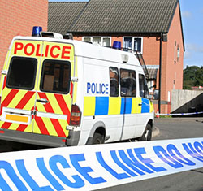
Summer preparation for Year 12 Criminology

On the following pages, you will find a selection of articles and suggested activities to prepare you for Year 12 Criminology.

The topics that you will learn are:
- Unit 1: Changing Awareness of Crime
- Unit 2: Criminological Theories
- Unit 3: Crime Scene to Courtroom
- Unit 4: Crime and Punishment

The textbook that we use in school are:
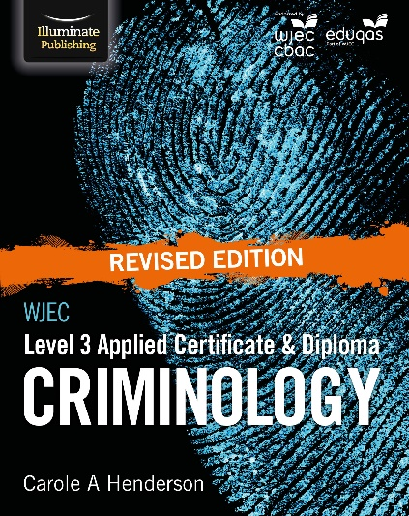
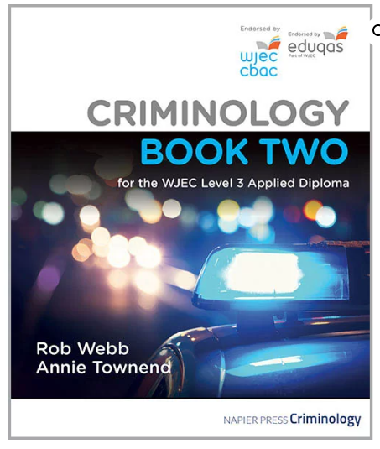
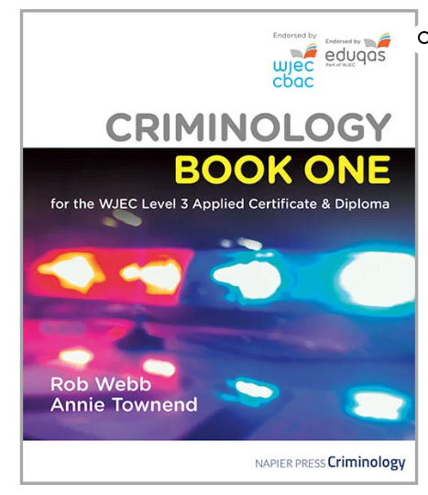
Textbooks are mandatory. They will support you in your private study periods and at home. You will need to purchase both Book one and two for your first year.

STUDENT REQUIREMENTS: Items to be bought to every lesson: 1. A pen
2. A4 lined paper
3. Class notes and ring binder

Look at the specification for more detail about these topics. You can find this at: https://www.wjec.co.uk/media/21xjkr24/applied-diploma-in-criminology-specification-from-2015.pdf

You will be expected to know and understand the information covered, to be able to apply that knowledge and understanding and to be able to analyse and evaluate that knowledge and understanding.

Task 1
Read the specification carefully and make a note below of the sections there are to each Unit:
Changing Awareness of Crime
…………………………………………………………...………………………………………………………………………………….………………...........
………………………………………………………………….........................................................................................................................................................................................................................................................................................................................................................................................................................................................................
Criminological Theories
…………………………………………………………...………………………………………………………………………………….………………...........
………………………………………………………………….........................................................................................................................................................................................................................................................................................................................................................................................................................................................................
Crime Scene to Courtroom
…………………………………………………………...………………………………………………………………………………….………………...........
………………………………………………………………….........................................................................................................................................................................................................................................................................................................................................................................................................................................................................
Crime and punishment in society
…………………………………………………………...………………………………………………………………………………….………………...........
………………………………………………………………….........................................................................................................................................................................................................................................................................................................................................................................................................................................................................

Task 2- Criminal Factfile • Below are a list of victims and offenders for you to research:
Case study | Background information which can explain their criminal behaviour | What crime/crimes have been committed against them and victim & detail about crime | Details of sentence (if any)
Shafilea Ahmed
Robert Thomas and Jon Venables
Fred West
Billy Dunlop
Jimmy Carr





Task 3: You can find criminology in most places from the news to documentaries, but also as society advances you’ll start to see new crimes emerge.
- 24 Hours in Police Custody (4OD)
- The Murder Detectives (4OD)
- Inside Britain’s Moped Crime Gangs / Life in Death Row (iPlayer)
- Dispatches documentaries (4OD)
- Reggie Yates / Professor Green and Stacey Dooley documentaries (iPlayer)
- Panorama documentaries (BBC iPlayer)
Make any notes from your video observations here:
Task 4: Police forces failing to record thousands of crimes
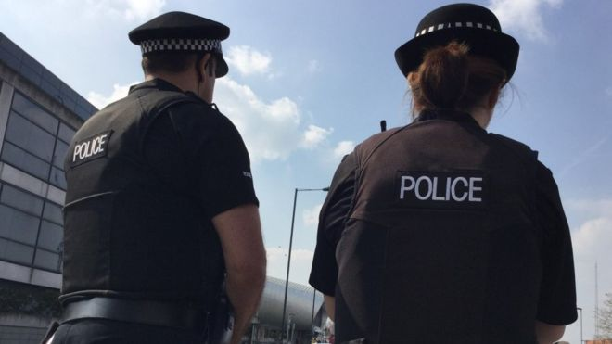
- 15 February 2018
- Three English police forces are failing to record thousands of reported crimes each year, new reports have found.
- Thames Valley Police and North Yorkshire Police failed to record one in five crimes, Her Majesty's Inspectorate of Constabulary and Fire & Rescue Services (HMICFRS) found.
- They are rated "inadequate" for recording crime. Durham Constabulary was rated "good", but failed to record 8.5% of crimes. HMICFRS has so far found 10 out of 20 forces in England and Wales "inadequate" in a series of audits of "data integrity".
- A further five were told they require improvement. Thames Valley was shown to have not recorded 35,000 crimes a year - about one in every five reported to it - including rape, violent assaults and domestic abuse. North Yorkshire also failed to record 9,200 crimes, again about one in every five. Durham did not record 4,700 crimes a year, HMICFRS said, including domestic abuse, public order and "young people sharing indecent images of themselves". All three forces have said they will work to improve crime recording, although Thames Valley stressed there was no suggestion it had failed to respond properly to calls.
- Rachel Almeida, from the charity Victim Support said not recording crimes could lead to victims being denied justice and could deter people from reporting crime. She said: "It is extremely concerning that almost half of the police forces investigated have been found to be inadequate in recording crimes reported to them."
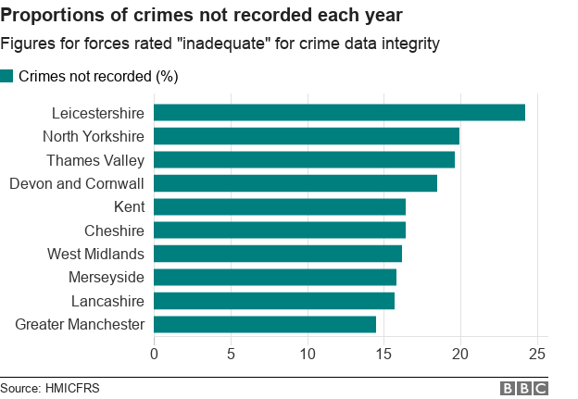
- If someone calls police about an incident, an officer may investigate and the victim may be given support. However, the police still have to decide whether or not to "record" that incident as a crime under categories such as "theft" or sub-categories such as "assault without injury". This data helps inform both the force itself in preventing, detecting and prosecuting crimes and it builds the national picture of whether certain types of crime are rising or falling. Inspectors have looked at the data for 20 out of the 43 police forces covering England and Wales and found 15 of them need to be doing better to take those incidents they are told about and make sure they are properly recorded.
- So far, Leicestershire has the biggest gap between crimes reported to it and those officially recorded, almost one in every four crimes.
- Thames Valley deputy chief constable John Campbell said the report made for "unwelcome reading". He added: "The matters subject to review were recorded as 'incidents' rather than crimes, but there is no suggestion that we failed to respond appropriately to the calls or to deal with the matters in hand. "I can assure the communities of Thames Valley that every day, every officer is working hard to keep you safe from harm and to protect victims of crime."
- HMICFRS estimates almost one in five crimes in North Yorkshire are "not properly being recorded" - something it described as "inexcusable". Flaws in the way the force recorded its crimes were identified by inspectors, with findings of a report saying there was "some confusion" as to who was taking responsibility for recording crimes.
- North Yorkshire's Deputy Chief Constable Lisa Winward said the force "needs to do much better" when recording crimes and added they are working on the recommendations for improvement. Durham's Police and Crime Commissioner Ron Hogg said: "Integrity around crime data recording is essential to maintaining public confidence and there is still some progress to be made."
What are some of the problems with crime statistics? Are they accurate?

Are we able to record every crime? Which crimes might be underreported?

Task 5
As part of your course you will have to look at campaigns that have caused a change in the law. You will also have to plan your own campaign.
Research how newspapers report crime and the types of crime they report on. Consider differences between local newspapers, national newspapers, tabloids and broadsheets in their reporting of crime.

Newspaper 1
Name: _________________________________________________________
Types of crime reported: __________________________________________________________________________________________________________________________________________
Examples of headlines/language used: ______________________________________________________________________________________________________________________________________________________________________________________________________________________________________________________________________________________________________________________________________________________________________________________________________________________________

Newspaper 1
Name: _________________________________________________________
Types of crime reported: __________________________________________________________________________________________________________________________________________
Examples of headlines/language used: ______________________________________________________________________________________________________________________________________________________________________________________________________________________________________________________________________________________________________________________________________________________________________________________________________________________________

Newspaper 1
Name: _________________________________________________________
Types of crime reported: __________________________________________________________________________________________________________________________________________
Examples of headlines/language used: ______________________________________________________________________________________________________________________________________________________________________________________________________________________________________________________________________________________________________________________________________________________________________________________________________________________________

Task 6: Glossary: define the following key terms
Crime
Deviance
Physiological
Atavistic
Somatotypes
Genetic
Monozygotic
Dizygotic
Concordance
Neurological
Biochemical
Observational learning
Introversion
Extraversion
Capitalism
Stereotyping
Custodial sentence
House of Lords
House of Commons
Judicial precedent
Statutory interpretation
Literal rule
Golden rule
Mischief rule
Crime control model
Due process model
Social control
Retribution
Proportionality
Rehabilitation
General deterrence
Individual deterrence
Public protection
Indeterminate sentence
Determinate sentence
Suspended sentence
Discharge
Conditional discharge
Absolute/unconditional discharge

The Reading and Watching List on the following page will help you to gain wider knowledge and a broader framework in which to apply your knowledge. You will be expected to choose something to watch/read every half term and to feed back to the rest of the class. You may do this individually, in pairs or groups.
• You are expected to use the resources available to you in the library and the textbook for each year of study.
• Your folders of notes will be checked on a regular basis to see if you are organised and up to date with your work.
• USE YOUR STUDY TIME AND BE PRO-ACTIVE.
Reading List – Criminology
• Folk Devils and Moral Panics – Stanley Cohen
• A Glasgow Gang Observed – Patrick James
• Gang Leader For A Day – Sudhir Venkatesh
• Fake Law – The Secret Barrister
• Traces: Memoir of a Forensic Scientist and Criminal Investigator – Patricia Wiltshire
• My Life With Murderers – David Wilson
• A wide range of newspapers including The Guardian and Independent Watching List – Criminology
Any documentaries, including Panorama, Louis Theroux, Stacey Dooley, Mind of a Murderer etc
• Black Mirror series (Netflix)
• Goodfellas
• The Godfather (part 2 is the best)
• Legend
• McMafia (previously BBC i-player)
• Freedom Writer’s Diary
• Dangerous Minds
• Chernobyl (drama)

