St Peters Science Dept
Environmental Science Transition Pack



Contents | Page
Understanding the specification and the assessment | 3-5
Transition activity 1-3: Scientific vocabulary | 6-9
Transition activity 4: SI Units and prefixes | 11
Transition activity 5: Converting data | 11
Transition activity 6: Investigating woodlice behaviour | 12-13
Transition activity 7: Investigating dandelion abundance | 14-15
Transition activity 8: Investigating weed killer | 16
Transition activity 9: Investigating moths | 17
Transition activity 10: Describing and explaining observations | 18
Transition activity 11: Analysing graphs | 19-21
Transition activity 12: Using maths skills | 22-23
Transition activity 13: Extended writing | 24-26
Transition activity 14: Key concepts from GCSE Biology | 28-30
Transition activity 15: Key concepts from GCSE Chemistry | 31-33
Transition activity 16: Key concepts from GCSE Physics | 33-35

Aim of the booklet
This booklet will support your transition from GCSE science to A-level. At first, you may find the jump in demand a little daunting, but if you follow the tips and advice in this guide, you’ll soon adapt. As you follow the course you will see how the skills and content you learnt at GCSE will be developed and your knowledge and understanding of all these elements will progress.

We have organised the guide into three sections:
- Understanding the specification and the assessment
- Transition activities to bridge the move from GCSE to start of the A-level course
- Progression of key ideas from GCSE to A-level.

Understanding the specification and the assessments

Specification at a glance

The specification is a useful reference document for you. You can download a copy from our website here.

The most relevant parts of the specification for students are the following:

Section 3: Subject content
Section 6: Appendix A: Working scientifically
Section 7: Appendix B: Maths requirements and examples

In Environmental Science the subject content is arranged into seven main sections, all of which need to be covered over the 2 years of your A-level course. The section titles are listed here:

3.1 The living environment
3.2 The physical environment
3.3 Energy resources
3.4 Pollution
3.5 Biological resources
3.6 Sustainability
3.7 Research methods

Each section of the content begins with an overview, which describes the broader context and encourages an understanding of the place each section has within the subject. This overview will not be directly assessed.

The content is presented in a two-column format. The left-hand column contains the specification content and the right-hand column contains additional information to further exemplify the content.

The seventh section (3.7) is Research methods. These are overarching methods that environmental scientists use to investigate a wide range of environmental issues. They include scientific methodologies and sampling techniques. You are not expected to have first-hand experience of all these methodologies and techniques but over your 2-year course you need to develop an understanding of the general principles and apply them to a range of environmental situations and techniques. The practical handbook will help with this, and you can download it here.

The Working scientifically and maths skills you need to develop are set out in Appendix A and Appendix B. At the end of each topic of the subject content we have listed opportunities for the development of these skills. These tables are extensive, and we do not expect that you would use all these opportunities during your learning of this content. They are there as examples for your teacher, not as a checklist for coverage. These skills can be assessed through any of the content on the written papers, not necessarily in the topics we have signposted.

Assessment structure

The assessment for the A-level consists of two exams, which you will take at the end of the course.
Paper 1
What's assessed
- The physical environment
- Energy resources
- Pollution
- Research methods
How it’s assessed
- Written exam: 3 hours
- 120 marks
- 50% of the A-level
Questions
A combination of multiple choice, short answer, and extended response (9 marks) and one essay from a choice of two titles 25 marks
+
Paper 2
What's assessed
- The living environment
- Biological resources
- Sustainability
- Research methods
How it’s assessed
- Written exam: 3 hours
- 120 marks
- 50% of the A-level
Questions
A combination of multiple choice, short answer, and extended response (9 marks) and one essay from a choice of two titles 25 marks

Assessment objectives

As you know from GCSE, we have to write exam questions that address the Assessment objectives (AOs). It is important you understand what these AOs are, so you are well prepared. In Environmental Science there are three AOs.

- AO1: Demonstrate knowledge and understanding of scientific ideas, processes, techniques, and procedures, including in relation to natural processes/systems and environmental issues (about 30-35% of the marks).
- AO2: Apply knowledge and understanding of scientific ideas, processes, techniques, and procedures, including in relation to natural processes/systems and environmental issues (about 40-45% of the marks).
- AO3: Analyse, interpret, and evaluate scientific information, ideas, and evidence, including in relation to environmental issues to make judgements and draw conclusions (about 25–30% of the marks).

Other assessment criteria

At least 10% of the marks for A-level Environmental Science will assess mathematical skills, which will be equivalent to Level 2 (Higher Tier GCSE Mathematics) or above.

At least 15% of the overall assessment of A-level Environmental Science will assess knowledge, skills and understanding in relation to practical work.

Command words

Command words are used in questions to tell you what is required when answering the question. You can find definitions of the command words in Environmental Science assessments on the website. They are very similar to the command words used at GCSE.

Subject-specific vocabulary

You can find a list of definitions of key terms used in our A-level Environmental Science specification here.

You will become familiar with, and gain understanding of, these terms as you work through the course.

Transition activities

The following activities cover some of the key skills from GCSE science that will be relevant at A-level. They include the vocabulary used when working scientifically and some maths and practical skills.

You can do these activities independently or in class. The booklet has been produced so that it can be completed electronically or you can print them out.

The activities are not a test. Try the activities first and see what you remember and then use textbooks or other resources to answer the questions. Don’t just go to Google for the answers, as actively engaging with your notes and resources from GCSE will make this learning experience much more worthwhile.
The answer booklet guides you through each answer. It is not set out like an exam mark scheme but is to help you get the most out of the activities.
Understanding and using scientific vocabulary

Understanding and applying the correct terms are key for practical science. Much of the vocabulary you have used at GCSE for practical work will not change but some terms like working out uncertainty are dealt with in more detail at A-level so are more complex.

Activity 1 Scientific vocabulary: Designing an investigation
Link each term on the left to the correct definition on the right.

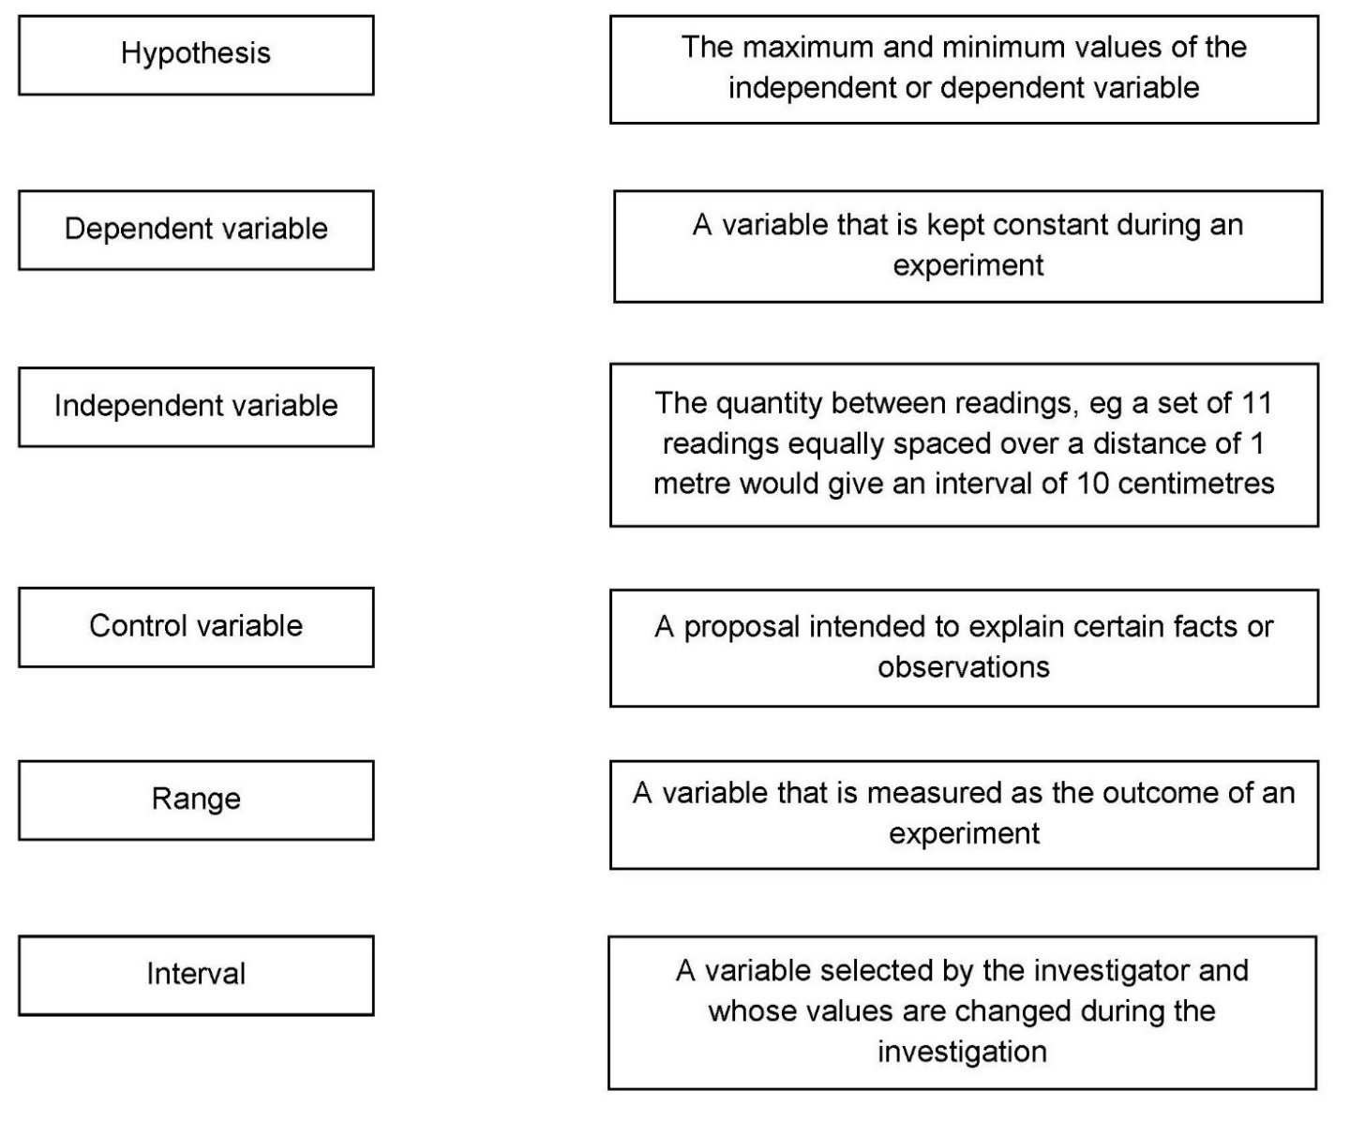

Activity 2 Scientific vocabulary: Making measurements
Link each term on the left to the correct definition on the right.

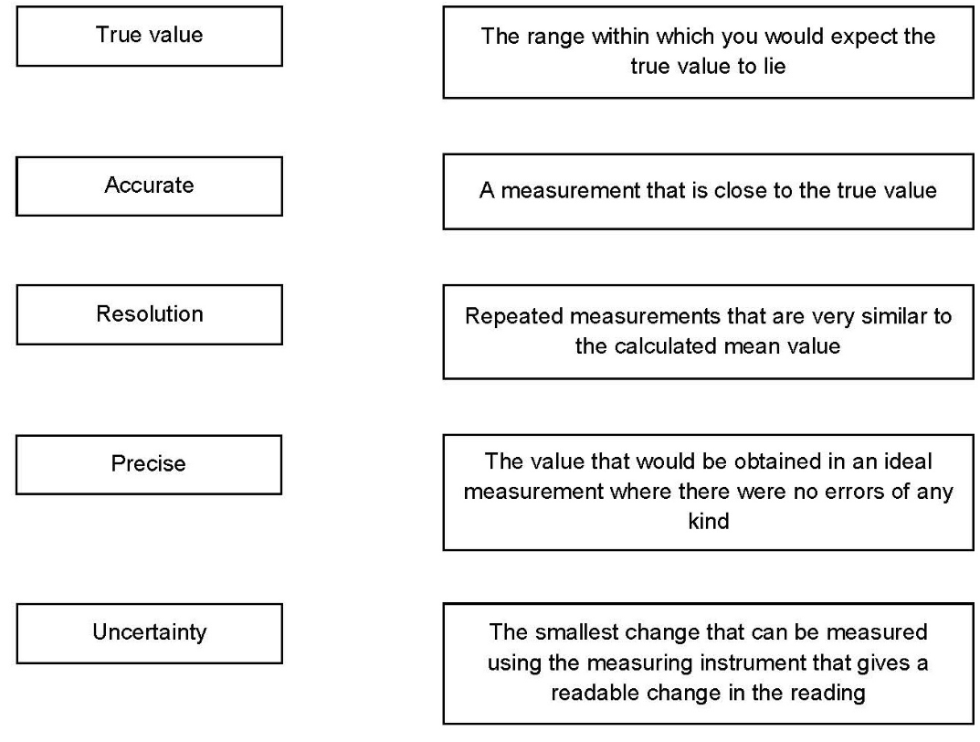

Activity 3 Scientific vocabulary: Errors
Link each term on the left to the correct definition on the right.

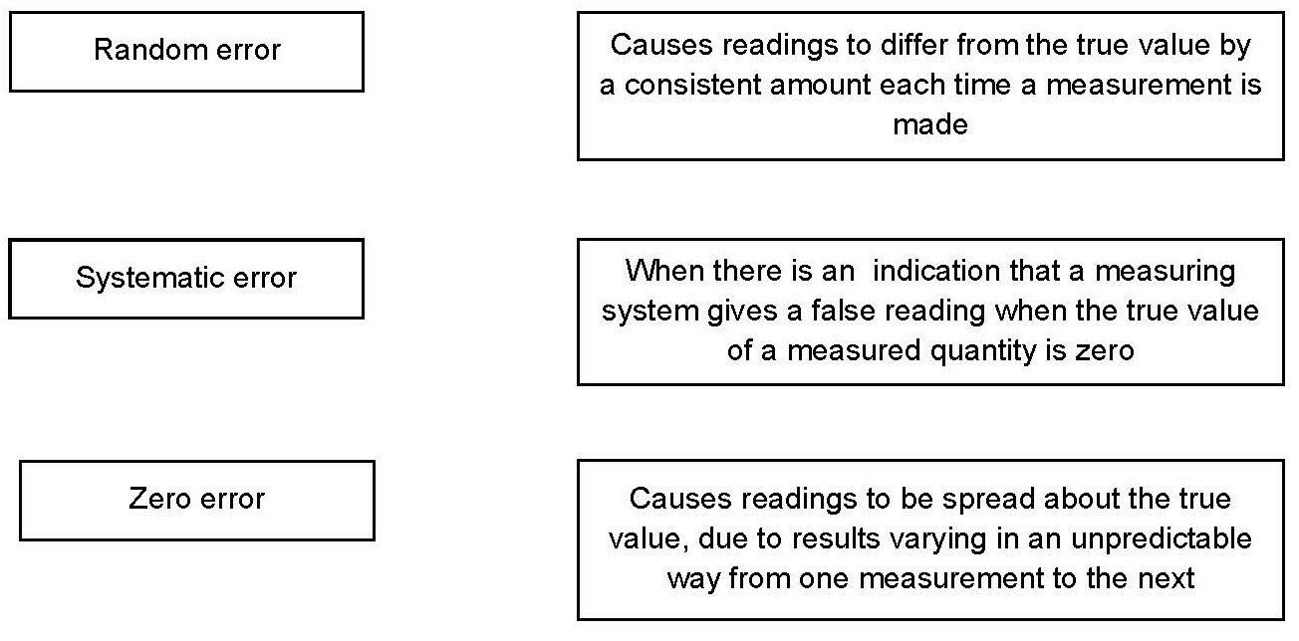

Understanding and using SI units

Every measurement has a size (eg 2.7) and a unit (eg metres or kilograms). Sometimes, there are different units available for the same type of measurement. For example, milligram, gram, kilogram and tonne are all units used for mass.

There is a standard system of units, called the SI units, which are used for most scientific purposes.

These units have all been defined by experiment so that the size of, say, a metre in the UK is the same as a metre in China.

There are seven SI base units, which are given in the table.

Physical quantity | Unit | Abbreviation
Mass | kilogram | kg
Length | metre | m
Time | second | s
Electric current | ampere | A
Temperature | kelvin | K
Amount of substance | mole | mol
luminous intensity | candela | cd

All other units can be derived from the SI base units. For example, area is measured in metres square (written as m²) and speed is measured in metres per second (written as m s^{–1}). This is a change from GCSE, where it would be written as m/s.

Using prefixes and powers of ten

Very large and very small numbers can be complicated to work with if written out in full with their SI unit. For example, measuring the width of a hair or the distance from Manchester to London in metres (the SI unit for length) would give numbers with a lot of zeros before or after the decimal point, which would be difficult to work with.

So, we use prefixes that multiply or divide the numbers by different powers of ten to give numbers that are easier to work with. You will be familiar with the prefixes milli (meaning 1/1000), centi (1/100), and kilo (1 × 1000) from millimetres, centimetres, and kilometres.

There is a wide range of prefixes. Most of the quantities in scientific contexts will be quoted using the prefixes that are multiples of 1000. For example, we would quote a distance of 33 000 m as 33 km.

The most common prefixes you will encounter are given in the table.

Prefix | Symbol | Power of 10 | Multiplication factor
Tera | T | 10¹² | 1 000 000 000 000
Giga | G | 10⁹ | 1 000 000 000
Mega | M | 10⁶ | 1 000 000
kilo | k | 10³ | 1000
deci | d | 10⁻¹ | 0.1 | 1/10
centi | c | 10⁻² | 0.01 | 1/100
milli | m | 10⁻³ | 0.001 | 1/1000
micro | μ | 10⁻⁶ | 0.000 001 | 1/1 000 000
nano | n | 10⁻⁹ | 0.000 000 001 | 1/1 000 000 000
pico | p | 10⁻¹² | 0.000 000 000 001 | 1/1 000 000 000 000
femto | f | 10^{–15} | 0.000 000 000 000 001 | 1/1 000 000 000 000 000

Activity 4 SI units and prefixes
What would be the most appropriate unit to use for the following measurements?

- The length of a leaf

- The distance that a migratory bird travels each year

- The diameter of a smoke particle

- The mass of a woodlouse

- The volume of the trunk of a large tree

- The flow volume of a river

Activity 5 Converting data
- Re-write the following.

- 0.00122 metres in millimetres
- 1 042 000 micrograms in grams
- 1120.2 metres in kilometres
- 0.7 decilitres in millilitres
- 70 decilitres in litres

- It is estimated that 33 000 000 000 tonnes of CO₂ was released globally in 2019 from energy-related sources. Circle the correct conversion. Use the prefix table above to help you.

33 Tt | 33 Gt | 33 Mt

- The distance between the Sun and the Earth is 149.6 Gm. In this case, Gm is not a common unit, so we can convert it to km and express it in standard form. Circle the correct conversion. Use the prefix table above to help you.

1.496 ×10⁶ km | 1.496 × 10⁸ km | 1.496 × 10¹² km

- The estimated volume of ice stored in the Antarctic ice sheet is 0.027 billion km³. Circle the correct conversion. Use the prefix table above to help you.

27 million km³ | 2.7 million km³ | 270 million km³

Practical skills

The practical skills you learnt at GCSE will be further developed through the fieldwork and practicals you undertake at A-level. Your teacher will explain in more detail the requirements for fieldwork, practical work, and the research methods.

There is a practical handbook for Environmental Science, which has lots of very useful information to support you in developing these important skills. You can download a copy here:

Activity 6 Investigating woodlice behaviour
Organisms have adaptations that enable them to survive in the conditions in which they normally live.

Students wanted to investigate if the distribution of invertebrates in a habitat depends on the intensity of light.

Equipment:
- 20 Woodlice
- Choice chamber with four sectors and a transparent lid
- Bench lamp
- Translucent material, eg tracing paper (to vary light intensity)
- Stop clock

Method:
- Place the choice chamber on the bench.
- Cover the sectors with different numbers of layers of translucent material. Leave one sector with no cover.
- Turn on the bench lamp so that it shines from directly above the choice chamber.
- Put 20 woodlice into the centre of the choice chamber.
- Immediately start a stop clock.
- Leave the apparatus for 2 minutes.
- Record the number of woodlice in each sector of the chamber.

- Write a hypothesis for this investigation.

- What do you predict will be the result of this investigation?

- What are the independent, dependent and control variables in this investigation?

- What is the difference between a repeatable measurement and a reproducible measurement?

The students’ results are shown below.

 | No cover | 1 layer | 2 layers | 3 layers
Number of woodlice after 2 minutes | 1 | 3 | 4 | 12

- Write a conclusion to explain what the results show.

- Suggest how you could improve this investigation to get more valid results.

Sampling techniques

Activities 7, 8 and 9 are based on GCSE questions. They cover a range of sampling techniques. Complete the questions to check you remember the key points.

Activity 7 Investigating dandelion abundance
Some students investigated the size of a population of dandelion plants in a field.

The diagram below shows the field.
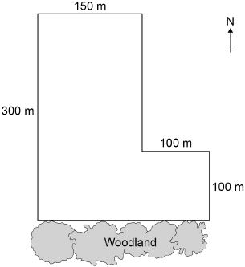

The students:
- placed a 1m × 1m square quadrat at 10 random positions in the field
- counted the number of dandelion plants in each quadrat.

The table below shows the students’ results.

Quadrat number | Number of dandelion plants
1 | 6
2 | 9
3 | 5
4 | 8
5 | 0
6 | 10
7 | 2
8 | 1
9 | 8
10 | 11

- Why did the students place the quadrats at random positions?

- Estimate the total number of dandelion plants in the field. Use the information in the diagram and the table to help you answer the question.
Give your answer in standard form.

Quadrats 5, 7 and 8 were each placed less than 10 m from the woodland. These quadrats contained low numbers of dandelion plants.

The students questioned if light intensity affected the abundance of dandelions, since the woodland created shade on the field.

They made the following hypothesis:

‘The number of dandelions will increase with distance from the woodland as
light intensity increases.’

- Write a method the students could use to test this hypothesis.

- Light is an abiotic factor that affects the growth of dandelion plants.

State two biotic factors that affect the growth of dandelion plants.

Activity 8 Investigating weed killer
Students investigated the effect of a weed killer on the weeds growing in a field.

They used 0.5 m × 0.5 m quadrats.

They sprayed half the field with liquid weed killer and half with water.

- Explain why the students used water on one side of the field instead of weed killer.

The table below shows the students’ results.

 | Number of weeds per quadrat
 | At start |  | After 2 weeks
 | Side A  (Weed killer) | Side B (Water) | Side A  (Weed killer) | Side B (Water)
 | 8 | 14 | 3 | 8
 | 2 | 9 | 4 | 15
 | 12 | 3 | 0 | 7
 | 15 | 16 | 2 | 12
 | 13 | 3 | 1 | 13
Mean

- Calculate the mean values in the table.

- Calculate the percentage decrease in the mean number of weeds on side A after 2 weeks.

- One student thought the results were not valid.

Suggest one improvement the students could have made to the method to make the results more valid.

Give the reason for your answer.

Activity 9 Investigating moths
Students were studying the ecology of their playing field. They wanted to count the population of ruby tiger moths.

Figure 1 shows the cross-section of the moth trap they used.

Figure 1
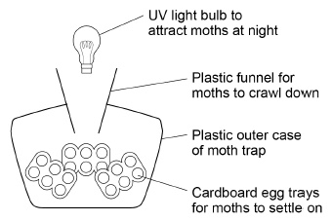

This is the method used.
- Set up the moth trap on the playing field.
- Leave the trap overnight with the light on.
- Remove the egg trays and count the number of ruby tiger moths.
- Release the moths on the playing field.

The students wanted to compare their results with another school.

- Suggest two ways that both schools could standardise the method to make sure their results were reproducible.

Give reasons for your suggestions.

- Suggest two reasons why moths are important to other species.

Describing and explaining observations

Activity 10 is based on a GCSE question. Complete the questions to ensure you understand about describing and explaining trends in data.

Activity 10 Climate change
The graph below shows changes in global air temperature and changes in the concentration of carbon dioxide in the atmosphere.

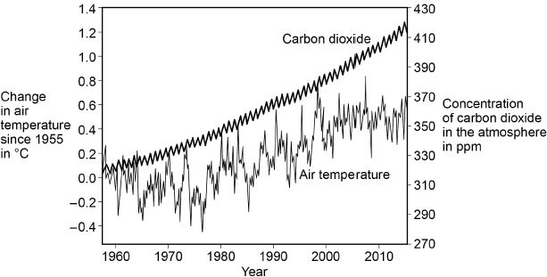

- Use the graph to describe two trends in carbon dioxide from 1955 to 2015.

- Many scientists think that an increase in carbon dioxide concentration in the atmosphere causes an increase in air temperature.
How would an increase in the concentration of carbon dioxide in the atmosphere cause an increase in air temperature?

In each year, the concentration of carbon dioxide in the atmosphere is higher in the winter than in the summer.

- Give one human activity that could cause the higher concentration of carbon dioxide in the winter.

- Give one biological process that could cause the lower concentration of carbon dioxide in the summer.

- Give the name of one other greenhouse gas that contains carbon.

Analysing graphs

Environmental Science is about collecting, analysing, and interpreting data on how our environment is changing. A wide range of different types of graphs are used in Environmental science and you will continue to develop the graph skills you gained at GCSE throughout the A-level course.

When you look at a graph remember to pay attention to the axes, units, key and trends before attempting any questions. At A-level the graphs become more complex than you will have seen at GCSE and may have two axes that you need to consider. You can see an example of this in Question 5 below.

Activity 11 Analysing graphs
Wildlife in rivers is affected by changes in conditions. The graph below shows how the oxygen content of water changes with temperature.

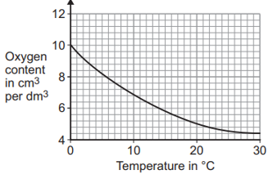

- Describe the relationship between the oxygen content and temperature.

- Does the data show a positive or negative correlation?

- Calculate the change in oxygen content when the temperature of water is increased from 0 ºC to 14ºC.

- The table below shows how the density of liquid water changes with temperature.
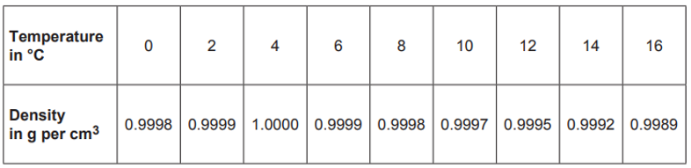

Which of the graphs below A, B, C or D, shows how the density of water changes with temperature?

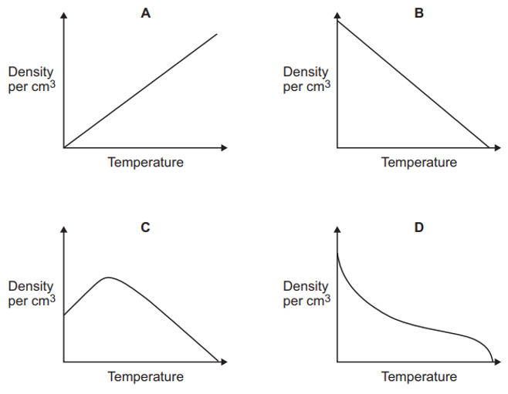

- The graph below shows how the stock and catch of one species of Artic fish have changed since 1960.

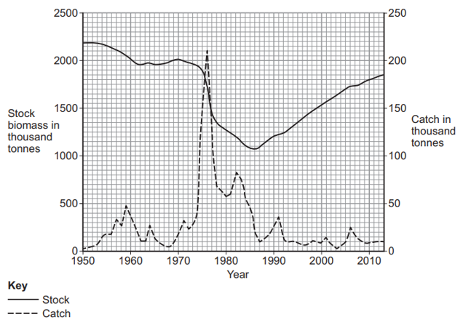

Describe how the catch of fish changed between 1973 and 1980.

Using maths skills

Throughout your A-level Environmental Science course you will need to be able to select relevant data and use the correct calculations to produce information that can then be used to inform how to manage environmental issues.

Activity 12 Maths skills
- In East Anglia, the average annual rainfall is 0.55 m.

A house in East Anglia has a flat roof with an area of 120 m².

If 75% of the rain falling on the roof is collected, what volume of rainwater would be collected in one year?

- The diagram shows the amount of water typically used in the home, in the UK, in one day.

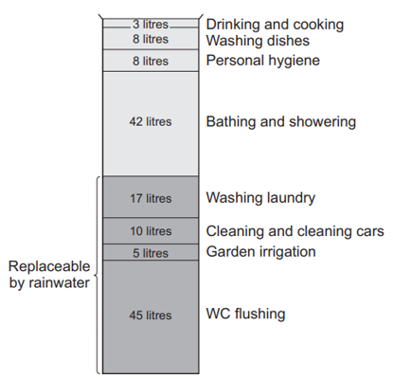

Calculate the percentage (%) of water use that is potentially replaceable by using rainwater.

- The table below shows how local authorities dealt with household waste they collected in 2009 and 2010.

 | January 2009 –  December 2009 |  | January 2010 –  December 2010
Local authority collected waste | 000 tonnes | % | 000 tonnes | %
Recycled, composted or reused | 10 275 | 38.7 |  | 39.7
Not recycled, composted or reused | 16 266 | 61.3 | 15 628 | 60.3

Calculate the mass of waste that was recycled, composted, or reused in 2010.

- A water company estimates that the 1.9 million people living in the area produce approximately 500 000 tonnes of sewage sludge a year.

Estimate the mass of sewage sludge produced by the UK in 1 year if it has a population of 67 million.

Give your answer in standard form.

- In 2017, the city of Manchester began a ‘City of Trees’ project. The project plans to plant 3 million trees over the next 25 years.

It was suggested that the council plant 3.6 × 10⁵ trees in the first year. The rest of the trees would be planted in equal numbers over the remaining years.

Calculate how many trees would need to be planted in each of the remaining years.

Give your answer in standard form.

- A sample of river water contains 125 mg per dm³ of dissolved solids.

Calculate the mass of dissolved solids in grams in 250 cm³ of this sample of river water. (Remember about your unit conversions dm³ to cm³.)

Give your answer in grams to 2 significant figures.

Extended writing

The ability to write coherently in a logical, well-structured way is an essential skill to develop. At GCSE the 6-mark extended response questions are used so students can demonstrate this skill. At A-level you need to develop this skill further, and you will be expected to write longer extended response questions. In each Environmental Science exam paper there are questions worth 9 marks and an essay worth 25 marks. You will practice this skill over the next 2 years.
The command word in a question, like at GCSE, is important as it gives you an indication of what to include in your answers. For example, ‘explain’ means you must give reasons why things are happening, not just give a description. A comparison needs advantages and disadvantages or points for and against. Your teacher will work with you on this skill during the course.

Activity 13 Extended writing
In this activity there are two questions and model student answers. The first question is taken from a GCSE Combined Science Biology paper and the second is the type of 9-mark question you might find on this topic on an A-level Environmental Science paper.

Look at the two questions and see how the demand has increased from GCSE to A-level.

Question 1: GCSE Combined Science Biology (6 marks)

Plants take in carbon dioxide from the atmosphere as part of the carbon cycle.

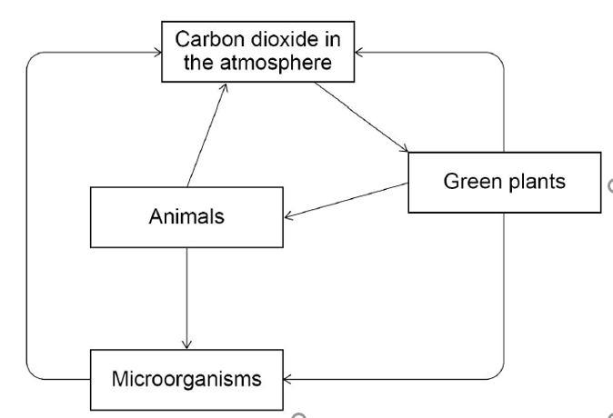

Explain how carbon from the atmosphere is cycled through living organisms.

Question 2: A-level Environmental Science question (9 marks)

Explain how an understanding of the carbon cycle can help us manage climate change.

How the demand progresses

At GCSE you have a question on the carbon cycle that requires you to know how the process works. There is a diagram to help support you and act as a stimulus.

In the A-level question you have to a make the link between the carbon cycle and the environment and apply what you know about the cycle to how it affects a real-life situation. There is no diagram to help you or act as a stimulus.

Environmental science is about applying knowledge and understanding of fundamental scientific ideas, processes and relationships to a variety of real-life environmental issues and situations. It is important for you to use the correct scientific vocabulary when you are doing this.

Model answer: GCSE Combined Science Biology

Carbon dioxide is absorbed by plants through their leaves for photosynthesis.
The plants take in water and CO₂ and make glucose and oxygen.
Animals then eat the plants and use the glucose for respiration and to grow.
During respiration the CO₂ is breathed out by the animals and goes back into the atmosphere. When the animal dies they begin to decay and the microorganisms eat them and release the carbon.

The microorganism also breath out CO₂ so some goes out then as well. The cycle starts again.

Model answer: A-level Environmental Science

Human activities have increased the concentration of carbon dioxide and methane in the atmosphere which has increased the greenhouse effect. This has happened because now, more outgoing infrared radiation is absorbed and doesn’t escape out of the atmosphere. This has led to global climate change. Our understanding of the processes that add or remove carbon can help us make management decisions that increase the processes that remove carbon, at the same time as reduce activities that increase the outputs of these greenhouse gases.

One of the main ways we can do this is using our understanding of the role of photosynthesis in the carbon cycle. Photosynthesis absorbs carbon dioxide, and therefore if we reduce deforestation and increase afforestation, we can increase the rate removal of carbon dioxide from the atmosphere by this process. If we then protect these forests, we can ensure that the carbon remains stored in these trees for a long time.

We also understand that the combustion of fossil fuels for the production of electricity releases large amounts of carbon dioxide to the atmosphere and therefore if we use alternative energy resources such as renewables like solar and wind we prevent the need to use fossil fuels and the carbon can remain stored in the Earth’s crust as coal, oil and gas. Additionally, if we can conserve energy, for example though home insulation, we can reduce the amount of electricity we use for heating and so reduce the amount of fossil fuels that is need to be combusted to make the electricity, so reducing CO₂ emissions.

One-way methane is released to the atmosphere is when the bacteria living inside the guts of ruminant animals, anaerobically respire. If we can change our diets to eat less meat and therefore reduce the numbers of cattle such as cows and sheep. This way we can reduce the methane emissions, which is a powerful greenhouse gas.

Progression of content

What you learnt at GCSE forms the foundation to your further study at A-level. Ideas will be developed and refined, new concepts and skills will be introduced. Topics from all three sciences are relevant for Environmental science.

Some key concepts from GCSE that are important for A-level Environmental Science are shown in the table.

Biology | Chemistry | Physics
- Factors affecting the rate of photosynthesis  - Factors affecting the rate of transpiration  - Selective breeding  - Ecosystem organisation and interactions  - Material cycles  - The importance of biodiversity  - Sampling ecosystems  - Human impacts on ecosystems | - Relative formula mass  - Acid and alkalis  - Evolution of the Earth’s atmosphere  - Climate change  - Air pollution  - Resources and sustainability  - Recycling and life cycle assessments  - The Earth’s water resources and obtaining potable water | - Energy stores and transfers  - Power  - Energy efficiency  - Energy resources  - Specific heat capacity  - Radioactive materials and half life  - EM spectrum

The following optional activities are questions on the topics you have studied in Science at GCSE. They are designed to help refresh your memory of some of the important concepts you will use during your study of A-level Environmental Science.

Work through these activities in your own time using your notes and revision guides from GCSE.

Activity 14 Key concepts from GCSE Biology
Factors affecting the rate of photosynthesis

- Name three limiting factors of photosynthesis.

- CO₂ can be added to the air in a greenhouse where tomatoes are growing. This increases the rate of photosynthesis.

Suggest why increasing CO₂ levels to very high concentrations will no longer increase the rate photosynthesis.

- Describe how global warming may affect the rate of photosynthesis and how this in turn by affect the greenhouse effect.

Factors affecting the rate of transpiration

- Why do plants transpire?

- Explain how the abiotic factors temperature, humidity and air flow affect the rate of transpiration in plants.

Selective breeding

- State two characteristics that may be useful to select when breeding plants or animals for agriculture.

- Selective breeding can reduce the gene pool. Describe two problems that may arise as a result of this reduction.

Ecosystem organisation and interactions

The diagram below shows a food web.

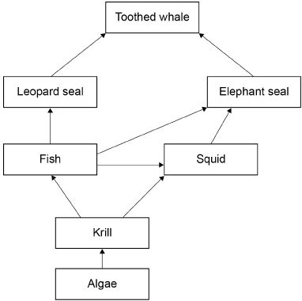

- What term is used to describe all the organisms living together in an ecosystem?

- What term is given to the place a particular species lives in?

- What do we mean by the term population?

- What term is used to describe the algae in this food web?

- Toothed whales will compete with each other for food. What else might toothed whales compete for?

- These organisms live in the ocean.

Name two abiotic factors and two biotic factors that could affect these organisms.

The importance of biodiversity and Human impacts on the ecosystem

- Define the term biodiversity.

- Tick which of the following statements are true.

- It is important to maintain biodiversity because:

- a great biodiversity ensures the stability of ecosystems.

- biodiversity increases the dependency of one species on another for
food and shelter.

- biodiversity helps maintain the physical environment.

- biodiversity is not important in maintaining the human species.

- many human activities are reducing biodiversity.

- Scientists and concerned citizens have put in place programmes to reduce the negative effects of humans on the ecosystem.

Which of the following are examples of these kinds of programmes?

- Breeding programmes for endangered species.

- Removing hedgerows to ensure more effective Intensive farming methods.

- Building houses on the green belt to alleviate the housing shortage.

- Reduction of deforestation.

- Recycling resources rather than dumping waste in landfill.

Activity 15 Key concepts from GCSE Chemistry
Acids and alkalis

- Cross through the bold words in the sentence below that are incorrect to produce a correct statement about pH.

The lower the pH the lower/ higher the content of H⁺ ions and so the more
acidic / alkaline the solution is.

- For every decrease of 1 on the pH scale, the concentration of H⁺ ions increases by a factor of 10.

For example, an acid of pH 4 has 10 times the concentration of H⁺ ions than that of an acid of pH 5.

The pH of two soil samples was analysed.

Soil A = pH 4
Soil B = pH 7

By what factor is the concentration of H⁺ ions greater in soil A than soil B?

Evolution of the atmosphere

- Complete the table below to show the Earth’s atmosphere as it is today.

Gas | % volume
Nitrogen
Oxygen
Carbon dioxide

The Earth’s early atmosphere had virtually no oxygen and much higher concentrations of carbon dioxide.

- Describe one physical process that led to the reduction in the concentration of CO₂ in Earth’s early atmosphere.

- State the name of one biological process that led to the reduction of CO₂ and the increase in O₂ in the Earth’s atmosphere from ~2.7 billion years onwards.

Air pollution

- Draw lines from each air pollutant to the environmental problems it causes. Each environmental problem can be used more than once.

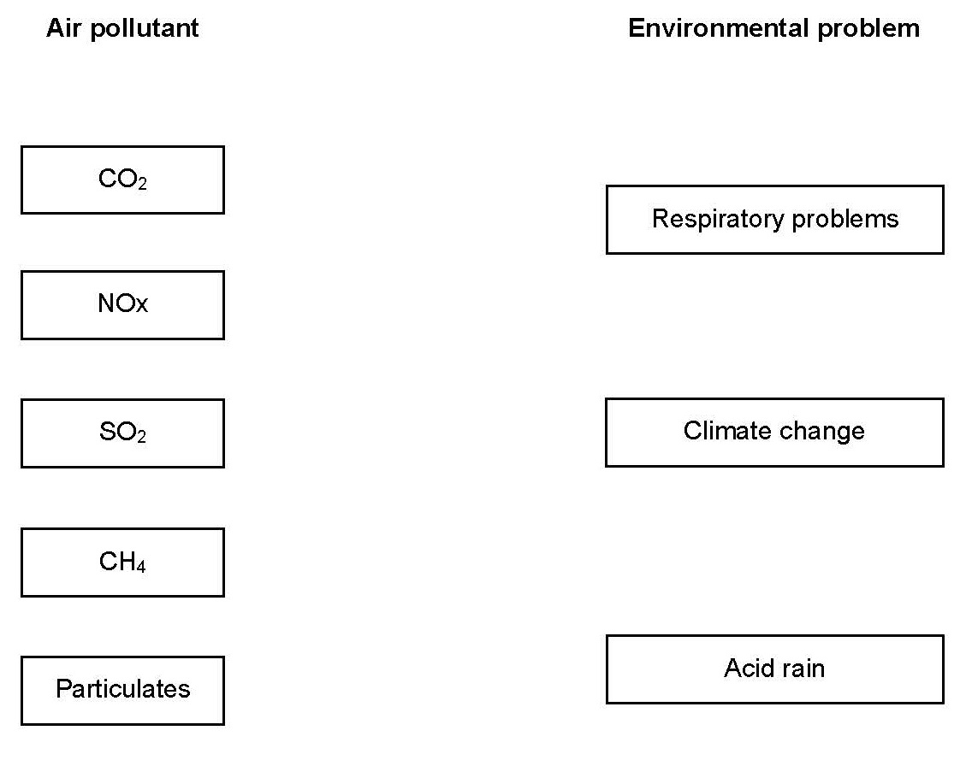

- Give one common human activity that leads to the release of each of the air pollutants in question 8.

Resources and sustainability

- Life cycle assessments (LCAs) assess the environmental impact of the entire lifetime of a product. State the four stages of a product’s life cycle that can be assessed.

- Suggest three factors that can be assessed as part of a LCA in order to quantify environmental impacts.

- Explain why using recycled materials in the manufacture of new products results in a better LCA outcome.

- Using the LCA model, compare the environmental impacts of wooden and plastic furniture.

The Earth’s water resources and obtaining potable water

- Potable water is water that is safe to drink. It is not pure water in the chemical sense because it contains dissolved substances.

Name three important water quality features of potable water.

- Urban lifestyle and industrial processes produce large amounts of waste water that require treatment before being released into the environment.
State the different stages involved in the treatment of sewage.

Activity 16 Key concepts from GCSE Physics
Energy stores and transfers

Thermal insulation can be used to reduce rate of energy transfer.

Students investigated how effective three different thermal insulating materials were in keeping a container of water hot.

The students:
- wrapped the three different insulating materials around three containers
- added hot water to each container
- measured the temperature of the water in each container
- left the containers for 5 minutes and then measured the temperature again.

- Identify the independent and dependent variable in this experiment.

- Suggest three variables that should have been controlled.

- Suggest how the experiment could be improved.

Energy efficiency

- The more energy efficient something is, the less energy is wasted.

What is the equation to calculate energy efficiency?

- Energy efficiency is important in environmental science. For example, improvements in efficiency means less energy is wasted and so less fossil fuel needs to be combusted, meaning fewer greenhouse emissions.

An electric fan is supplied with 1500 kJ of energy. 500 kJ is wasted as thermal energy.

Calculate the % energy efficiency of the electric fan.

Energy resources

- Tick the box to identify if the energy resources are renewable or non-renewable.

Energy resource | Renewable | Non-  renewable
Coal
Wind
Gas
Geothermal
Solar
Nuclear
Wave
Hydroelectric
Oil
Biofuel
Tidal

- Describe two advantages and two disadvantages of using wind as an energy resource instead of coal.

Specific heat capacity

- What unit is energy measured in?

- A substance’s specific heat capacity is the amount of energy needed to raise the temperature of 1 kg by 1 ºC. Water has a specific heat capacity of 4200 J/ kg ºC.

How much energy is needed to heat 2.00 kg of water from 10 ºC to 80 ºC?

Use the equation

Change in thermal energy | = | mass | × | specific heat capacity | × | temperature change
Power

- What is power?

- What unit is power measured in?

- What unit is energy transfer measured in?

- A wind turbine transfers 180 MJ of wind energy into electricity in 1 minute.

Find its power in MW.

Use the equation

power | = | energy transferred
 |  | time

Radioactive materials and half lives

- Radioactive substances give out radiation from the nuclei of their atoms. Half-life is the time taken for the number of nuclei of a radioactive isotope in a sample to halve.

The half-life of radioactive carbon-14 is 5730 years. If a sample contains 40 g of radioactive carbon after 5730 years it will contain 20 g, after another 5730 years that will have halved again to 10 g.

Calculate the total amount of time for a 40 g sample to reduce to 2.5 g.

Electromagnetic spectrum

- Write out the seven types of electromagnetic radiation in order of increasing wavelength.

- Match the electromagnetic radiation to its environmental significance.



