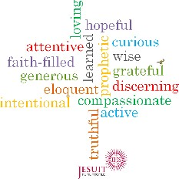

A LEVEL CURRICULUM OVERVIEW FOR THE HISTORY DEPARTMENT EXAM BOARD: OCR H505
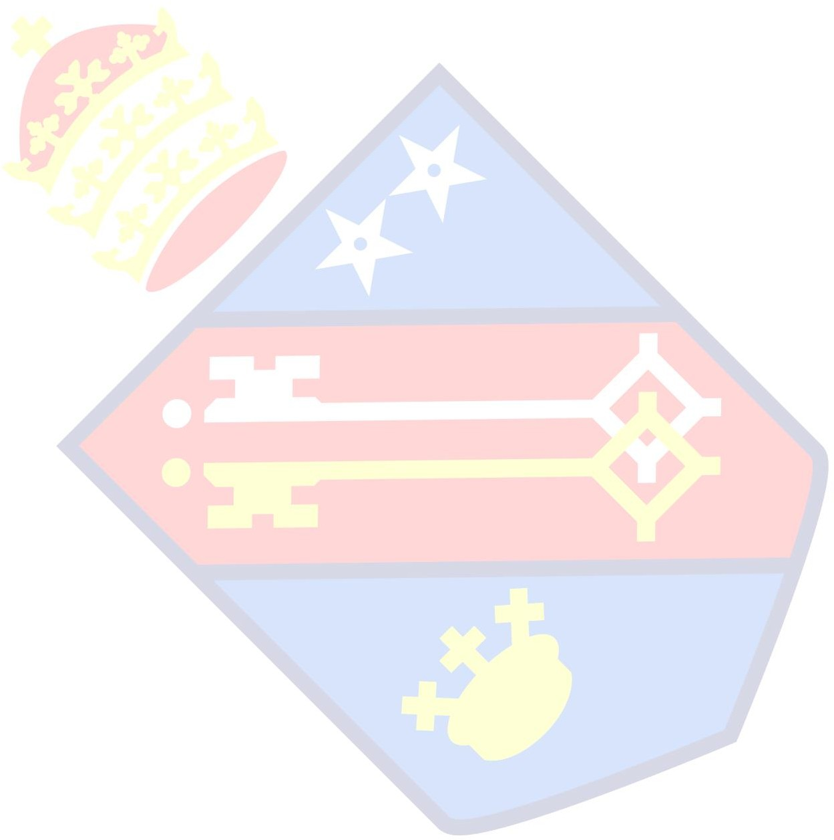
HEAD OF DEPARTMENT: MRS KELLEHER

 | AUTUMN 1 |  | AUTUMN 2 |  | SPRING 1 |  | SPRING 2 |  | SUMMER 1 |  | SUMMER 2
 | Attentive & Discerning |  | Faith-filled & hopeful |  | Intentional & prophetic |  | Compassionate & Loving |  | Learned & Wise |  | Curious & Active
Year 12  Teacher 1  3 hours a week | The Early Tudors 1485-1558  Henry VII domestic and foreign policy |  | The Early Tudors 1485-1558  Henry VIII and the age of Wolsey |  | The Early Tudors 1485-1558  Henry VIII Cromwell and the Reformation |  | The Early Tudors 1485-1558  Henry VIII 1540-1547  Mid-Tudor Crises |  | The Early Tudors 1485-1558  Mid Tudor Crises: the reigns of Edward VI and Mary I |  | The Early Tudors revision  Coursework planning
Year 12  Teacher 2  2 hours a week | Germany: Democracies and Dictatorships 1919-1963  Weimar Germany |  | Germany: Democracies and Dictatorships 1919-1963  Hitler’s Consolidation of Power |  | Germany: Democracies and Dictatorships 1919-1963  Nazi Germany |  | Germany: Democracies and Dictatorships 1919-1963  Nazi Germany |  | Germany: Democracies and Dictatorships 1919-1963  Post-war Germany |  | Germany: Democracies and Dictatorships 1919-1963  Post-war Germany
Year 13  Teacher 1  3.5 hours a week | Russia and its Rulers 1855-1963  The Nature of Government |  | Russia and its Rulers 1855-1963  The impact of dictatorial regimes on the economy and  society of the Russian Empire and the USSR  Impact of war and revolution on the development of the Russian Empire and the USSR  Russia: Empire, nationalities and satellite states |  | Russia and its rulers 1855-1963  Alexander II’s domestic reforms  The Provisional Government |  | Russia and its rulers 1855-1963  Khrushchev in power 1956-1964  Revision of Russia Course |  | Revision of Russia and its rulers 1855-1963 |  | N/A
Year 13  Teacher 2  1 hour a week | Coursework |  | Coursework |  | Coursework |  | Tudors revision |  | Tudors revision |  | N/A
Year 13  Teacher 3  1 hour a fortnight | Germany revision |  | Germany Revision |  | Germany revision |  | Germany revision |  | Germany revision |  | N/A

