

UCAS guide for
2026 entry


Student Name | Tutor group

Key information

UCAS personal ID number
User name
Password

Ensure the password you create is one that is not linked to any other accounts. Your form tutor will have a copy and it is visible in this booklet.

Contents page
Contents
Essential Dates 4
How to register with UCAS 7
Awarding Organisations for GCSE, AS and A level qualifications for students studying at St Peter’s School. 8
Choosing a course 10
Predicted grades 11
UCAS Tariff 13
Writing an effective personal statement 14
Applying to Oxbridge 30
Applying for Medicine 31
Applying for a music conservatoire 32
Studying abroad 35
Differences between US and UK Admissions 36
Submitting your application 37
Final Decisions 39
Track, Offers, Interviews & Tests 41
Extra, Clearing & Adjustment 44
FAQs 45
Useful links 47
Tracking Sheet 48

Essential Dates

The following page outlines the key dates in the UCAS application process. The essential deadlines you must meet are:
- 6th October 2025
  - for any students applying to course at the universities of Oxford and Cambridge, or for most courses in medicine, veterinary medicine/science, and dentistry to complete, pay and send their UCAS form.
- 10th December 2025
  - for all applicants to complete, pay and send their UCAS form.

The UCAS timeline can be found here - Dates and deadlines for uni applications | Undergraduate | UCAS

The importance of the internal UCAS deadlines
We work to the internal deadlines highlighted on the previous two pages. The reasons for this are explained below.
The final UCAS deadline is 14th January 2026 for entry in September 2026 to most university courses. This does not mean that universities stockpile all the applications received since 13th May 2025 when UCAS opened. Most universities read through submitted applications as they come through, many of them will also be making offers along the way. And every offer they make, is one less chance available to you. Hence, by the time 14th January comes around they may only have a handful of offers still to distribute, and a 2 foot high pile of applications on their desk still to read. Apart from the numbers game that you now find yourself in the middle of (with the odds stacked against you), consider how much more difficult it is to make a remarkable and original impression on an Admissions Tutor who has spent the last 4 months of his or her life reading through hundreds of Personal Statements. Consider also what it says about you as a student if your application only just manages to meet the deadline.

It is true that some university departments (usually where courses are particularly competitive) do still take a ‘gathered field’ approach to UCAS applications. That is, they will leave it until 14th January before they start making their final decisions on who is offered a place. That said, most of these departments will have eliminated the weakest candidates along the way leaving your late application competing with the cream of the crop.

So what is actually meant by UCAS’s 14th January deadline is that this is the VERY LAST DATE by which universities are committed to reading and considering your UCAS form. Your application, if received on this day, will be read but it won’t necessarily have the same chances (and impact) as one that arrived, say, 3 months earlier. Arrive a day later, however, and universities have every right to toss is straight in the wastepaper bin.

The reality is you are competing for offers with around 350,000 other students. You have come this far and worked this hard so give yourself the best chance of getting the offer from the university you have set your heart on by getting your application in front of admissions tutors as early as possible. It is also a case of helping yourself. Getting you application in early means you can put all your focus into getting the grades you need to get onto that dream course.

You must also understand that completing your application and sending it off only gets it as far as our sixth form team. It will then be checked again by them, be sent on to Dr Aslam and Mr Grice who will add your reference and predicted grades and finally you must sign off your reference before your application is sent into UCAS. The earlier you get your form to us, the earlier it will get submitted and be in front of the admissions tutors. Our internal deadlines are 6th October for selected course and 10th December for all other courses.

How to register with UCAS

Enter the web address – www.UCAS.com
Step 1: Create an Account
- Go to the UCAS Hub.
- Click ‘Sign in’ and then ‘Register’ for the 2026 undergraduate application.
- Enter your personal details, including your name, date of birth, and email address. Your email is required to verify the process. UCAS and universities will communicate with you via this email so sexy123@hotmail.co.uk is not a good choice of email address to provide! (Make a new professional account for this maybe)
- Set a username, password, and security questions.
- Make a note of your username and password in this booklet. Your tutor will also keep a copy.
- Devise your personal security questions when prompted. You WILL be required to give the answers to these over the phone if you call UCAS.

Step 2: Start a New Application
- Once signed in, go to your UCAS Hub dashboard.
- Click ‘Your application’ to begin the 2026 undergraduate application.
- Confirm you are applying for 2026 entry and that it is for an undergraduate course.

Step 3: Enter Your Buzzword
- When asked "How are you applying?", select ‘Through my school or college’. - St Peters R C School (Whitefields Road, Solihull)
- Enter the buzzword SPCS2026 your school or college has provided.
- This will link your application to your school so teachers can add your reference and predicted grades.

Awarding Organisations for GCSE and AS level qualifications for students studying at St Peter’s in Year 11.
To ensure this information is accurate, you are advised to check your certificates, but the information below will help if you don’t have access to them. For GCSE (full course) and Level 2 BTEC taken at St Peter’s in 2024:
Subject | Qualification | Awarding Organisation
Art & Design | GCSE 9-1 | OCR
Business Studies | GCSE 9-1 | OCR
Computer Science | GCSE 9-1 | OCR
Drama | GCSE 9-1 | AQA
English Language | GCSE 9-1 | AQA
English Literature | GCSE 9-1 | AQA
French | GCSE 9-1 | AQA
Hospitality & Catering | Level 1/2 Vocational Award | WJEC
German | GCSE 9-1 | N/A
Geography | GCSE 9-1 | AQA
Health & Social Care | OCR National | OCR VQ
History | GCSE 9-1 | AQA
Maths | GCSE 9-1 | AQA
PE | GCSE 9-1 | OCR
Product Design | GCSE 9-1 | AQA
Religious Studies A | GCSE 9-1 | Edexcel
Science Combined | GCSE 9-1 double award | AQA
Biology | GCSE 9-1 | AQA
Chemistry | GCSE 9-1 | AQA
Physics | GCSE 9-1 | AQA
Spanish | GCSE 9-1 | AQA
Sociology | GCSE 9-1 | AQA

For AS levels taken at St Peters in 2024/5
Subject | Qualification | Awarding Organisation
Health & Social Care | Cambridge Technical Certificate | OCR
Core Maths | Level 3 Certificate | AQA
EPQ | L3 Project Qualification | AQA

A Levels to be taken at St Peters in 2024/6
Subject | Qualification | Awarding Organisation
Art & Design Fine Art | A Level | OCR
Biology | A Level | AQA
BTEC Sport | Level 3 National Extended Certificate | Pearson
Business Applied | Level 3 National Extended Certificate | Pearson
Business Studies | A Level | WJEC GCE
Chemistry | A Level | AQA
Computer Science | A Level | OCR
Criminology | Level 3 Applied Diploma | WJEC
Drama | A Level | AQA
Film Studies | A Level | WJEC
English Literature | A Level | AQA
Geography | A Level | AQA
Gov & Politics | A Level | Edexcel
Health & Social Care | Cambridge Technical Ext Cert | OCR VQ
History | A Level | OCR
Maths | A Level | Edexcel
Medical Science | Level 3 Applied Diploma | WJEC
Further Maths | A Level | Edexcel
PE | A Level | OCR
Physics | A Level | AQA
Psychology | A Level | AQA
RS | A Level | OCR
Spanish | A Level | AQA
Sociology | A Level | OCR

Choosing a course
One of the most important decisions you will make in this process is the course you apply to study. You need to make sure that you are choosing the right course and that you have explored the course options BEFORE deciding upon the universities you wish to apply to.
The main question you should ask yourself is: What subject am I happy to study in depth for the next three or more years?

There are a few reasons why you may want to study a particular course:
- You have really enjoyed it at A level and want to continue exploring the subject
- You have proven ability in the subject
- You would like to use this Degree to go on into a rewarding career

Remember that although your parents / carers / teachers are an invaluable source of advice, the final decision is yours. Make sure you choose a subject that you have a genuine interest and passion for, make an informed decision that gives you every chance of success!
Remember that:
- Whilst university courses might carry the same name as your A Level course, they may be very different. Ensure that you read around the topics you will be required to study.
- Go to open days and attend sample lectures / talks which will help you to understand the content covered in your Degree.
- Do not assume that each course will be the same at each university. Psychology at Birmingham is completely different from Psychology at Oxford. There will be huge variations in the content of the course and the way in which it is taught.
Many universities differ in the way in which they assess. If you struggle in high pressure examination situations, ensure that you look for courses that offer a more coursework or modular type of Degree. You need to start researching your courses as soon as possible. The tools and advice given on the UCAS website links below are a great place to start when deciding on what course to study.
https://www.ucas.com/ucas/subject-guide-list
Subjects - Student - Unifrog
If you are completely stuck on where to start, try a few of the links below and don’t forget to use your UniFrog subscription to help by completing the quiz’ and tools
Home - Student - Unifrog
https://university.which.co.uk/advice/choosing-a-course/help-i-dont-know-what-course-to-choose-what-do-i-do
https://www.thecompleteuniversityguide.co.uk/courses/choosing-a-course/

Predicted grades
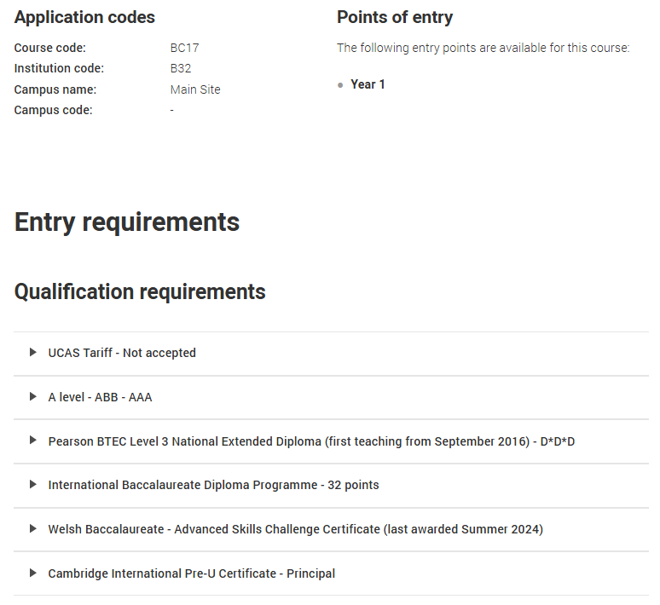
When you have chosen a course the next thing you need to do is look at your predicted grades and see if they tally with what the university would ask for. This information is usually found here on the UCAS website for a course towards the bottom:

Your teachers will provide you with your predicted grades in September following your mocks. These can also be altered based on your post-summer exams. You need to remember the following:
- Your teachers are the experts. They have a vast amount of experience and know what grade you are most likely to get.
-This information will be based on your mock examinations and your progress to date, including you post-summer assessments.
-The universities may ask to see the progress data from your time in Sixth Form. This is why your predicted grade, and this data must tally.
-The universities will also look at your GCSE grades to see if this tallies with your predicted grades. For example, if you achieved 5/6 grades at GCSE and then you are predicted A*and A in all subjects this is likely to raise questions and queries. Universities are likely to ask for evidence to support that you are working at the grade predicted (if you are working at a significantly higher level – then well done! Your data will support this, and you can look forward to lots of offers flooding in)
- You can aim a little higher than your predicted grades, but you need to be realistic. If you have been predicted CCC then applying to universities with AAA as their entry requirement is not a wise way to proceed. Try to apply to the majority that match your predicted grades. Have one lower and one a little higher. Remember if you are over ambitious in all of your applications you could end up with no offers.

DO NOT PUT PRESSURE ON TEACHERS TO CHANGE YOUR PREDICTED GRADES. A CAREFUL AMOUNT OF CONSIDERATION WILL HAVE GONE INTO THESE PREDICTIONS FROM THE OUTSET. TRUST THAT THE GRADES WE PREDICT ARE THE GRADE YOU ARE MOST LIKELY TO GET BASED ON THE EVIDENCE WE HAVE.
ASKING FOR SIGNIFICANTLY HIGHER GRADES BECAUSE YOU WANT TO GO TO A PARTICULAR UNIVERSITY WILL ONLY PUT MORE PRESSURE ON YOU AT EXAM TIME…PROMISES TO ‘WORK HARDER IN THE FUTURE’ PERHAPS GIVE RISE AS TO WHETHER FURTHER ACADEMIC STUDY IS REALLY YOUR BEST OPTION AND WHY HAVNT YOU SO FAR ANYWAY?

UCAS Tariff
Some universities will base their offers around Tariff points. These can be found below:

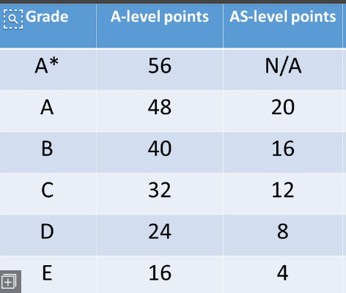

You can find this information on the course specific pages of the UCAS website. For example:
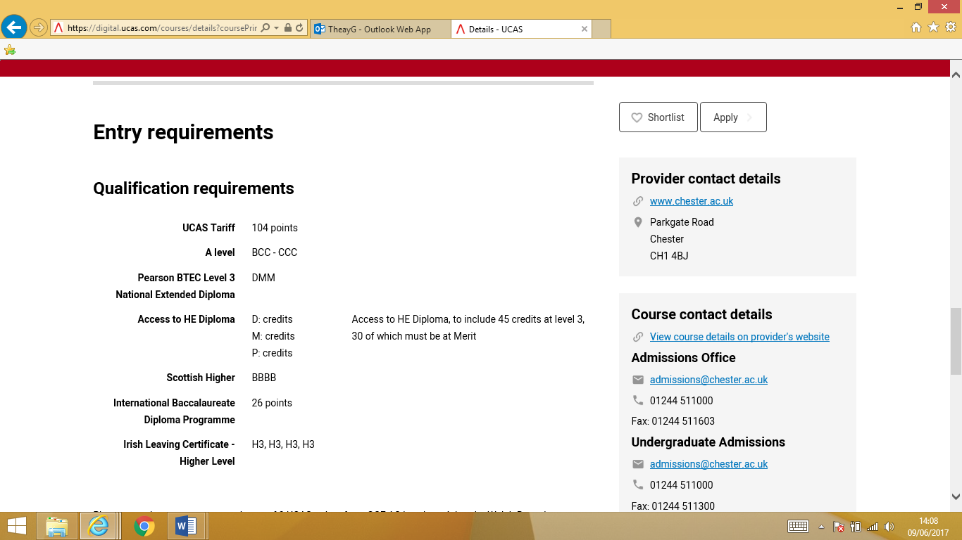

UCAS Grade Tariff spreadsheet -
UCAS Tariff Points - what are they and how do they work?

Writing an effective personal statement

Everything is available on the UCAS website on the new structure and how to target your personal statement - Writing your personal statement | Undergraduate | UCAS
And guides for each type of course - 2026 personal statement guides | Undergraduate | UCAS
The personal statement is your opportunity to tell the admissions tutors why you want to study the subject (s) you are applying for. You will easily find examples of highly effective personal statements, however:
BE AWARE THAT UCAS USES SOPHISTICATED COPYRIGHT / PLAGIARISM SOFTWARE. IF YOU COPY LINES / PHRASES / STATEMENTS FROM THE INTERNET OR FROM PEERS (EVEN IF IT WAS YEARS AGO!) THE SOFTWARE WILL PICK IT UP AND THE UNIVERSITIES WILL BE INFORMED.

Crafting an Effective Personal Statement for 2026 UCAS Applications
As you embark on your journey to higher education, your personal statement plays a pivotal role in showcasing your passion, qualifications, and readiness for your chosen course. For the 2026 entry cycle, UCAS has restructured the personal statement into three focused questions, each designed to help you present a comprehensive and compelling narrative. This guide will walk you through each question, offering insights and tips to help you craft responses that stand out.

Understanding the New Structure
The revised personal statement format comprises three distinct sections:
- Why do you want to study this course or subject?
- How have your qualifications and studies helped you to prepare for this course or subject?
- What else have you done to prepare outside of education, and why are these experiences useful?
Each section allows you to highlight different aspects of your journey and suitability for the course. The total character limit remains 4,000 characters (including spaces), with each section requiring a minimum of 350 characters. This structure aims to provide clarity and ensure you address key areas of interest to admissions tutors.
Question 1: Why Do You Want to Study This Course or Subject?
This section is your opportunity to convey your enthusiasm and motivation for your chosen field. Consider the following when crafting your response:
- Personal Inspiration: Reflect on experiences, events, or individuals that sparked your interest in the subject. Perhaps a particular book, lecture, or personal experience ignited your passion.
- Subject Knowledge: Demonstrate your understanding of the subject area. Mention specific topics, theories, or issues within the field that intrigue you and explain why.
- Career Aspirations: Outline how the course aligns with your future goals. Whether you have a specific career in mind or a broader ambition, show how the course will help you achieve these objectives.
Starter Example:
- "My fascination with environmental science began during a school project on climate change, where I explored the impact of carbon emissions on global temperatures. This experience, coupled with my commitment to sustainability, has driven me to pursue a degree in this field to contribute to meaningful environmental solutions."

Question 2: How Have Your Qualifications and Studies Prepared You for This Course or Subject?
In this section, highlight how your academic background has equipped you with the necessary skills and knowledge:
- Relevant Coursework: Discuss specific subjects or modules that are pertinent to the course. Explain how they have provided a foundation and prepared you for advanced study.
- Skills Development: Identify transferable skills you've gained, such as critical thinking, research abilities, or problem-solving, and relate them to the demands of the course.
- Academic Achievements: Mention any notable accomplishments, such as high grades in relevant subjects, awards, or participation in academic competitions.
Starter Example:
- "Studying A-level Biology and Chemistry has honed my analytical skills and deepened my understanding of complex biological processes. Completing a research project on renewable energy solutions further developed my ability to conduct independent research, a skill essential for success in environmental science."

Question 3: What Else Have You Done to Prepare Outside of Education, and Why Are These Experiences Useful?
This section allows you to showcase experiences beyond the classroom that have prepared you for university study:
- Work Experience and Volunteering: Detail any placements, internships, or volunteer work related to your field. Highlight the insights gained and how they have reinforced your commitment to the subject.
- Extracurricular Activities: Discuss clubs, societies, or hobbies that have developed relevant skills or demonstrated your passion for the subject.
- Personal Responsibilities: Reflect on any personal challenges or responsibilities, such as caregiving or part-time work, and the skills you've developed, like time management or resilience.
Starter Example:
- "Volunteering at a local environmental conservation group allowed me to apply theoretical knowledge to real-world challenges, enhancing my problem-solving skills. Additionally, leading the school's eco-club improved my leadership abilities and reinforced my dedication to promoting environmental awareness."

Final Tips
- Be Specific: Use concrete examples to illustrate your points. Specificity adds credibility and depth to your narrative.
- Reflect and Connect: Don't just list experiences; reflect on what you learned and how they connect to your chosen course.
- Proofread: Ensure your statement is free from grammatical errors and typos. A polished statement reflects attention to detail and professionalism.
- Start with an interesting opening sentence. Avoid ‘I’ve always loved English’ as many people will use opening statements such as this.
- Spend time doing your statement. A typical personal statement will take anywhere between 7-10 drafts to get right.

Unifrog Personal Statement Tool
Personal Statement - Student - Unifrog
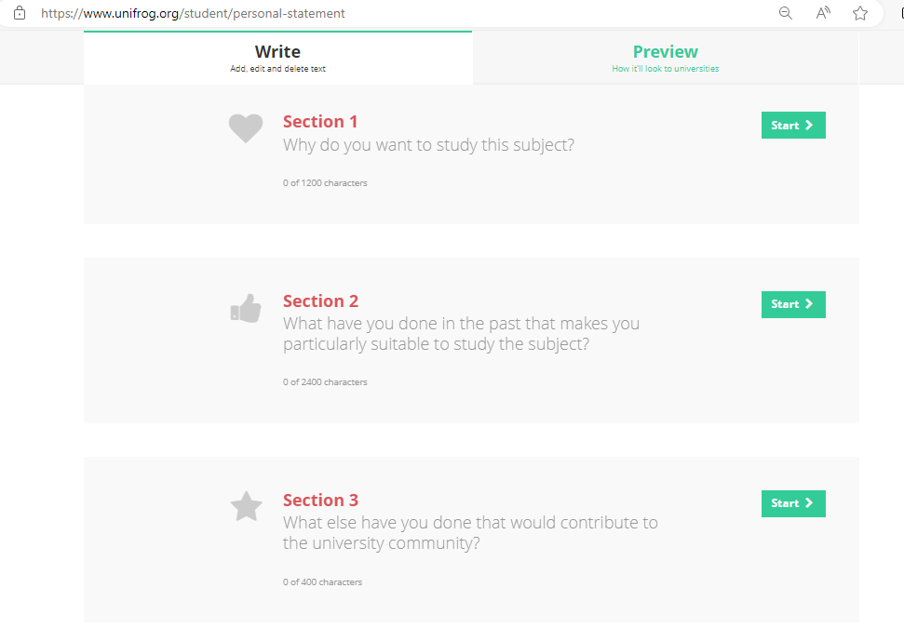
This will be one of the biggest benefits of using your UniFrog account. Completing your statement on the Unifrog platform means you can request feedback from your Form Tutor and other members of the sixth form team and teaching staff, and they can simply add feedback and notes all in one place. No need to get 4 different emails of feedback as all staff can see what others have written and won’t need to write the same things.
THIS IS HOW YOU ARE EXPECTED TO COMPLETE AND SAVE YOUR DRAFTS AND FINAL PERSONAL STATEMENT.

There are also Example Personal statements for all different courses, as well as a starter video https://www.unifrog.org/student/courses/preview/how-to-write-your-personal-statement.

The following magazine article is very helpful as a checklist for your personal statement:

Applying to Oxbridge

Oxford and Cambridge rank among the leading universities in the world and so therefore are very competitive to get into. If you have an excellent academic record you should give serious thought to making an application. Both of the universities pride themselves on their ‘world class teaching’, excellent facilities and wide range of extra-curricular activities.
In addition to making an application through UCAS (for either Oxford OR Cambridge) you will also need to complete an Oxford or Cambridge preliminary form. Applicants will also complete a test which will help the admissions tutors shortlist candidates for interview. Many of these tests will be done at school but for Cambridge some are taken at the university on interview day.
Points to consider if you are thinking of making an application:
- You must have excellent GCSE results
- You must have predictions of at least one A* in your A levels and A grades if you took any AS subjects.
- You must read around the subject that you are taking
- You must keep up to date with research/news around the degree you have chosen.
- Be prepared to take a test and attend an academically demanding interview. All courses hold interviews which usually require you to attend the university for two days.
- Your personal statement must be strong. Around 5 people will read your personal statement and it will form part of the interview.
- They universities get far more applications than places. In 2024 there were 3317 students who were predicted 3 A* that applied to Oxbridge, 1780 were made offers.
If you apply and are offered an interview, you may find the following information useful:
- If you reach the interview stage, you chance of getting a place has reduced from 1 in 16 to 1 in 3. Just to reach the interview stage is a real achievement…you have already beaten off a large amount of competition!
- You will be given a number of problem solving scenarios and discussions. These will usually be with two tutors.
- They will discuss your recent academic work so you will need to revise for the interview. They will ask you what you have been looking at in your lessons and stretch you further on this.
- The interviews are designed to stretch you to see how you will cope. The Oxbridge way of working is to work through problems together, so your interview will mirror this way of teaching.
- Expect to discuss your chosen subject in a wider context.
- They like to give prompt material and ask you to discuss it – for example a text, painting or even a model of a molecule.
- They will discuss the content of your personal statement with you.
- You should come out of the interview feeling like you have been challenged. There are no trick questions designed to catch you out!

Applying for Medicine

Competition for Medicine is as fierce as Oxbridge. Work experience and voluntary work are vital to obtaining a place and all medical schools require you to have experience in a caring or service role. You must ensure you have done or arranged this and it is included in your personal statement. It is better to get a broad range of experience – spending short periods of time in a number of healthcare environments rather than one long placement. For a list of recommended work experience guidelines, visit medschools.ac.uk
The universities will require you to take a test. This will either be a BMAT or UKCAT test. You need to be clear which tests you need to take for the respective course you are applying for. This will be clear on the entry criteria for each course.
UKCAT: a two-hour computer based test, which assesses applicants on decision making, situational judgement and verbal, quantitative and abstract reasoning. Most medical schools use this test, and you must register for and sit the exam before submitting your UCAS application.
BMAT: this exam focuses more on academic aptitude. You must register for the exam before sending your application, but the test is taken later (end of October/beginning of November) your score is then automatically sent on to the schools listed on your application.
You may only choose 4 Medicine courses. Your final course should be something else, usually Biomedical Science.
Your personal statement is key if you are applying for Medicine. This subject can attract a hundred or more strong applications for every place. You must have positive reasons for wanting to become a doctor. The training is long and expensive and medical schools cannot afford to take risks. You have to show that you are passionate about becoming a doctor and that you also have the academic potential to succeed. Your statement must be well written as so many people are applying for each place, your application could be rejected solely on the strength of your personal statement.

Grades
Each medical school sets their own entry criteria, but generally speaking the minimum expected is 3 A grades at A level. At least one of your subjects must be lab- based science (Chemistry or Biology) and some universities require maths and physics at A – Level, too.
GCSE’S must also be 8-9 generally

Applying for a music conservatoire
The conservatoires in the UCAS scheme are:
- Royal Birmingham Conservatoire
- Bristol Old Vic Theatre School
- Leeds College of Music
- Royal Academy of Music
- Royal College of Music
- Royal Conservatoire of Scotland
- Royal Northern College of Music
- Royal Welsh College of Music and Drama
- Trinity Laban Conservatoire on Music and Dance
The conservatoire application is different to a normal UCAS application, and operates on a different section of the UCAS website. You can make an application via the conservatoire route AND the normal UCAS route. Note that the conservatoire application process does not open until July 18th.
In order to make a conservatoire application:
- Register to use apply ( you can only apply once in a cycle) you will find this under ‘sign in’ – students – apply for conservatoires
- Sign into the welcome screen
- Fill in the rest of your personal details
- State your education
- State your qualifications

Making your course choices
You can choose up to six courses – in no preference order. Unlike the normal UCAS route, conservatoires will be able to see where else you have applied. For music there are ‘study type’ options that you will need to fill in. You will then choose from one of the audition locations. You will need to pay for each audition that you attend.
If you are studying music, you might be able to select two instruments if you’d like to. You will come across come key terms which are as follows:
- Main specialism is just one instrument
- Joint main specialism is two instruments studied equally
- Secondary specialism is two instruments – one as your main and one as your secondary
- Alternative main specialism is giving two options, either of which you’d be happy to study as one main instrument.
References
You will require two references which will need to be sent to each conservatoire that you are applying to. These will be sent via post. You require a practical reference and an academic reference (written by your form tutor)

Personal statement
This is also slightly different to a ‘normal’ UCAS personal statement, as it is less about your academic achievements and more about your performance or composition experience. Below is a good example of a personal statement suitable for a conservatoire application. Note the wealth of experience in the statement:
Music example
The Oxford dictionary describes the word ‘journey’ as ‘an act of travelling from one place to another.’ This definition epitomises my journey with music. From being a five year old girl playing the piano in my front room trying to play as many notes as my hand could reach, to hearing my own composition played by a professional ensemble, music has been a significant part of my journey. This journey has also been an inspiration when I am composing. Research shows that music is the last memory trigger a person with dementia will respond to, which led me to composing my piece modelled around dementia as part of the Young Composer’s Project. Looking up at the teary eyed audience who had been so touched by my piece was all the confirmation I needed to be sure that composition was the direction in which my journey should go.
Piano is definitely where my passion for composing began. I have now been playing for 12 years and in March 2017 achieved a merit in Grade 8. I also play the Flute which I have been playing for 8 years and am now working towards Grade 8. To help further my knowledge of instruments I decided to learn the Bassoon and have taken Trinity Grade 4 achieving a merit. In order to improve my understanding of string instruments I have learnt the Double Bass and have successfully transferred these skills onto the Bass Guitar.
As my passion for composing increases I have embarked on several experiences designed to challenge me as a composer. For example, I have taken part in the New Voices weekend organised by the YCP at The Birmingham Conservatoire, where I wrote my aforementioned Dementia piece for piano and nine voices. Furthermore I enrolled on an eight month YCP course, writing a piece for the Birmingham Conservatoire’s LEAP Ensemble.
Another composing journey I have been on was this summer were I was lucky enough to be selected to attend the Sound and Music Summer School at The Purcell School of Music. Once again I challenged myself to be out of my comfort zone with my composing by being part of the Jazz group. Studying under Issie Barratt, Mick Foster and Tom Hewson was enough to inspire me to write a jazz piece for a sextet. I was also involved in workshops with Orphy Robinson, Judith Weir and Laura Bowler whist at the summer school and learnt about their journey composing. By the end of the week I had fallen in love with Jazz and had composed a piece, “Summer Punch” .As well as having my piece recorded and performed by Issie Barratt, Mick Foster, Tom Hewson, Laura Jurd, John Hirst and Matt Ridley, I was also interviewed on BBC Radio 5 Live during the week.
I have had my compositions listen to by Black Sabbath’s Tony Iommi and received positive feedback which was very encouraging. I like to compose music for a reason and about a certain meaning; I want the audience to feel what I feel when they hear my music. I have always been inspired by Einaudi and the way he can express so many emotions through his minimalistic melodies. My composing style is similar to Einaudi’s and it is clear to see this in my first two compositions on the piano.

Moreover, I have performed alongside The Birmingham Conservatoire’s Orchestra as part of the OSOSIC performance at Birmingham Symphony Hall. I have also met and played alongside Sir James Galway and Lady Genie Galway at the Birmingham Conservatoire. As my journey continues to blossom I am looking forward to the future. I already have projects lined up for 2017/188 including composing a score and being the musical director for a youth theatre’s production of Hamlet and I have also applied for the next Young Composers Project.
I would love to be offered a place at a Conservatoire doing composition as I would find it deeply enjoyable and rewarding to continue to create music in a dedicated musical environment. Going from studying A levels to studying composition would be the continuation of my musical journey ‘from one place to another’.

Next steps
Once you have uploaded your personal statement you will need to do the following:
- Read the declaration. This allows UCAS to process your information and send it to your chosen conservatoires.
- Verify your email address. To do this you click on ‘generate a verification code’ and then enter it on the screen
- Pay the application and assessment fees – There is an application fee of £27.50 paid when you send your application. You will also usually have to pay a fee for your auditions/assessments. These will either be collected at this stage or paid directly to the conservatoire.

Submitting your application

There is a clear cut process for submitting your application and this should be followed. This is explained on the following page. The tracking sheet at the end of this booklet has each stage of the application process and each stage should be signed off by your tutor; we will not look at your application until this form has been completed and signed by your tutor and parents/carers. Please note the tracking sheet is there for you, your parents and your tutor to check the detail.
Payment
In order to send your application, you need to pay £28.95
This needs to be paid by card on the UCAS website. This WILL NOT SEND OFF THE APPLICATION.
There are waivers for students who received Free School Meal Payments in the last 6 years.
This will only send it to the sixth form team and will not be sent to the universities at this point.
This can only be done by a member of the sixth form Team (Mr Grice)

Final Decisions
Once you have been notified of all offers or rejections by UCAS you will have to narrow down the choices to two. These are called Firm and Insurance offers.

Firm
The firm offer will be from the university you hope to attend. It should be one where you have a realistic chance of meeting their offer. You should check the conditions of your offer carefully. Note that once you accept this offer if you meet the conditions you are expected to take up this offer. Ensure you are happy with the choice you are making.

Insurance
This is a backup if you do not quite meet your predicted grades. It should be one that you are happy to go to but the grades you are required to achieve are lower.
Universities also offer unconditional places. An unconditional offer means that no matter what grades you achieve, you will be accepted by that university. Although exciting at first, consider what this may mean for your motivation and performance. Think carefully about accepting an unconditional offer, it may well be iron pyrites (fool’s gold), it appears shiny and enticing but is the offer the best for you or the university in the long term? Speak to the Mr Grice if you are offered an unconditional place.
UCAS advise the following about unconditional offers
‘Sometimes universities and colleges make unconditional offers against predicted grades, work experience, or performance in an interview, audition or admissions test. Please make sure your students understand the implications of accepting an unconditional offer. Applicants who accept an unconditional offer cannot make an insurance choice, and will not be eligible for Adjustment or clearing. They should also be reminded of the importance of completing their qualifications, as this is likely to be something future employers will ask for. This blog post is a must read for those considering accepting an unconditional offer’ www.ucas.com/connect/blogs/accepting-unconditional-offer-0

Track, Offers, Interviews & Tests
UCAS Student helpline - 0371 468 0 468
Track
- The Track system is part of UCAS: it is a way of finding out how your application is progressing and will enable you to reply to any offers you receive.
- You can log into Track once you have received your welcome email from UCAS. It can be accessed via a link on the UCAS website.
- You will need your ID Number, Username and Password to log onto the Track system. Please check this regularly, as all offers you get will appear on Track. UCAS will email you to the email address provided with any updates.
- No one else has access to your Track, so if you need any help with the system please bring along your log in details.
- For more information see the ‘Introduction to Track’ video guide on the UCAS website, www.ucas.com
Receiving Offers
- UCAS will start sending your application to your chosen universities/colleges as soon as they receive it. No university will know where else you have applied.
- The universities/colleges will reply to your application at different times. Please do not worry if you haven’t heard from a university/college straight away, some will take longer to reply than others.
- Some will reply within a couple of weeks, it may take others a couple of months. There are 5 types of reply/offer you will receive:
  - Unconditional Offer –you are offered a place regardless of what grade you achieve on your current course. This is a rare reply and normally only given when you have already gained the qualifications you need to meet the entry requirements of that course.
  - Conditional Offer – this is a common reply, where the university would like to offer you a place on the course as long as you gain the needed points/grades asked for.
  - Unsuccessful – the university is unable to offer you a place. Your Track page may give feedback to explain this decision.
  - Referred – this is a common reply, all this means is that your university is still considering your application, and has not yet made a decision.
  - Withdrawn – this will appear on Track if either you or the university has withdrawn from a course. The reason for this should be on Track – for example, not replying to correspondence from universities or not attending an interview.

Replying to Offers
You can only reply to your offers once you have received decisions from all of your choices.
- Firm acceptance – This is your first choice. If you are holding an unconditional offer you don’t have to do anything further, you’re in regardless of your grades/points. If you have a conditional offer you are accepted onto that place but depending on you achieving the entry requirements.
- Insurance acceptance – This is your second choice and is a back-up option if you don’t get the grades/points you need to get into your first choice. You should not choose an insurance choice that has a higher offer (higher grades, more points) than your firm choice. However be realistic and make sure this is somewhere you would be happy to go to.
- Decline – Once you have made your decision about your first and second choices, you will then need to decline any other offers you are holding.
Please think carefully about these decisions. You must be happy with both of these choices as you are entering into a contract situation at this point.
You can then reply via Track. You will have a deadline shown in Track to do this by – you must reply by this date. If you do not reply by the deadline then your application will automatically be rejected.
There are deadlines for replying to offers. Your reply date will depend on when your last university makes their decision, see Track for your personal reply date.

Interviews
Applicants to Oxford or Cambridge, Medicine, Dentistry and Vet Medicine/Science will be interviewed before being made an offer.
For Social Work, Nursing, Midwifery, Healthcare Professions, Teaching and Art and Design courses it is also highly likely that you will have an interview before you are made an offer. Some other universities and courses may interview you.
If you do not attend an interview the university will withdraw their offer.
It is a good idea to research the type of questions you will be asked and to prepare some answers. Read over your personal statement and remind yourself what you have said about your experience and knowledge.
The following websites offer useful interview advice, but you may wish to use tips that are more specific to your course.
Know How - Student - Unifrog
http://www.allaboutcareers.com/careers-advice/university-interviews/how-to-prepare-for-a-university-interview
http://university.which.co.uk/advice/ucas-application/university-interviews-as-told-by-students
https://www.studential.com/university/applying/UCAS-application-guide/interviews

If at this stage you don’t get any offers… don’t panic! You can still go to uni!

Admissions Tests
Some universities or courses will require you to pass a specific admissions test before you are given an offer of a place. They will inform you if this is necessary and will give you details of how to register to take the test. Each one is different so please check your information carefully and ask for help if needed.
Guidance on these tests and recommended preparation and practice tests are available online.
www.admissionstestingservice.org – The Cambridge Assessment Admissions Tests website includes links to the BMAT and the TSA Cambridge and the TSA Oxford – Thinking Skills Assessments
www.bmat.org.uk – Biomedical Admissions Test
www.lnat.ac.uk – The National Admissions Test for Law
www.ukcat.ac.uk – UK Clinical Aptitude Test

Extra, Clearing & Adjustment
UCAS Extra
UCAS offers the Extra service for students who hold no offers before 30th June
That means you have already applied to all 5 choices, and either had 5 rejections or declined all offers you have received. Extra gives you the opportunity to add one more choice to your application.
You apply for one course at a time, through Track, and if you are unsuccessful with that place, you can apply for another.
Extra is available from the end of February until early July.
Track will let you know if you can use Extra

UCAS Clearing
Clearing is a service offered by UCAS for applicants who have no offers from their course choices, have rejected any offers or do not gain the required grades.
Universities or colleges that still have places available will advertise them, and you will then be able to apply for these courses one at a time.
If you are eligible for Clearing UCAS will automatically send you Clearing details and instructions of what to do. Track will advise you if you are eligible for clearing.
Clearing starts from mid-July, any late applications after the 30th June will automatically go into Clearing
Students who have received better grades than expected can now decline their original offer and participate in Clearing to seek alternative places at universities or colleges

FAQs
I’ve changed my mind! What can I do now?
You are able to swap a choice for a different one in Track within 7 days of the date of your welcome email from UCAS. After these 7 days, you cannot change your choices.
If you wish to apply for somewhere completely different and you are sure you do not want any of your original choices, you can withdraw yourself from your choices and are then able to add on 1 more choice at a time through Extra. Extra is only available from 25th February to 5th July. However, once you have withdrawn from your choices you cannot return to these. This is a risky choice – you need to consider this carefully!
I’ve sent my application off, but now I want to add another choice…
If you haven’t used all of your 5 choices you can add more in Track up until 31st January. You may have to pay an extra amount to add more choices if you originally only applied for 1 choice.
If you have used all of your 5 choices you will need to wait until Extra becomes available from February onwards. You will only be able to use this service if you have either had no offers or have declined all of your 5 choices
I’ve accepted my firm and insurance offers, but now I’ve changed my mind about my universities. Can I do anything?
You need to contact the universities directly to discuss this with them. If you wish to withdraw your offer of a place you need to talk about this with the university directly. Staff at school cannot do this for you. For further, more detailed advice about what you can do next contact UCAS on their student helpline number: 0871 468 0 468
I’ve got enough UCAS points for my first choice but I want to go next year instead of this year. What do I do?
You need to contact the university directly and ask if they would consider you for next year instead and accept you as a deferred entry. (UCAS Student helpline 0871 468 0 468)

Can I choose to cancel a choice on my Ucas application?
If you would like to withdraw just one of your choices, you can cancel it in Track (as long as the university has not made a decision yet). However, you cannot replace this with another choice.
I haven't applied, but now I've got my results I've decided that I should go to uni after all. What to do?
You still need to apply through UCAS and fill in a complete application form to be sent to UCAS. Your application form will then go through clearing automatically. Clearing can help you to find courses with vacancies if you've applied late or your results are not as expected. Or you can apply early in next year’s application cycle (September 2024) for entry in the following year, September 2025
I've got an offer from my first choice uni, but I want to do a different course there now?
You can swap a choice for a different one in Track within seven days of the date on your welcome letter/email. However you can't swap a choice after 30 June, unless for exceptional reasons (like a change in family circumstances or personal problems).
If you're happy with the university or college but you'd like to change the course details, you'll need to get in touch with the university or college rather than us. You are not able to change your UCAS form once it has been sent to UCAS, but you can contact the universities you have applied to by phone to ask if they would offer you a place on a different course. The university can then put in a change of course offer through UCAS, which should show up on your Track page. If you have not used all of your 5 choices you can add on other courses to the maximum of 5 choices. You might, however, need to write a new personal statement if you are changing courses radically. As previously stated you cannot change the UCAS form, so will have to write a new personal statement which will need to be sent to each university directly. The university will also get a copy of your original personal statement on their UCAS form, so you will need to justify the change of course.
What do I do if I’ve missed something off my application form and need to get it back?
Once it has been sent to UCAS, you cannot get it back, or make any changes. Make sure you check and recheck, before you send it. If you have noticed a serious mistake then please speak to us and we will advise you how to proceed.

Useful links
Unifrog (PAID SUBSCRIPTION BY THE SIXTH FORM)
Home - Student - Unifrog
National career service (England)
https://nationalcareers.service.gov.uk/
Prospects (to see what you can do with a degree)
www.prospects.ac.uk
UCAS buzz quiz
www.ucas.com/buzz-quiz
Information about higher and degree apprenticeships
www.ucas.com/apprenticeships
Discover Uni – higher education statistics. Compare student satisfaction scores, percentage of coursework, teaching etc.
https://discoveruni.gov.uk/
University league tables
www.timeshighereducation.com
www.thecompleteuniversityguide.co.uk

