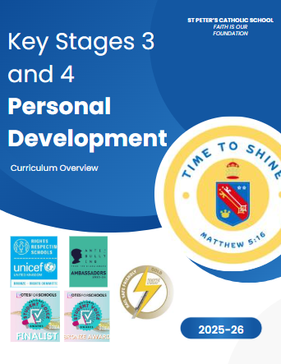
In support of our Discipleship Pathway.
St Peter’s Whole School MISSION
We work hard to build a better world where Faith is our Foundation.

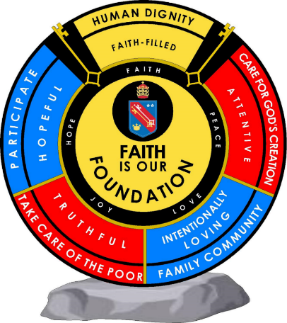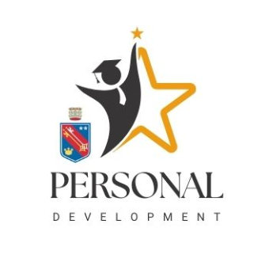

“The school’s work to promote pupils’ personal development is exceptional. “
Ofsted. March 2025
Personal Development
At St Peter’s Catholic School, we strive to fulfil the potential of all pupils.
The Personal Development Curriculum offer is broad and balanced. We have ensured that pupils at St Peter’s are exposed to a rigorous and research led model for Personal Development which is guided by the:
Catholic Education Service
the PHSE Association (whole school membership)
University of Birmingham Jubilee Centre of Research – Character Education

The purpose of Personal Development is to:
- Develop our St Peter’s Profile and mission - spiritual growth, good sense, practical wisdom; the capacity to choose intelligently between alternatives.
- Supports pupils to access diverse aspects of life
- Provides skills and opportunities to support them in adult life.

At St Peter’s Personal Development is ‘taught’, ‘caught’ and ‘sought’.

Taught in :
- RE
- Prayer and Liturgy
- PSHE curriculum
- PSHE form
- Through Votes for Schools

Caught through:
- Behaviour
- Actions

Sought through:
- Leading in prayer and liturgy
- Extra curricular activities and events
- Sports
- Time to Thrive events
- Pupil leadership opportunities
- Community Voice
- Careers work experience days at Ks3 and work experience week in KS4

PSHE
PSHE (Personal, Social, Health Education) is part of our taught Personal Development curriculum. Our timetabled curriculum has been designed to have a spiral approach where every year virtues and values are built on in an age appropriate, inclusive and constructive way. It is a responsive curriculum that is increasingly ambitious year on year and accessible to all students. PSHE is divided into exploring three core themes within which there will be a broad overlap.

The three themes are:
• Created and loved by God (this explores the individual)
The Christian imperative to love self, made in the image and likeness of God, shows an understanding of the importance of valuing and understanding oneself as the basis for personal relationships.
• Created to love others (this explores an individual’s relationships with others)
God is love. We are created out of love and for love. The command to love is the basis of all Christian morality.
• Created to live in community – local, national & global (this explores the individual’s relationships with the wider world)

Each theme covers the core strands of ‘Education in Virtue’ and ‘Religious Understanding’ and all lessons aim to celebrate our Catholic faith and respect the diverse nature of British society, including different cultures, ethnicities, disabilities, faiths, ages and sexual orientations. The curriculum teaches dignity, respect and tolerance towards all God’s children. It will also prepare pupils for life in modern Britain.

Within these themes, our curriculum explores topics under the following headings: living in the wider world / careers, relationships and health and wellbeing. Even though much of ‘living in the wider world and careers’ is not included in statutory requirements, the theme as a whole remains vitally important for students’ Personal Development and economic wellbeing. This strand also helps St Peter’s Catholic School to meet the Gatsby Benchmarks for careers education as part of the DfE Careers Strategy, as we seek to nurture aspiration and inform our pupils about the range of opportunities open to them including higher education, apprenticeships and employment.
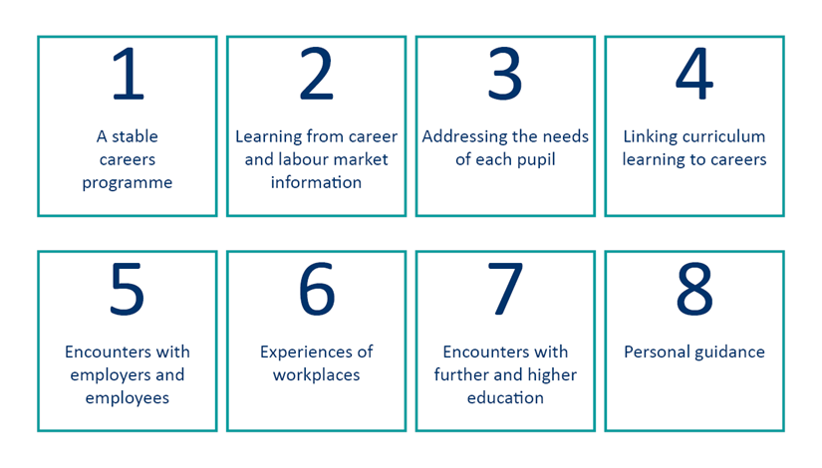

PSHE Curriculum INTENT
1. To prepare pupils for life outside of school. They develop the knowledge, skills and attributes pupils need to manage life’s challenges and make the most of life’s opportunities.

2. PSHE should give pupils the confidence and conviction so that they can act with others, have influence, and make a difference in their communities.

3. The challenges identified and addressed with this curriculum are relevant to the country, local area and time of delivery and is responsive to any significant changes in those areas.

4. The substantive PSHE and RSHE knowledge is designed to be delivered in a sequence that allows for connection-making across the topics. The knowledge becomes more complex and age specific as pupils’ progress through the academic year.

5. To embed the substantive knowledge relating to RSHE, pupils need to reflect on the human and spiritual experience, linked to our St Peter’s Profile and Mission. The curriculum and assessment of pupils at this stage of education has been carefully designed to prepare pupils for life outside of school.

Our PSHE Programme
PSHE focuses on teaching how to keep young people healthy, safe and prepare them for life and work. PSHE not only supports pupils’ health, relationships and wellbeing but also their academic attainment. A DfE review of PSHE education provision found a range of positive outcomes, including improved attitudes to health, being able to deal with personal difficulties and improved behaviour.

At Key Stage 3, pupils build on the knowledge and understanding, skills, attributes and values they have acquired and developed during the primary phase. PSHE acknowledges and addresses the changes that young people experience, beginning with transition to secondary school, the challenges of adolescence and their increasing independence. It teaches the knowledge and skills which will equip them for the opportunities and challenges of life. Pupils learn to manage diverse relationships, their online lives, and the increasing influence of peers and the media. The curriculum has been designed with a presumption that pupils will not have been taught all of the statutory primary content for RSHE. Knowing that the guidance only became statutory in September 2020, where necessary, lessons have been included that re-cap primary content, to ensure our secondary curriculum can be fully accessed.

At Key Stage 4, pupils deepen their knowledge and understanding, extend and rehearse skills, and further explore attitudes, values and attributes acquired during key stage 3. PSHE reflects the fact that pupils are moving towards an independent role in adult life, taking on greater responsibility for themselves and others.

Relationships and Sex Education (RSE) aims and learning objectives:
- to help pupils come to an understanding of themselves and others as fully human
- to enable young people to learn what the Church teaches and build bonds of trust and communication with each other
- to augment pupils’ understanding of their physical and emotional development
- to promote ways in which young people can examine contemporary stereotypes of masculine and feminine behaviour and assume responsibility for their actions
- to augment teachers’ subject knowledge and confidence
- to help pupils develop the confidence and skills to discern messages in the media and the positive and negative effects of peer pressure, enabling them to make decisions about how to act in accordance with their own beliefs and values.

At St Peter’s, all staff sensitively teach lessons to help our students identify signs of healthy and unhealthy relationships and their impact. We aim to develop knowledge and understanding of the different types of families and relationships, including LGBTQ+, in line with our Catholic faith and its teachings of Gospel values.

Pupils are shown how to develop positive and healthy relationships with their peers, both now and in the future, as well as demonstrating respect for themselves and others. Pupils will also develop knowledge and understanding of their own emotions, so they are able to manage them effectively.

Relationship and Sex Education is taught in curriculum PSHE lessons and supported by outside agency organisations, such as Kenelm Youth Trust, which was established by Birmingham Archdiocese to provide Catholic youth work in various settings. Parents have the right to withdraw their child from sex education but not from lessons on relationships.

The right to withdraw from sex education

From September 2020 parents will continue to have the right to request that their child be withdrawn from some, or all of sex education content, delivered as part of statutory RSE. However, three school terms before the child turns 16 a pupil who wishes to receive sex education lessons can do so without their parent’s permission. Before a request for withdrawal is granted, parents expressing concern regarding relationships and sex education will be invited to their school by a representative from the leadership team to talk through those concerns. This will help clarify: the nature and the purpose of the curriculum, the benefits of receiving this education and to raise concerns regarding the possible effects and safeguarding issues which could result from withdrawing the pupil. Once this meeting has taken place, those parents who still wish to withdraw their child, will have this documented by the school so that a future record is kept.

There is also no parental right to withdraw from any other aspect of PSHE, including Relationships Education. Certain lessons are mandatory under the National Curriculum in Science and are excluded from the right of parents to withdraw their children. Likewise, Relationships Education, RSE and Health Education is complemented by the following national curriculum subjects: PE, RE, computing and there continues to be no right to withdraw from any part of this national curricula. Any pupil withdrawn will be placed in an alternative year group classroom and expected to complete independent revision.

At St Peter’s, the following topics are categorised as:

Health Education
Contraception
Sexually Transmitted Infections
Sex Education
Impact of Pornography
The right to delay sexual intimacy

Relationships Education
Consent
Healthy and unhealthy relationship

Health and Wellbeing
We help pupils get to know and understand their bodies, including having a healthy and positive body image. Pupils develop knowledge on the importance of diet, fitness, oral hygiene and the impact of puberty. Positive self-esteem is nurtured by promoting self-care and encouraging all pupils to talk about their emotions, signposting where pupils and families can access support.
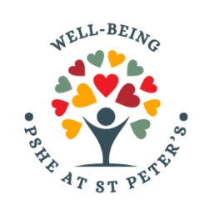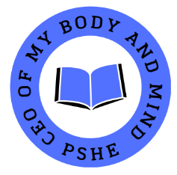
Pupils are educated in how to look after their own, and others, mental health and wellbeing. Pupils also learn key life skills, such as how to respond in emergency and non-emergency situations, and first aid.

Living in the Wider World
British Values are embedded into every booklet used in all key stages at St Peter’s. Pupils are taught - through a range of lessons, enrichment activities and the ethos of the school - how to apply the British Values of democracy, rule of law, individual liberty, mutual respect, tolerance for different faiths and beliefs, to support a positive outlook towards school and the wider
community.
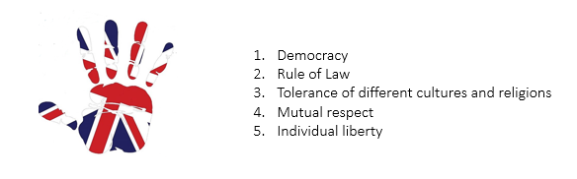Through a range of real-life situations, pupils are supported to apply their skills and attributes to navigate their way through modern life. Our tailored careers guidance interventions boost self-confidence and enhance decision-making skills helping students to understand post-16 and post-18 pathways. Pupils are taught about risks such as knife crime, strangers, road, rail and water safety, drugs, gangs, sexual harassment, the Equality Act of 2010 and the 9 Protected Characteristics and extremism. Lessons provide advice on how to stay safe online and the impact of digital footprints, as well as how to report concerns. Pupils develop age-appropriate knowledge on saving, debt and budgeting, helping them to make informed choices as they progress through the different life phases.
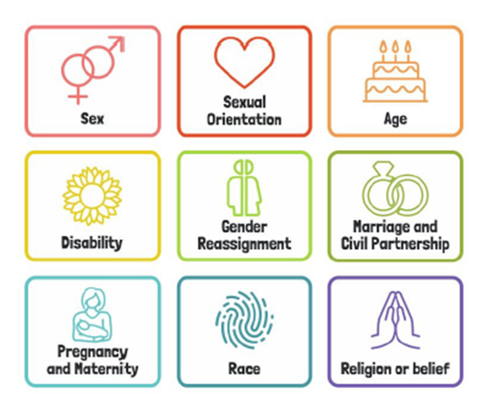

We have been recognised as a Bronze Rights Committed school, where as a school children and young people’s rights are respected, promoted and protected by everyone. These rights and values will be discussed and have become part of our Personal Development learning journey.

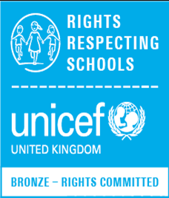

CEIAG - Careers Education, Information, Advice and Guidance
“The work that the school does
to promote careers education across all year groups is highly organised and impressive.” Ofsted March 2025

Pupils will be provided with a range of information about future choices and given support in relation to their next steps. Pupils develop their knowledge and understanding of employability skills and learn how to successfully apply for college and university and how to access a variety of employment opportunities, understanding how to create a professional C.V and how to effectively plan and perform in an interview. Links to our career platform UNIFROG in all careers curriculum lessons, as are signposts to the Skills Builder Framework, Future Skills Questionnaires and Morrisby. We are working towards gaining accreditation under the Quality in Careers Standard - the national quality award for careers education, information, advice and guidance (CEIAG) in secondary schools, colleges and work-based learning. https://www.qualityincareers.org.uk/

Contextualised Curriculum
We have taken into account the contextual needs of our pupils when designing the curriculum. We have gathered information through the use of in-school pupil and staff voice surveys, work with the school Safeguarding Team and internal results from Votes for Schools SMSC debates.

We also plan our curriculum which is responsive to data eg:
Local crime https://crimerate.co.uk/west-midlands/solihull#recent-crimes-in-solihull
Public Health https://fingertips.phe.org.uk/
Census & labour market data https://www.nomisweb.co.uk/sources/census_2021/report?compare=E08000029#section_8
Labour Market Information (LMI) https://bep.education/birmingham-careers-hub/lmi/

Our local context from a transport perspective means that we are surrounded by many rail lines, we have linked up with Rail Safe Friendly. They are an organisation that provides schools and the rail industry with an opportunity to work together towards a common goal to improve rail safety in all schools across the UK. We have gained our Bronze, Silver and Gold Awards for Rail Safety awareness.

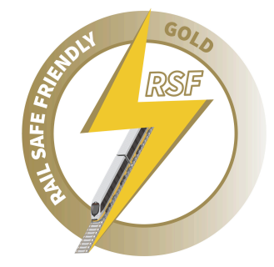

In form time, VotesforSchools is used to prompt discussion on a challenging current issue. Activities are designed to improve oracy, critical thinking and media literacy skills. All Votes for Schools lessons give opportunities also for pupils to make links from their learning to our St Peter’s Profile and Mission. VotesforSchools is a national voting platform of over 1,200 schools that captures what young people think about key issues. It supports our coverage of SMSC, British Values & Prevent curriculum criteria throughout the academic year and allows pupils to compare their vote results with other educational settings, on a regional and national level. St Peter’s pupils form part of the VotesforSchools Ambassador team and share their opinions with the Youth Advisory Board meetings and on webinars, where they can discuss and share their thoughts with their peers, charities and businesses. Mrs Shelton is a member of the National Youth Advisory Board for Votes for Schools.

Community Voice
The opinions of our pupils, parents and staff are actively sought as part of our development of the Personal Development provision. Feedback is transparent, shared with pupils and very much valued. This was recognised in 2024 as we were selected for the Votes for Schools Student Voice National Finals in which we were awarded Bronze.
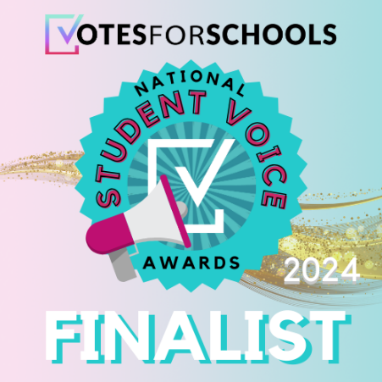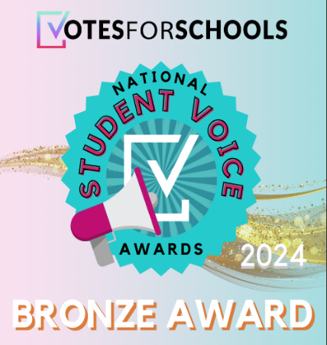

Catholic Character Virtues
At St Peter’s we give pupils every opportunity to guide their quest for knowledge and skills and to use their God given talents. The choices an individual makes determines their future, and the purpose of developing good character is the ability to make good choices. Character allows us to flourish as individuals, and as a wider society. Character education at St Peter’s is shaped by the needs of the pupils and through the language and values of our St Peter’s Profile and Mission. Pupils across all Key Stages also experience character education, through the assembly programme and form tutor PSHE programme, developing their knowledge and understanding of awareness events throughout the academic year. Embedded into prayer and liturgy,pastoral and curriculum are character traits such as faithfulness, attentiveness, intentionally loving behaviour, truthful and hopeful (FAITH), underpinned by an understanding of the importance of self-respect and self-worth providing planned opportunities for young people to undertake social action, active citizenship and voluntary service to others locally or more widely. The Personal Development Team have achieved the Live Simply Cafod Award, an award that enables Catholic communities to care for God's creation and stand in solidarity with our global family. We are really proud of our efforts to support our community to be more sustainable and to become better stewards of our common home, in support of Pope Franci’s encyclical Laudato Si. Initiatives begun include our own vegetable garden ‘ The St Peter’s Patch’, 2nd hand markets stalls, pre loved uniform sales and an annual OAP Christmas party.
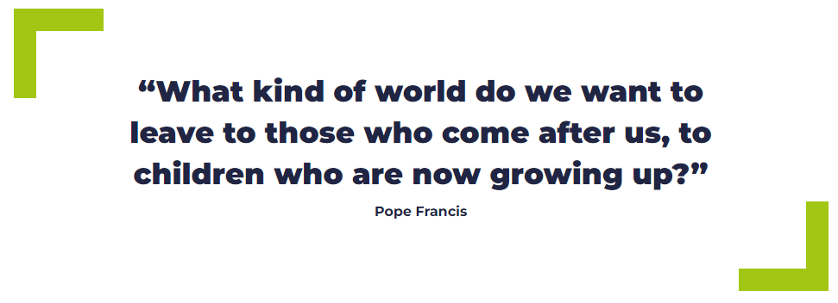

SEND and Vulnerable Pupils – inclusive and ambitious

Learning within this curriculum is, by law, an entitlement of all children in the UK. By nature of the subject matter, certain elements may resonate with specific pupils more than others, based on their background and life experience. However, the content is designed to be taught to all pupils on the basis that it aims to build understanding and appreciation of others in order to further strengthen relationships and preparedness for adult life. Content relating to relationships and sex will be taught in such a way as to be equally applicable to LGBTQ+ young people as to CIS opposite sex relationships. It is hoped that in delivering this curriculum, teachers are further embracing and enhancing inclusivity within our community.

The curriculum breaks down lengthy guidance into deliverable, manageable chunks. It aims to challenge pupils to deeply reflect, and to embrace a wide range of subject (and topic) specific vocabulary, to equip them with the tools needed to navigate their lives as teenagers and adults, and to understand experiences that might affect friends, relations, partners, marriage, family and colleagues both now and in the future, thus hopefully making them more empathetic and faith-filled individuals.

Reasonable adjustments are made to support learning and empower SEND and vulnerable students through the Personal Development PSHE programme. Resources and materials are reviewed by the Director of Learning for Personal Development to ensure it is developmentally appropriate and considers the context of individual students. Personal Development supports our SEND and vulnerable pupils by promoting independence and transition and helping pupils to stay safe in and out of school. We also target support for SEND and vulnerable pupils at St Peter’s to increase attendance, participation and engagement where concerns are identified. We work with the SEND team, Pastoral officers, our lead tutors and our school nurse to ensure all of our pupils feel safe and able to appropriately access the curriculum.

Behaviour, Culture and Context
Our Personal Development PSHE programme supports our behaviour curriculum which encourages positive behaviour patterns to promote good relationships throughout the school community built on our St Peter’s Profile and Mission FAITH. The behaviour curriculum helps to embed good manners and instill high expectations to create a positive school culture underpinned by respect. This is celebrated in many ways, such as ‘Time to Shine’ celebrations progress breakfast and praise assemblies.
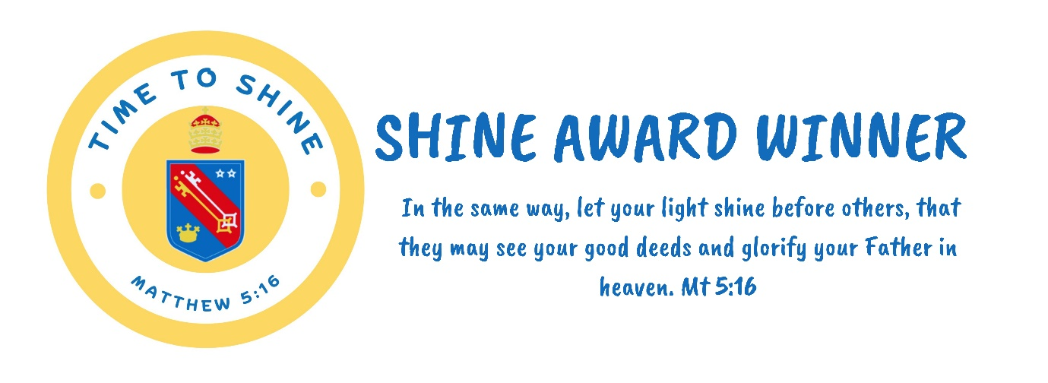
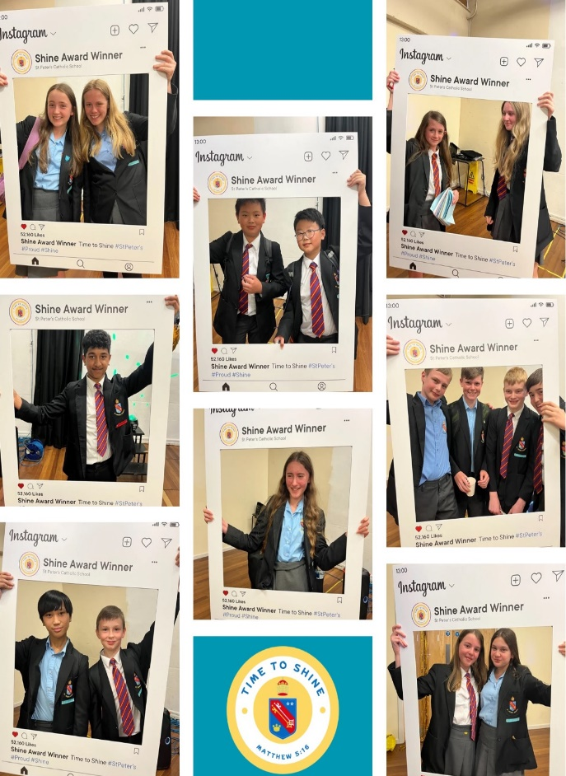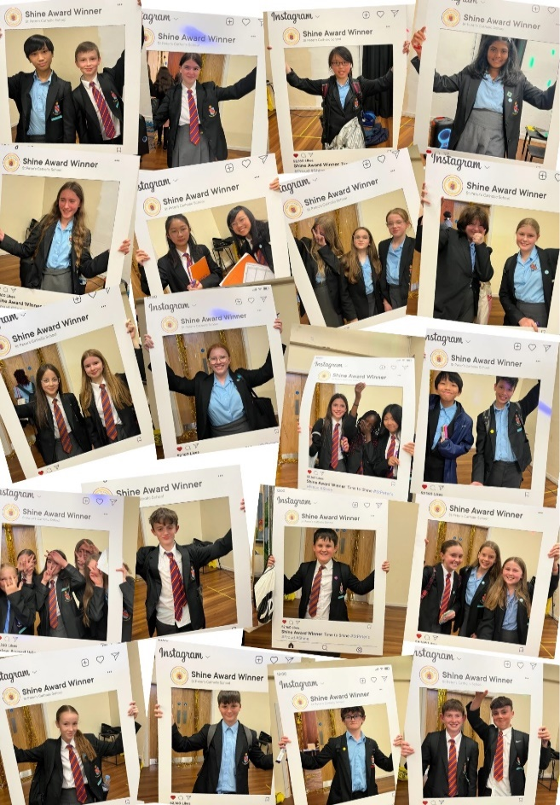

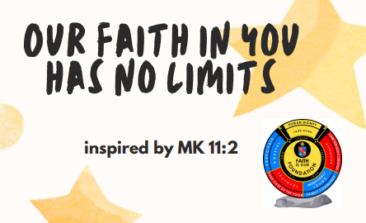

Parent and Carer Partnerships
At St Peter’s, we recognise the importance of continuing Personal Development education at home and seek to develop strong relationships with our families. All Parents and Carers will receive Personal Development communication on topics taught and support available. This aims to empower and inform families so that they feel part of PSHE and Personal Development. Parents and Carers will have access to the PSHE curriculum online and our RSE Policy should they require more information.

Curriculum Overview – Year 7.
Year 7 PSHE Curriculum time |  | PSHE form time
Autumn: Who am I going to be at St Peters? | Topic 1: Moving to secondary school  Managing the challenges of a new school  How to identify, express and manage emotions in a constructive way  Importance of independence and organisation at secondary school  Topic 2: Making friends  How to establish new friendships  Qualities to look for in a friend  Topic 3: Staying safe in the community (Roads, and Buses)  How to cross a road safely and what to be aware of on the roads  Treating others with respect  Etiquette on public transport and responsibilities  Topic 4: Staying safe in the community (Rail and Water)  The law and dangers of trespassing on railways  Importance of water safety  How to respond in an emergency situation  Topic 5: British Values: Respect  What is respect?  What does respectful behaviour look like?  Topic 6: How do I recognise and build my personal skills?  TBAT to reflect on our own skills, how these could be useful in the workplace and how we can improve our skills  To develop teamwork, problem solving and communication skills  To link our learning to Gatsby benchmarks 1,and 4  Topic 7: What is my career journey?  To know the importance of planning a career journey  To recognize stereotypes and laws to protect us against discrimination  To link our learning to Gatsby benchmarks 1,3 and 4 | Who we are  Managing money at secondary school  Travel Safety  Teamwork  Team Conflict  Building Self-confidence
Spring How am I wise in my actions towards myself and others? | Topic 1: How does lifestyle affect our mood?  To understand how important a healthy lifestyle is for young people  To suggest strategies to maintain a healthy lifestyle that link to diet, sleep and exercise  Topic 2: Smoking and Vaping  Understand the physical impact of smoking and vaping  Topic 5: Health and Hygiene  Understand the importance of personal hygiene  Suggest ways that everyone can keep clean and stop infections  Topic 3: Puberty  Understand what puberty is and the changes that take place within the body  Know how to manage the effects of puberty  Topic 4: Periods and Well-being  Know what a period is and how to manage this effectively  Understand the variety of different period products that exist  Topic 4: FGM and FBV Individual Liberty  About FGM and how to access help and support  How to recognise and respond to inappropriate and unwanted contact  What are individual liberties?  Examples of individual liberties  How to respond when our individual liberties are threatened  Topic 6: FLEXI – Pupil Voice response | Friendship  Respect  Verbal Bullying  Showing our Feelings  Mindfulness  Families
Summer: How am I intentional about my rights? | Topic 1: Safer Online Relationships  •About online communication  •Recognising online grooming in different forms  •How to respond and seek support in cases of online grooming  •Recognising and reporting cyber bullying  •Using social networking sites safely  Topic 2: Safer online gaming  •Being mindful of making comments online and sharing personal information  •Reporting online abuse  •How to protect financial security online  •How to assess and manage risks in relation to gambling  Topic 3: Biased and misleading online information  •How to recognise biased or misleading information online  •How to critically access different media sources  •Laws around online behaviour  •How laws keep us safe online  Topic 4: How is the UN Convention on the Rights of the Child (UNCRC) relevant to me ?  •TBAT understand the impact of our actions locally, nationally and globally  •TBAT recognise some of the articles of the UNCRC  •TBAT know about the history of human rights  •TBAT understand some of the principles behind human rights  •TBAT prophetic in our ability to identify injustice, and be able to identify human rights abuses  Topic 5: How can I make a difference?  •TBAT answer moral questions in a balanced and informed way  •TBAT to be self discuss giving – putting aside our own wants to serve others locally, nationally and globally  •Understanding the importance of teamwork both at school and in employment  •Identifying the range of roles within teamwork and learning from setbacks and challenges  TOPIC 4 : FLEXI – responsive to Community Voice | Online personalities  Privacy settings  Social media  Diversity  Alcohol
Curriculum Overview – Year 8.

Year 8 |  | PSHE form time
Autumn: Who am I going to be at St Peters? | Topic 1: Mental health and emotional wellbeing  •Definition of mental health  •Equal importance of mental and physical health  Topic 2: Resilience  • Understand the term resilience and know of ways to develop your resilience to support better mental health  - Understand the impact of social media on mental health and emotional wellbeing  Topic 3: Body Image and Tolerance  •Meaning of body image  •Variety of pressures which might impact on someone's body image  •Strategies for healthy and positive attitudes toward body image  •Tolerance (FBV) linked to understanding around mental health and refraining from labelling or stigmatizing  Topic 4: What is work?  •Exploring reasons why people work  •Understanding different types of employment  •Defining different work styles and work places  •Introduction to NHS and Social Care sectors spanning many sectors beyond 'medical' – ref to LMI NHS Birmingham and Solihull  Topic 5: What is the NHS?  - To develop opportunity awareness about a key employer within the UK.  - To identify general skills and qualities required for all employment as well as specialist ones for working in the Health Service.  - Link to Gatsby Benchmarks 1,2,3 and 5  Topic 6: Health and Safety in the workplace  •Recognising and responding to health and safety within school  •Being aware of rights and responsibilities in the workplace  •The Equality Act and mental health at work | Who we are  Employability skills  Managing Criticism  Technology in the workplace  Responsibility  Communication
Spring How am I wise in my actions towards myself and others? | Topic 1: Relationships, values and influences  - Positive relationship with myself  - Realistic and healthy relationship values and expectations  - Gender stereotypes in relationships  Topic 2: Relationships and the Equality Act 2010  - To understand the variety of different relationships that exist  - To explain the impact of homophobic bullying and why this must be challenged  - To know about Protected Characteristics and the Equality Act 2010  - To recognise that everyone is created unique and equal in dignity  Topic 3: Managing conflict in Relationships  - Explain the causes of conflict in relationships  - Suggest healthy ways to resolve conflicts successfully  Topic 4: Consent and avoiding assumptions  - About common assumptions related to consent and how to challenge these  - To understand what is meant by the word respect  Topic 4: Vaping and smoking  • To recognise the impact that the use of substance such as vapes, has on our ability to make healthy decisions  •To recognise different influences and consequences that might affect decisions relating to vaping  Topic 5: Energy drinks and caffeine, Counter medication and prescription drugs  • About over-consumption of energy drinks  • Impact of caffeine on the body  • Recognise counter medication and prescription drugs  • Using over the counter and prescription medications safely  Topic 6: County lines  • What are country lines?  • Dangers and risks surrounding country lines  • British Values - How laws help to keep us safe | Connection  Managing misunderstandings  Inclusion  Positive Self-Talk  Mental health stigmas
Summer: How am I intentional about my rights? | Topic 1: What is Democracy?  - To understand the key features of a democratic country  - To know why private voting is necessary for a successful democracy  Topic 2: Parliament and Government  - To explain the different roles of the monarch, parliament and government  Topic 3: The Law and how laws are made  - To explain how laws are made, and the process new laws go through  Topic 4: Civil and Criminal Law  - To know the differences between civil and criminal law  Topic 5: Staying in control of your money  • Meaning of credit and debt  • Importance of role budgeting plays in managing money well  •Different payment cards and which are suitable options to use  •Influences on our attitudes to money e.g peer pressure, marketing, social media  •Forming good and bad habits with money  •Recognising persuasive advertising throughout society and how to critically assess this  Topic 6: Keeping your finances secure  •Recognising different types of fraud and scams e.g. phishing, smishing, social media scams  •Ways to safeguard vulnerability to fraud and scams | Managing family expectations  Parenting teens  Family disputes  Revision support  Emergency First Aid

Curriculum Overview – Year 9.

Year 9 |  | PSHE form time
Autumn: Who am I going to be at St Peters? | Topic 1: Peer pressure and risky behaviour  - To understand your uniqueness and that value and dignity derive from God – respect foryourself is key and define peer pressure and give examples of how this can happen online  - To consider how a good friend should behave and resisting peer pressure online and offline  - To identify different types of risky behaviours and ways to keep yourself safe  Topic 2: Gangs  - Reasons why some young people decide to join a gang and impact of this  - Risky and criminal behaviour  - Support for someone wanting to leave a gang  Topic 3: Staying safe – knife crime  - Safety in the community  - Risks of carrying a knife and laws  - Joint enterprise  - Effect of knife crime  Topic 4: Decision-making – options year 9  - Understanding the implications of choice  - Recognising how information gathering is vital for good decision making in any context  - Good decisions around option choices  - LMI local area job opportunities  Topic 5: Work Motivation  - Understand that 'work' has always changed and evolved  - Recognise that we need to prepare ourselves now for future roles  - Consider what employers want from young people when they come to work  - Identify stereotyping and prejudice  - Reflect on personal responses to stereotyping  - Awareness of stereotypes and how to challenge these | Who we are  Exam stress  Career pathways  Self-Employment  Entrepreneurs  Career opportunities
Spring How am I wise in my actions towards myself and others? | Topic 1: Family and Commitment  - Catholic teachings on the role of the family  - Range of families in the UK and what characteristics and values make them similar or diverse.  - Roles and responsibilities for parents and carers in bringing up children successfully and the  - support that is available to them.  Topic 2: Healthy Relationships  - Importance of communication in a healthy relationship  - To consider the importance of commitment in relationships, and understand the laws around different types of committed relationships  Topic 3: Communication in Relationships  - Feelings and emotions people feel when relationships end  - Laws involved in the ending of certain relationships  - Features of a healthy and unhealthy relationship are  - Know and identify different types of abuse and where to seek support  Topic 4 : Freedom and Capacity to Consent  - To consider how to being and develop positive relationships  - To be able to assess readiness for intimate relationships  - To explain what is meant by freedom and capacity to consent  Topic 5: Intimate Relationships and Health  - Catholic teachings on sexual intimacy in the sacrament of marriage  - To be able to assess readiness for intimate relationships  - Freedom and capacity to consent  - Law about consent  Topic 6: Relationships and Keeping Safe  - Catholic teachings on sexual intimacy in the sacrament of marriage  - TBAT recognise the positives and negatives of intimate relationships, linked to Catholic teachings  - To know how first experiences can impact on future sexual health. | Mental health and isolation  Peer Pressure  Money worries  Financial Debt  Relationship changes  Prevention of illness
Summer: How am I intentional about my rights? | Topic 1: Causes of Addiction  - Understand the term addiction and know different types of addiction that exist  - Consider some reasons why addictions develop  Topic 2: Effects of drugs  - Know the effects of different types of drugs and understand what legal highs are and the dangers which surround them  - Understand the different components of cannabis and the effects these have on the body  - Explain how cannabis can impact on someone’s lifestyle  Topic 3: Drug Classifications  - Know the different categories of drugs and how they classified  - Know the potential implications of being caught in possession or with intent to supply drugs  Topic 4: Party Drugs  - To understand the term ‘party drugs’  - To explore the way ‘party’ drugs affect users and how users might put themselves in very dangerous situations  Topic 5: Employability and Post 16 Options  - To know what employability skills means and identify these skills personally  - Identifying and understanding all of the options available to students on leaving school at 16  - Identifying and understanding all of the options available to students on leaving school at 18  - Consider learning pathways which interest students most for the future at this age  - Realise that there is scope for decisions to change  Topic 6: FLEXI – responsive to community voice | Behaviour online  Sleep  Financial Exploitation  Revision support
Curriculum Overview – Year 10

Year 10 |  | PSHE form time
Autumn: Who am I going to be at St Peters? | Topic 1: Stress and Anxiety  - Know how to recognise stress and suggest ways to manage this effectively  - Be able to explain the spectrum of anxiety  - Be able to identify ways to manage anxiety successfully and when to seek help  Topic 2: Grief and Bereavement  - Understand the effects of change, loss and grief  - Explain and signpost strategies for managing these feelings and accessing support  Topic 3: Applying for a Job  - TBAT identify own personal strengths, virtues, values, attitudes and belief which can drive my  - purpose in life and understand why employers use application forms  - To link to Gatsby Benchmarks 1,2 and 4  Topic 4: Personal Statements  - To know how to write a good personal statement  - To link to Gatsby Benchmarks 1,2 and 4  Topic 5: Interview Techniques  - To understand the importance of an interview and how to make a good first impression  - To know what potential employers, look for in an interview candidate  - Describe different work styles and about the unacceptability of all forms of discrimination and the need to challenge it  - Link learning to Gatsby Benchmarks 1,2 and 5 | Who we are  Revision study skills  Stereotypes in the workplace
Spring How am I wise in my actions towards myself and others? | Topic 1: Pleasure, intimacy and respect  - Recognising enthusiastic consent  - Role of intimacy, readiness, and pleasure in consensual relationships  - Communication and respect in relationships  - Respecting own boundaries and well as others (Sexual Harassment)  - Importance of respect in intimate relationships  Topic 2: Impact of pornography  - Impact of pornography on people’s understanding and expectations of consent  - Challenge inaccurate and dangerous messages perpetuated by pornography about sexuality, gender, and consent  - Laws relating to pornography and sharing explicit images  Topic 3: Pressure, persuasion and coercion  - Recognising when consent becomes inappropriately pressurising or persuasive  - Understanding of rights to not give, or withdraw consent, and challenge victim-blaming  - Legal consequences of pressure, persuasion, and coercion in relation to consent  Topic 4: Valuing Diversity  - To understand what is meant by ‘Being British’  - To suggest ways we can embrace diversity in our communities  Topic 5: Hate Crime  - To understand the term hate crime  - To reflect on the increase in hate crime  - To explore hate crime in football  Topic 6: Topic 6 –Understanding and challenging extremism  - To learn about how violent extremism differs from legitimate protest and dissent  - To learn ways to respond to worrying behaviour | Work place rights  Budgeting  Social media and data  Screen time  Women’s safety  Words and mental health
Summer: How am I intentional about my rights? | Topic 1: Rights and Responsibilities  - Review democratic structure of the UK  - Specific responsibilities that citizens in the UK hold  - Roles of magistrates and a jury  - Benefits of volunteering e.g. work experience, boost to mental health, sense of purpose  Topic 2: The British Legal System  - Parliamentary democracy and the key elements of the constitution of the United Kingdom, including the power of government, the role of citizens and Parliament in holding those in power to account, and the different roles of the executive, legislature and judiciary and a free press  - To appreciate why citizens should obey the law and respect one another  Topic 3: Ways to get involved in the legal system  - To explore the role of a Special Constable and explain the importance of civic responsibilities  - To explain the importance of laws in society  - Link to Gatsby Benchmark 1, 2 and 8  Topic 4: Mobile phones and Crypto Currency  - Identify the costs of and requirements for having a mobile phone contract  - Compare different mobile phone contracts and suggest strategies to manage mobile phone costs  - Explain what cryptocurrency is and how it compares with traditional money  - Assess the factors that influence financial decisions and suggest ways to engage with crypto assets  Topic 5: Financial exploitation  - Identify situations where young people are vulnerable to exploitation  - Explain the impact of financial exploitation  - Rehearse strategies to respond to unwanted pressures | Self esteem  Stress and Anxiety  Coping strategies  Gambling
Curriculum Overview – Year 11.
Year 11 |  | PSHE form time
Autumn: Who am I going to be at St Peters? | Topic 1: Effective Study Techniques  - To identify signs of stress and be able to explain a range of healthy coping strategies  - Know where to access support  Topic 2: Fueling your body and brain  - To differentiate between healthy and unhealthy coping strategies  - To evaluate a range of ways to promote mental and emotional wellbeing  - Can suggest ways to develop my own and others’ self-confidence and self-esteem.  - I can suggest strategies for dealing with negative influences that have the potential to damage my confidence and self-esteem.  Topic 3: Planning for success in Year 11  - Understand how organisation can promote good wellbeing and fuel success  - Plan your own revision schedule for a week to maintain a healthy work-life balance  Topic 4: Knowing the Curriculum Vitae  - Understand what should and should not be included in a good CV  - Be equipped to write your own CV  - To know how LMIs can inform career pathway choices  - To link learning to Gatsby Benchmarks 1,2 and 8  Topic 5: Different types of employment and options at 16  - Understand the law around part time employment for 15 and 16 year olds  - Identify the benefits of lifelong learning  - Understand the law around the Raising of the Participation Age  - Link learning to Gatsby Benchmarks 1 and 2.  Topic 6: FLEXI – responsive to Community Voice | Who we are  How to revise  Best ways to revise  Resilience  Sleep
Spring How am I wise in my actions towards myself and others?  Summer: How am I intentional about my rights? | Topic 1: Independence - Cancer and self-examination  Know what cancer is and the signs to look out for  Explain why it is important to report any concerns about health as soon as possible  Topic 2: Independence – Sexual Health  The nature and important of marriage  To explain ways to promote sexual health, To identify different types of contraception and which help to protect against STIs  Topic 3: Independence – Organ donations  Explain choices and individual liberties available with donation  Be able to explain what it means to donate blood, stem cells and organs and why  donations are needed  To know how we can grow to be self giving, recognising the importance of human life  Topic 4: Fertility and routes to parenthood  The nature and important of marriage  To explain how fertility changes over time, and the different routes to becoming a parent  Discerning in decision making  Topic 5: Parenting  TBAT understand and explain key parenting responsibilities and challenges  Suggest aspects of parenting which may lead to conflict and how to manage this effectively  Topic 6: Caring for a Newborn  Roles, rights and responsibilities of parents  Understand some of the challenges of a newborn baby  Be able to explain what a parent can do to sooth a newborn baby | Role modelling  First aid  Domestic violence  Misogyny  Risky behaviour  Substance abuse  NHS Services

PSHE Curriculum statutory mapping
 | Statutory Content | Year 7 | Year 8 | Year 9 | Year 10 | Year 11
Families | That there are different types of committed, stable relationships.
Families | How these relationships might contribute to human happiness and their importance for bringing up children.
Families | What marriage is, including their legal status e.g. that marriage carries legal rights and protections not available to couples who are cohabiting or who have married, for example, in an unregistered religious ceremony.
Families | Why marriage is an important relationship choice for many couples and why it must be freely entered into.
Families | The characteristics and legal status of other types of long-term relationships.
 | The roles and responsibilities of parents with respect to raising of children, including the characteristics of successful parenting.
 | How to: determine whether other children, adults or sources of information are trustworthy: judge when a family, friend, intimate or other relationship is unsafe (and to recognise this in others’ relationships); and, how to seek help or advice, including reporting concerns about others, if needed.
Respectful relationships, including friendships | The characteristics of positive and healthy friendships (in all contexts, including online) including: trust, respect, honesty, kindness, generosity, boundaries, privacy, consent and the management of conflict, reconciliation and ending relationships. This includes different (non-sexual) types of relationship.
Respectful relationships, including friendships | Practical steps they can take in a range of different contexts to improve or support respectful relationships.
Respectful relationships, including friendships | How stereotypes, in particular stereotypes based on sex, gender, race, religion, sexual orientation or disability, can cause damage (e.g. how they might normalise non-consensual behaviour or encourage prejudice).
Respectful relationships, including friendships | That in school and in wider society they can expect to be treated with respect by others, and that in turn they should show due respect to others, including people in positions of authority and due tolerance of other people’s beliefs.
Respectful relationships, including friendships | About different types of bullying (including cyberbullying), the impact of bullying, responsibilities of bystanders to report bullying and how and where to get help.
Respectful relationships, including friendships | That some types of behaviour within relationships are criminal, including violent behaviour and coercive control.
Respectful relationships, including friendships | What constitutes sexual harassment and sexual violence and why these are always unacceptable.
Respectful relationships, including friendships | The legal rights and responsibilities regarding equality (particularly with reference to the protected characteristics as defined in the Equality Act 2010) and that everyone is unique and equal.
Online and Media | Their rights, responsibilities and opportunities online, including that the same expectations of behaviour apply in all contexts, including online.
Online and Media | About online risks, including that any material someone provides to another has the potential to be shared online and the difficulty of removing potentially compromising material placed online.
Online and Media | Not to provide material to others that they would not want shared further and not to share personal material which is sent to them.
Online and Media | What to do and where to get support to report material or manage issues online.
Online and Media | The impact of viewing harmful content.
Online and Media | That specifically sexually explicit material e.g. pornography presents a distorted picture of sexual behaviours, can damage the way people see themselves in relation to others and negatively affect how they behave towards sexual partners.
Online and Media | That sharing and viewing indecent images of children (including those created by children) is a criminal offence which carries severe penalties including jail.
Online and Media | How information and data is generated, collected, shared and used online.
Being Safe | The concepts of, and laws relating to, sexual consent, sexual exploitation, abuse, grooming, coercion, harassment, rape, domestic abuse, forced marriage, honour-based violence and FGM, and how these can affect current and future relationships.
Being Safe | How people can actively communicate and recognise consent from others, including sexual consent, and how and when consent can be withdrawn (in all contexts, including online).
Intimate and sexual relationships, including sexual health  Linked to CES – faith based learning | How to recognise the characteristics and positive aspects of healthy one-to-one intimate relationships, which include mutual respect, consent, loyalty, trust, shared interests and outlook, sex and friendship.
 | That all aspects of health can be affected by choices they make in sex and relationships, positively or negatively, e.g. physical, emotional, mental, sexual and reproductive health and wellbeing.
 | The facts about reproductive health, including fertility, and the potential impact of lifestyle on fertility for men and women and menopause.
 | That there are a range of strategies for identifying and managing sexual pressure, including understanding peer pressure, resisting pressure and not pressurising others.
 | That they have a choice to delay sex or to enjoy intimacy without sex.
 | The facts about the full range of contraceptive choices, efficacy and options available.
 | The facts around pregnancy including miscarriage.
 | That there are choices in relation to pregnancy (with medically and legally accurate, impartial information on all options, including keeping the baby, adoption, abortion and where to get further help).
 | How the different sexually transmitted infections (STIs), including HIV/AIDs, are transmitted, how risk can be reduced through safer sex (including through condom use) and the importance of and facts about testing.
 | About the prevalence of some STIs, the impact they can have on those who contract them and key facts about treatment.
 | How the use of alcohol and drugs can lead to risky sexual behaviour.
 | How to get further advice, including how and where to access confidential sexual and reproductive health advice and treatment.
Mental wellbeing | How to talk about their emotions accurately and sensitively, using appropriate vocabulary.
Mental wellbeing | That happiness is linked to being connected to others.
Mental wellbeing | How to recognise the early signs of mental wellbeing concerns.
Mental wellbeing | Common types of mental ill health (e.g. anxiety and depression).
Mental wellbeing | How to critically evaluate when something they do or are involved in has a positive or negative effect on their own or others’ mental health.
Mental wellbeing | The benefits and importance of physical exercise, time outdoors, community participation and voluntary and service-based activities on mental wellbeing and happiness.
Internet safety and harms | "The similarities and differences between the online world and the physical world, including: the impact of unhealthy or obsessive comparison with others online (including through setting unrealistic expectations for body image), how people may curate a specific image of their life online, over-reliance on online relationships including social media, the risks related to online gambling including the accumulation of debt, how advertising and information is targeted at them and how to be a discerning  consumer of information online."
Internet safety and harms | How to identify harmful behaviours online (including bullying, abuse or harassment) and how to report, or find support, if they have been affected by those behaviours.
Physical health and fitness | The positive associations between physical activity and promotion of mental wellbeing, including as an approach to combat stress.
Physical health and fitness | The characteristics and evidence of what constitutes a healthy lifestyle, maintaining a healthy weight, including the links between an inactive lifestyle and ill health, including cancer and cardiovascular ill-health.
Physical health and fitness | About the science relating to blood, organ and stem cell donation.
Healthy Eating | How to maintain healthy eating and the links between a poor diet and health risks, including tooth decay and cancer.
Drugs, alcohol and tobacco | The facts about legal and illegal drugs and their associated risks, including the link between drug use, and the associated risks, including the link to serious mental health conditions.
Drugs, alcohol and tobacco | The law relating to the supply and possession of illegal substances.
Drugs, alcohol and tobacco | The physical and psychological risks associated with alcohol consumption and what constitutes low risk alcohol consumption in adulthood.
Drugs, alcohol and tobacco | The physical and psychological consequences of addiction, including alcohol dependency.
Drugs, alcohol and tobacco | Awareness of the dangers of drugs which are prescribed but still present serious health risks.
Drugs, alcohol and tobacco | The facts about the harms from smoking tobacco (particularly the link to lung cancer), the benefits of quitting and how to access support to do so.
Health and Prevention | About personal hygiene, germs including bacteria, viruses, how they are spread, treatment and prevention of infection, and about antibiotics.
Health and Prevention | About dental health and the benefits of good oral hygiene and dental flossing, including healthy eating and regular check-ups at the dentist.
Health and Prevention | (Late secondary) the benefits of regular self-examination and screening.
Health and Prevention | The facts and science relating to immunisation and vaccination.
Health and Prevention | The importance of sufficient good quality sleep for good health and how a lack of sleep can affect weight, mood and ability to learn.
Basic First Aid | Basic treatment for common injuries. | Curriculum and Time to Thrive outside providers Yr 7, 11, 12.
Basic First Aid | Life-saving skills, including how to administer CPR.
Basic First Aid | The purpose of defibrillators and when one might be needed.
Changing adolescent body | Key facts about puberty, the changing adolescent body and menstrual wellbeing.
Changing adolescent body | The main changes which take place in males and females, and the implications for emotional and physical health.
KS3 Citizenship | the development of the political system of democratic government in the United Kingdom, including the roles of citizens,  Parliament and the monarch
KS3 Citizenship | the operation of Parliament, including voting and elections, and the role of political parties
KS3 Citizenship | the precious liberties enjoyed by the citizens of the United Kingdom
KS3 Citizenship | the nature of rules and laws and the justice system, including the role of the police and the operation of courts and tribunals
KS3 Citizenship | the roles played by public institutions and voluntary groups in society, and the ways in which citizens work together to improve their communities, including opportunities to participate in school-based activities
KS3 Citizenship | the functions and uses of money, the importance and practice of budgeting, and managing risk.
KS4 Citizenship | parliamentary democracy and the key elements of the constitution of the United Kingdom, including the power of government, the role of citizens and Parliament in holding those in power to account, and the different roles of the executive, legislature and judiciary and a free press
KS4 Citizenship | the different electoral systems used in and beyond the United Kingdom and actions citizens can take in democratic and electoral processes to influence decisions locally, nationally and beyond
KS4 Citizenship | other systems and forms of government, both democratic and non-democratic, beyond the United Kingdom
KS4 Citizenship | local, regional and international governance and the United Kingdom’s relations with the rest of Europe, the  Commonwealth, the United Nations and the wider world
KS4 Citizenship | human rights and international law
KS4 Citizenship | the legal system in the UK, different sources of law and how the law helps society deal with complex problems
KS4 Citizenship | diverse national, regional, religious and ethnic identities in the United Kingdom and the need for mutual respect and understanding
KS4 Citizenship | the different ways in which a citizen can contribute to the improvement of his or her community, to include the opportunity to participate actively in community volunteering, as well as other forms of responsible activity
KS4 Citizenship | income and expenditure, credit and debt, insurance, savings and pensions, financial products and services, and how  public money is raised and spent.

CELEBRATION AND REWARDS
PSHE contributes to the whole school reward systems, taking a lead in the Time to Shine celebrations, Progress breakfasts and Success Assemblies. Personal Development also supports reward trips/visits, collecting and analysing community voice.

EXTRA CURRICULAR and TIME TO THRIVE

“The school is meticulous in providing rich and varied experiences, which
complement their academic studies.” Ofsted. March 2025

As we deliver the curriculum, we draw clear links to how pupils can engage with both our in-school extra-curricular programme as well as our opportunities with our external partners delivered on set days known as ‘Time to Thrive’. On these days we invite personal speakers in to discuss PSHE topics, we have Ks3 work experience days, finance workshops, as well as supporting prayer and liturgy.

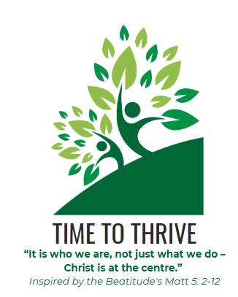
In addition, the Personal Development team oversea pupil leadership formation at St Peters and are very proud of the talent we have in our sixth form Leadership Team and our KS4 prefect team.
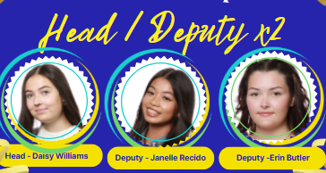

We also lead on our whole school Pupil Parliament which is formatted into departments in support of our St Peters Profile. We currently have just over 100 pupils who are active Pupil Parliamentarians who are our change makers here at St Peter’s. Pupils share views and make decisions, working in partnership with senior and middle leaders to instigate positive change and action throughout our school and community.

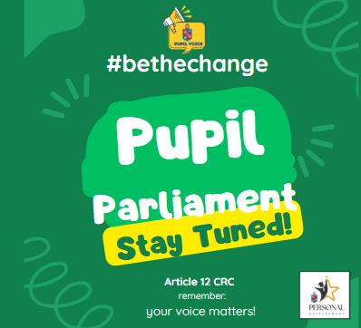
We are responsive to local and national events and enjoyed setting up our own Pupil election to correspond with the General Election of 4th Jul 2024.
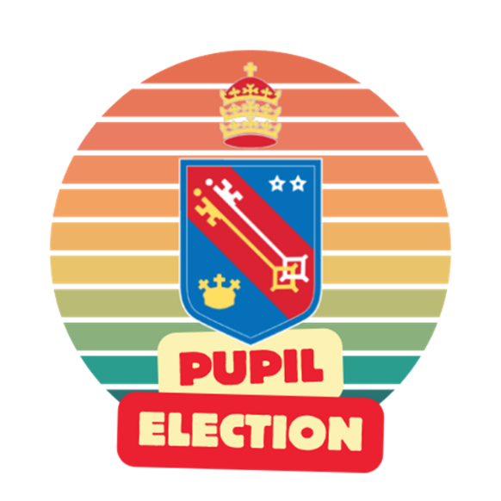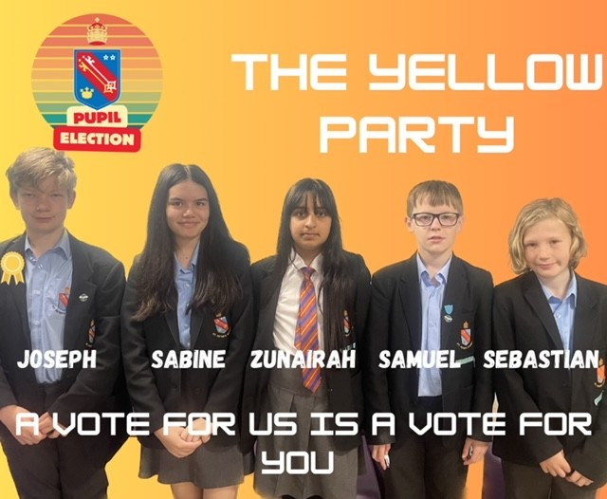

The Personal Development Curriculum encourages ALL pupils to get involved in pupil leadership opportunities. This is to enable pupils to feel empowered to:
- Reflect the views of the school community
- Be examples of upstanders in the community.
- Support the promotion of diversity, equity, equality and inclusion.
- Make a difference
- Help staff to understand what it is like to be a pupil, and bring to our attention issues that matter.

INCLUSION AND SUPPORT
Supporting other pupils at St Peter’s who may experience bullying/mental health issues or concerns, is a priority. We work with leadership and those trained to support in these roles, to ensure we work with vulnerable and SEND students. St Peter’s has its own Anti-Bullying Ambassadors team, trained by the Diana Award to be peer mentors around school.



TEACHING AND LEARNING
Personal Development supports the school its involvement in the staff recruitment process, support staff recruitment process and being involved in student panels during interviews. The Personal Development Curriculum also promotes and encourages full attendance in school, which supports academic success. We have also led initiatives on oracy, with reference to use of the Harkness Method for Turn and Talk and for debates. Personal Development is also involved in Quality Assurance reviews of teaching and learning, book looks, and in attending meetings with Directors of Learning to collaborate, discuss cross-curricular links and provide feedback. Personal Development offers support to new staff at St Peter’s, with insight into the PD curriculum and expectations and has supported teaching and learning sessions for Early Careers Teachers. We share best practice through INSET training, staff CPD support and weekly drop ins regarding curriculum specific content. We subscribe to the PSHE Association, Votes for Schools platform and are members of the Association for Teaching Citizenship to support in professional development and current curriculum advice. This academic year we are also sharing best practice within our school MAC and other local schools who recognise, as Ofsted did in our school inspection in 2025, that Personal Development at St Peter’s is “exceptional”.

https://www.st-peters.solihull.sch.uk/our-school/inspection-reports

Reviewed by: Mrs Shelton. Director of Learning Personal Development
Date: June 2025

