Year 7 Curriculum and Assessment Plan for MFL

The curriculum and assessment of pupils at this stage of education has been carefully designed to provide a solid foundation for second language acquisition.
Research shows that 75% of time communicating is spent listening and speaking, and our Year 7 MFL curriculum is built around this idea, ensuring that students have plenty of opportunities to hear, mimic and practise speaking the language before progressing onto the written form – just as you would when you learn your native language. We have designed our KS3 curriculum around a set of communicative functions so that students regularly practise the most useful sentence patterns, and we teach vocabulary in chunks to progress fluency and help with long-term memory recall. Through frequent exposure to the language of a particular topic, students will also be taught phonemes, syllables, lexis, grammar, syntax and meaning. Our aim is for students to routinise the language we teach so that they can retrieve it quickly and effortlessly in order to understand as well as speak and write confidently in the target language.
Unit 1: Introduce oneself  All pupils will know:  - How to great in TL (Target Language)  - How to say their name, age birthday.  - How to use a TL dictionary.  - Spanish Phonics.  - The ABC  - How to describe their bodies and personality.  - How to describe someone else’s appearance and personality.  All pupils will be assessed by:  - Short knowledge quizzes every 3 lessons for key lexical items.  - End of unit tests.  - Data Feeds.  - In-class formative assessment by the teacher  - Written feedback given on specified pieces of writing and speaking throughout the topic.  Impact- Why do we teach this?  - All students begin Year 7 with a topic they are familiar with, this will boost their self-esteem to begin in Y7.  - This topic immediately allows students to introduce themselves and have short conversation in TL.  - Students practise core patterns from the outset, including adjective agreements, negative structures, opinions, and verb conjugations.    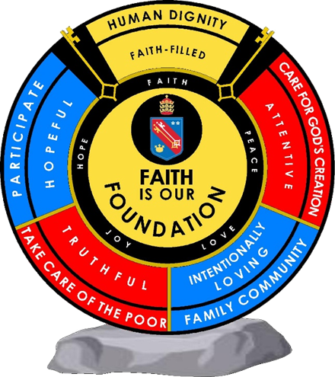  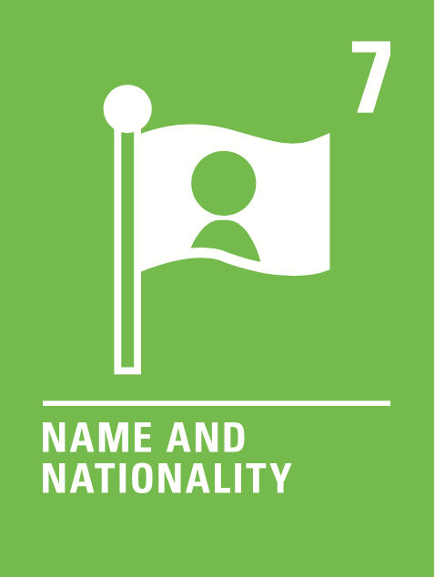  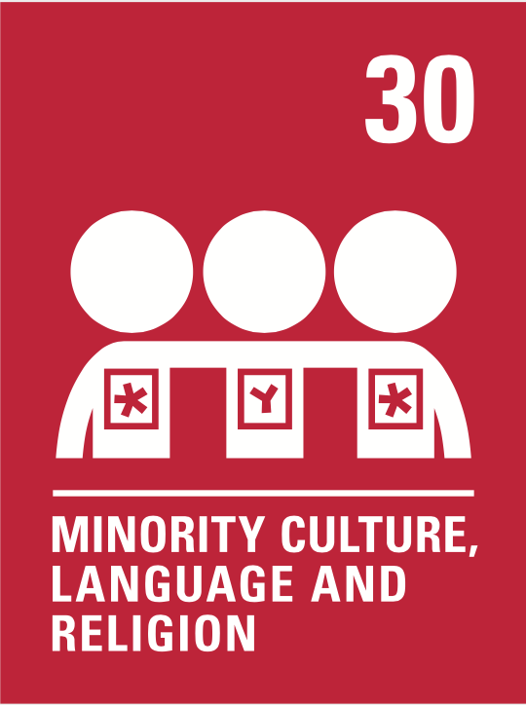  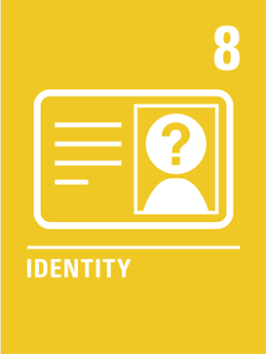  Human dignity  Truthful  Intentionally loving  Human dignity  Attentive  Intentionally loving |  | Unit 2: Me, my family and friends  All pupils will know:  - How to introduce themselves and other people, giving key information such as their age, birthday, nationality  - How to describe friends and family members  - How to describe their personality  - How to describe their physical appearance  All pupils will be assessed by:  - Short knowledge quizzes every 3 lessons for key lexical items.  - End of unit tests.  - Data Feeds.  - In-class formative assessment by the teacher  - Written feedback given on specified pieces of writing and speaking throughout the topic.  Impact - Why do we teach this?  - We use this topic in conjunction with the previous two, so that students can describe themselves, their hobbies and where they live in substantial detail.  This topic builds on the grammar taught in the previous two, so it is used to cement key concepts such as present tense verb conjugations, adjective agreement, word order, negatives before students move onto more complex structures in Year 8.  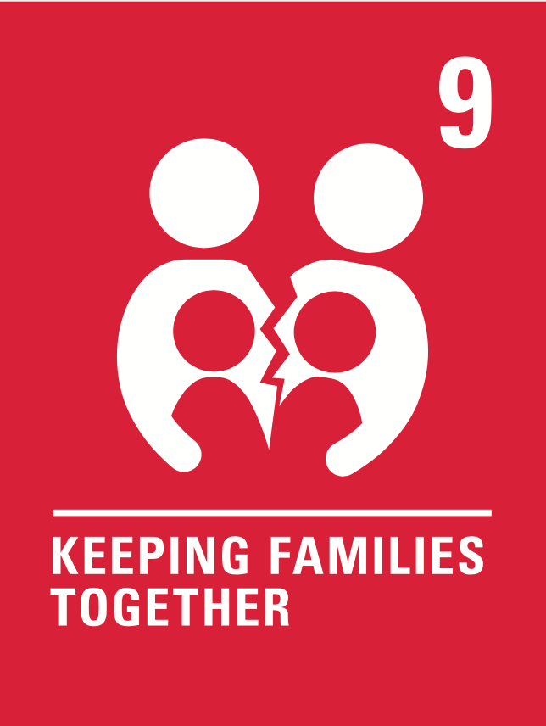 | Unit 3: My free time  All pupils will know:  - How to describe the weather  - How to say what they do in their free time  - How to say what others do in their free time.  - How to give opinions about different activities  - How to describe what clothes they wear for different occasions.  All pupils will be assessed by:  - Short knowledge quizzes every 3 lessons for key lexical items.  - End of unit tests.  - Data Feeds.  - In-class formative assessment by the teacher  - Written feedback given on specified pieces of writing and speaking throughout the topic.  Impact - Why do we teach this?  - This topic leads on from the topic of the town. and grammatical structures  - Students develop their opinions further with a wider range of phrases, including adjectives – a key skill they will need throughout their MFL careers.  - Students build on the verb they learnt in the first unit to practise other fundamental present tense conjugations.  - Students further explore the idea of adjective agreement and word order within sentences.    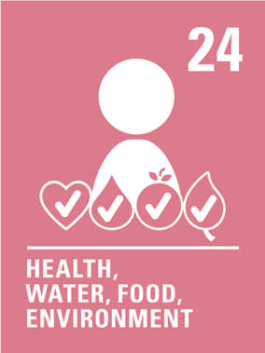  Human dignity  Hopeful  Human dignity  Hopeful  Intentionally loving | Unit 4: My house  All pupils will know:  - How to describe the size and location of their house  - How to say what there is and isn’t in their house.  - How to give their opinion about their house and describe where they live using a range of adjectives  - How to describe the location of rooms in the house precisely using prepositions  All pupils will be assessed by:  - Short knowledge quizzes every 3 lessons for key lexical items.  - End of unit tests.  - Data Feeds.  - In-class formative assessment by the teacher  - Written feedback given on specified pieces of writing and speaking throughout the topic.  Impact- Why do we teach this?  - This topic links well with and builds on the first topic from Year 7, allowing for retrieval of key vocabulary and patterns whilst adding further detail and complexity.  - We build on key verb patterns taught in Year 7, now adding a wider variety.  - Teaching students how to make plans means that they can begin to communicate for a real purpose.  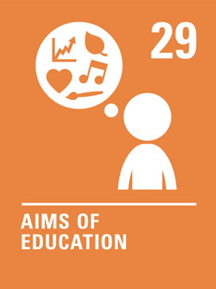  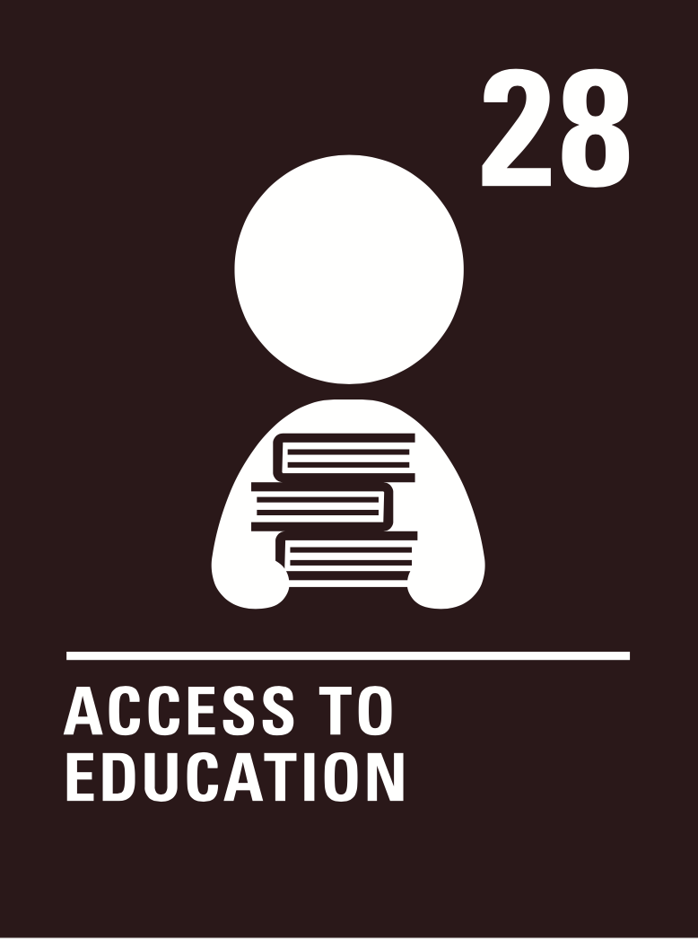  Human dignity  Truthful  Intentionally loving | Unit 5: My town  All pupils will know:  - How to describe the size and location of their town  - How to give their opinion about their town and describe where they live using a range of adjectives  - How to say what there is and isn’t in their town.  - How to describe the location of places in town precisely using prepositions  - How to talk about where they go, and where other people go, in town and why  All pupils will be assessed by:  - Short knowledge quizzes every 3 lessons for key lexical items.  - End of unit tests.  - Data Feeds.  - In-class formative assessment by the teacher  - Written feedback given on specified pieces of writing and speaking throughout the topic.  Impact- Why do we teach this?  - All students begin Year 7 with a topic they are unlikely to have learnt at primary school – this allows everyone to begin on an even footing.  - This topic immediately allows students to construct complete sentences and give their opinion.  - Students practise core patterns from the outset, including adjective agreements, negative structures, opinions, and verb conjugations.  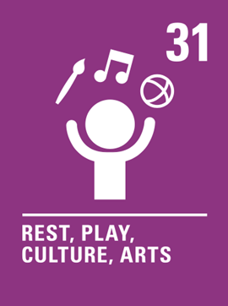  Human dignity  Intentionally loving | Unit 6: Celebrities  All pupils will know:  - How to recognise singers and songs.  - How to recognise writers and books.  - How to recognise actor and films.  - How to recognise designers and brands.  - How to recognise restaurants.  - How to recognise Fashion week.  - How to recognise cinema festivals.  All pupils will be assessed by:  - Short knowledge quizzes every 3 lessons for key lexical items.  - End of unit tests.  - Data Feeds.  - In-class formative assessment by the teacher  - Written feedback given on specified pieces of writing and speaking throughout the topic.  Impact- Why do we teach this?  - This topic links with the culture of the European countries.  - This unit will get them identified with the TL country where they will study differences and similarities as much as how do TL countries affect us in the UK.  - This unit will allow students to speak with cultural knowledge, explore other cultures and approach a more realistic learning of real life. | Subject specific skills being developed:  - Listening  - Reading  - Speaking  - Writing  - Phonics  - Adjective agreement  - Developing opinions  - Negative structures  - Present tense conjugations
Reading Skills needed for this unit:
- Reading aloud
- Reading for gist
- Reading for detail
- Sound/spelling links

Key Vocabulary:
See Unit 3 knowledge organisers
Opportunity for cross-curricular skill development
- Literacy
- Numeracy
- PSHE
- RE
- Catholic values (human dignity, hopeful and intentionally loving)
- British values

 | Ensuring this curriculum meets the needs of all pupils: this curriculum has been designed to ensure pupils from all starting points will develop the key curriculum skills and knowledge identified. The curriculum design ensures that each unit forms part of the overall learning journey and there are opportunities for revisiting skills and linking together key pieces of knowledge. Whole Academy policies and practices are followed to tailor the delivery of the curriculum for individuals and groups of students. For example, SEND students have individual learning profiles that outline needs/strategies to be used, Whole group RIPs are in place to identify key teaching strategies that will be used with individual teaching groups. Ongoing formative assessment and clear summative assessment points allow individual staff and departments to identify misconception and adjust curriculum appropriately.
Enrichment opportunities:
- Learning about Francophone or Hispanic cultures
- Foreign language trips in the summer term
- Languagenut weekly competitions
- External opportunities with other education establishments
- Cultural trips
 | Career opportunities/ links: whole school careers and MFL presentations. Jobs in the tourist sector (where around the French or Spanish speaking world could you work); translation (skills needed to work in this industry).

