Year 8 Curriculum and Assessment Plan for MFL

The curriculum and assessment of pupils at this stage of education has been carefully designed to build on the Year 7 scheme of work in order to continue providing a solid foundation for second language acquisition.
Research shows that 75% of time communicating is spent listening and speaking, and our Year 8 MFL curriculum continues to build on this idea, ensuring that students have plenty of opportunities to hear, mimic and practise speaking the language before progressing onto the written form – just as you would when you learn your native language. We have designed our KS3 curriculum around a set of communicative functions so that students regularly practise the most useful sentence patterns, and we teach vocabulary in chunks to progress fluency and help with long-term memory recall. Through frequent exposure to the language of a particular topic, students will also be taught phonemes, syllables, lexis, grammar, syntax and meaning. Our aim is for students to routinise the language we teach so that they can retrieve it quickly and effortlessly in order to understand as well as speak and write confidently in the target language.
Unit 1: Eating and drinking  All pupils will know:  - How to state what they eat and drink.  - How to identify cultural foods.  - How to ask for quantities.  - How to create a role play for a restaurant or market situation.  - How to differences and similarities with the UK.  All pupils will be assessed:  - Short knowledge quizzes every 3 lessons for key lexical items.  - End of unit tests.  - Data Feeds.  - In-class formative assessment by the teacher  - Written feedback given on specified pieces of writing and speaking throughout the topic.  Impact - Why do we teach this?  - This topic continues to recycle vocabulary from Year 7 regarding opinions and cultural facts.  - In this unit students will get closer to the culture of the language they study, and they will have the chance to compare lifestyles. | Unit 2: Healthy living  All pupils will know:  - How to state healthy and unhealthy dishes.  - How to name healthy and unhealthy habits.  - How to name actions to improve your health.  - How to speak about mental health.  - How to use the past tense.  All pupils will be assessed:  - Short knowledge quizzes every 3 lessons for key lexical items.  - End of unit tests.  - Data Feeds.  - In-class formative assessment by the teacher  - Written feedback given on specified pieces of writing and speaking throughout the topic.  Impact - Why do we teach this?  - This topic carries on with meals from last unit.  - Apart from languages, this unit will allow students to think about the healthy and unhealthy routines they may have and think about how to improve those. |  | Unit 3: Body and illnesses  All pupils will know:  - How to describe body parts.  - How to describe someone’s body.  - How to use their imagination to describe imaginary monsters.  - How to create a role play to book a doctor’s appointment.  - How to create a role play with the doctor.  All pupils will be assessed:  - Short knowledge quizzes every 3 lessons for key lexical items.  - End of unit tests.  - Data Feeds.  - In-class formative assessment by the teacher  - Written feedback given on specified pieces of writing and speaking throughout the topic.  Impact - Why do we teach this?  - Linking with the last two units’ students will learn more about their bodies and how to get responsible for the.  - They will give freedom to their imagination creating TL monsters.  - And will get essential experience in role plays for their future GCSEs. | Unit 4: Holidays  All pupils will know:  - How to say where they went on holiday, who with, for how long.  - How to say where they stayed on holiday and the pros/cons of this accommodation.  - How to say how they travelled to their destination.  - How to describe the weather in the past tense  - How to say what they did on different days of their holiday.  - How to give opinions about different activities.  All pupils will be assessed by:  - Short knowledge quizzes every 3 lessons for key lexical items.  - End of unit tests.  - Data Feeds.  - In-class formative assessment by the teacher  - Written feedback given on specified pieces of writing and speaking throughout the topic.  Impact - Why do we teach this?  - This topic provides plenty of recycling opportunities for vocabulary from previous topics including the town, free time, family, house.  - As the vocabulary is more familiar, this is an ideal place to add complexity elsewhere – through a new grammatical concept (the past tense)  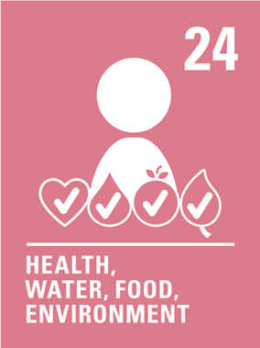    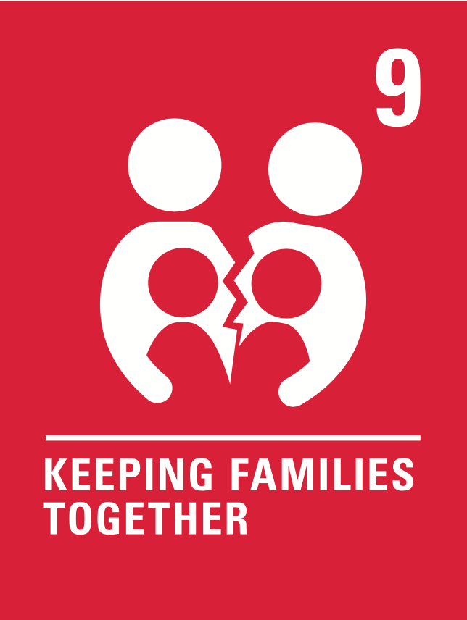  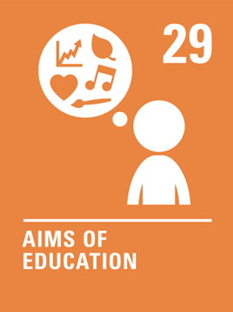  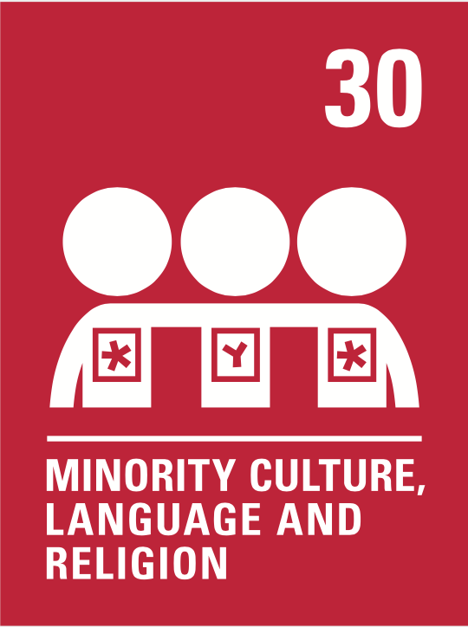  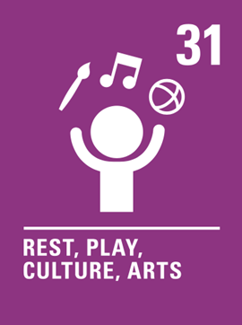    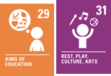  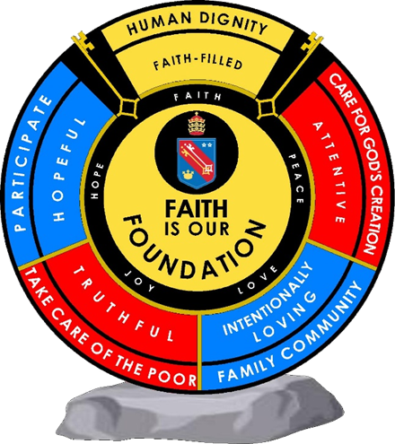  Human dignity  Attentive  Intentionally loving  Human dignity  Intentionally loving  Human dignity  Truthful  Intentionally loving  Human dignity  Hopeful  Intentionally loving | Unit 5: Festivals  All pupils will know:  - How to give their opinion about different types of festivals and justify it.  - How to describe a typical day at a festival in the present tense  - How to make plans to go to a festival  All pupils will be assessed:  - Short knowledge quizzes every 3 lessons for key lexical items.  - End of unit tests.  - Data Feeds.  - In-class formative assessment by the teacher  - Written feedback given on specified pieces of writing and speaking throughout the topic.  Impact - Why do we teach this?  - This topic continues to recycle vocabulary from Year 7 and Year 8, helping embed this in students’ long-term memories.  - We build on the grammar taught throughout Year 7 (present tense, modal verbs, past tense) in this unit of work, so students are given further opportunities to practise and secure this knowledge. | Unit 6: Places of interest  All pupils will know:  - How to identify recreation places in TL countries.  - How to describe trips.  - How to name and describe TL countries.  - How to talk about colonisation and the effects on the TL culture in the UK.  All pupils will be assessed:  - Short knowledge quizzes every 3 lessons for key lexical items.  - End of unit tests.  - Data Feeds.  - In-class formative assessment by the teacher  - Written feedback given on specified pieces of writing and speaking throughout the topic.  Impact - Why do we teach this?  - With this unit we pretend for our students to deep in the TL culture from a point of view of a tourist.  - We are looking forward to create some curiosity in them and a willing to open up their minds to new cultural environments. | Subject specific skills being developed:  - Listening  - Reading  - Speaking  - Writing  - Phonics  - Adjective agreement  - Developing opinions  - Negative structures  - Present tense conjugations  - Past tense conjugations  - Interrogatives  - Modal verbs
Reading Skills needed for this unit:
- Reading aloud
- Reading for gist
- Reading for detail
- Sound/spelling links

Key Vocabulary:
See Unit 3 knowledge organisers
Opportunity for cross-curricular skill development
- Geography
- History
- Literacy
- Music
- PSHE
- Catholic values (human dignity, Truthful, care for God’s creation and hopeful)
- British values

Ensuring this curriculum meets the needs of all pupils: this curriculum has been designed to ensure pupils from all starting points will develop the key curriculum skills and knowledge identified. The curriculum design ensures that each unit forms part of the overall learning journey and there are opportunities for revisiting skills and linking together key pieces of knowledge. Whole Academy policies and practices are followed to tailor the delivery of the curriculum for individuals and groups of students. For example, SEND students have individual learning profiles that outline needs/strategies to be used, Whole group RIPs are in place to identify key teaching strategies that will be used with individual teaching groups. Ongoing formative assessment and clear summative assessment points allow individual staff and departments to identify misconception and adjust curriculum appropriately.
Human dignity
Truthful
Intentionally loving
Human dignity
Hopeful
 |  | Enrichment opportunities: students will learn about Francophone or Hispanic culture, including regions and specialities. Some students may have the opportunity to go on a foreign language trip abroad in the summer term.
 |  | Career opportunities/ links: whole school careers and MFL presentations. Jobs in the tourist sector (where around the French or Spanish speaking world could you work); translation (skills needed to work in this industry).

