Year 9 Curriculum and Assessment Plan for MFL

The curriculum and assessment of pupils at this stage of education has been carefully designed to build on key phrases and structures taught in Year 7 and 8, giving students a solid foundation before starting their KS4 studies.
Throughout Year 9, students will have regular opportunities to practise and revisit key vocabulary as well as important structures and grammar rules with the aim of embedding this knowledge in the long-term memory. Being able to manipulate three tenses accurately and give, and justify, opinions on a variety of different topics will facilitate the transition between KS3 and KS4.
Unit 1: Education  All pupils will know:  - How to give opinions on school subjects.  - How to compare school subjects.  - How to describe teachers.  - How to describe your school.  - How to describe their ideal school.  - How to describe their primary school.  - How to describe their daily routines.  - How to describe what they did yesterday.  - How to describe what they will do the day after.  All pupils will be assessed:  - Short knowledge quizzes every 3 lessons for key lexical items.  - End of unit tests.  - Data Feeds.  - In-class formative assessment by the teacher  - Written feedback given on specified pieces of writing and speaking throughout the topic.  Impact - Why do we teach this?  - In this unit students will explore their immediate surrounding in TL.  - They will have a close look at all parts of their daily routine at home but overall, during school days. | Unit 2: World of work  All pupils will know:  - How to name jobs.  - How to name places of work.  - How to describe work routines.  - How to describe what job they would like to do.  - How to describe future career plans.  - How to create a CV in TL.  All pupils will be assessed:  - Short knowledge quizzes every 3 lessons for key lexical items.  - End of unit tests.  - Data Feeds.  - In-class formative assessment by the teacher  - Written feedback given on specified pieces of writing and speaking throughout the topic.  Impact - Why do we teach this?  - Students will navigate through their day-to-day routine, being able to name subjects, teachers… identify their routine and the differences between British and TL daily routines.  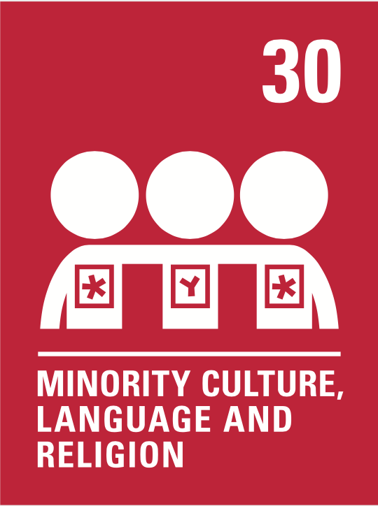    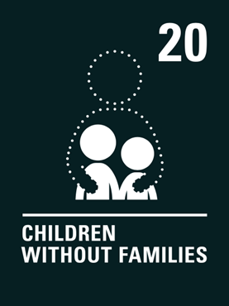  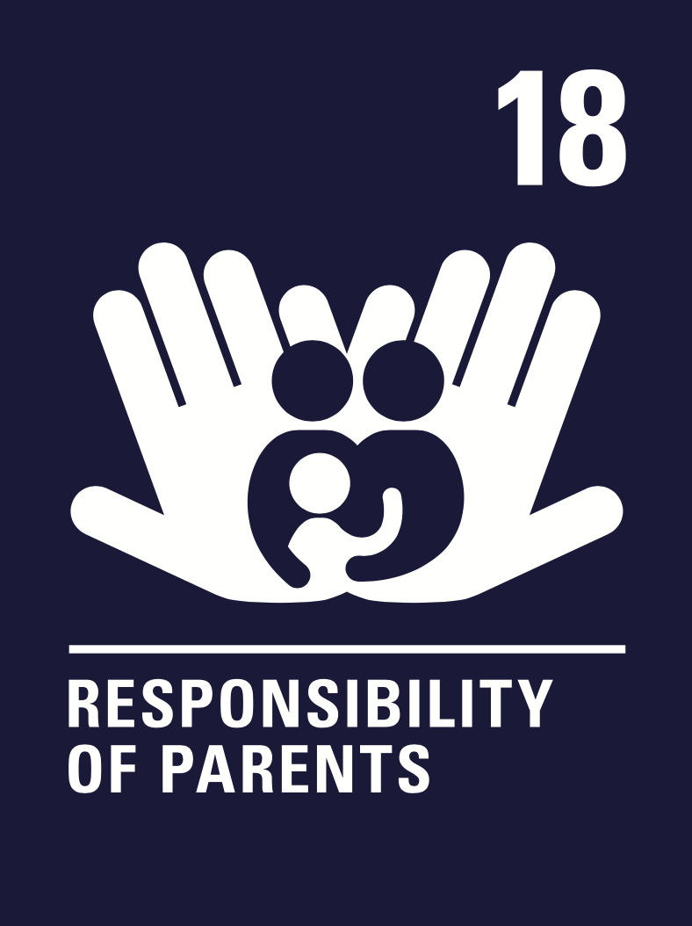    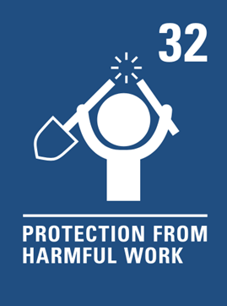  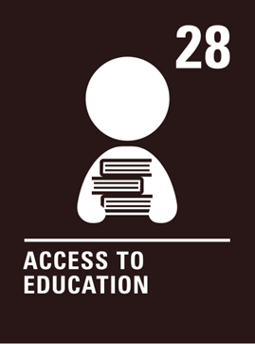  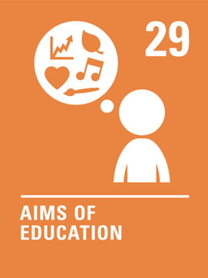  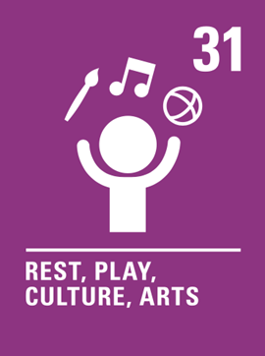  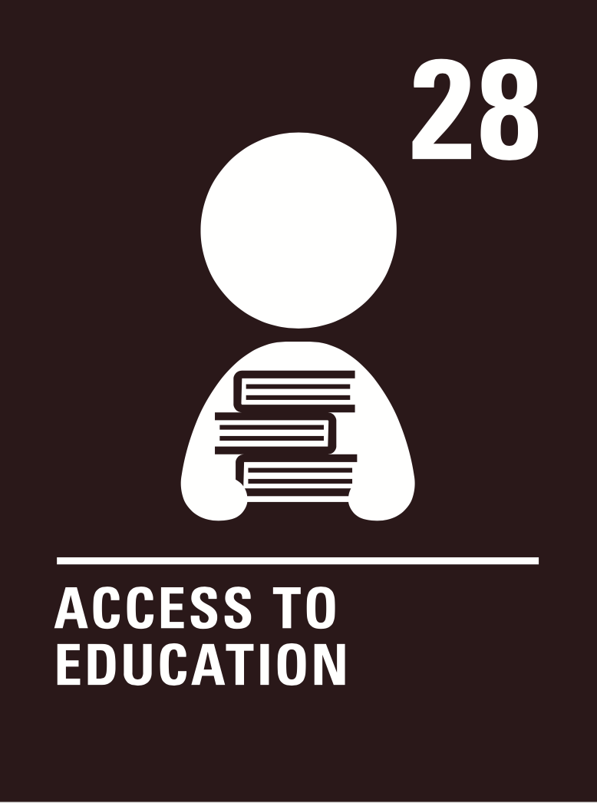      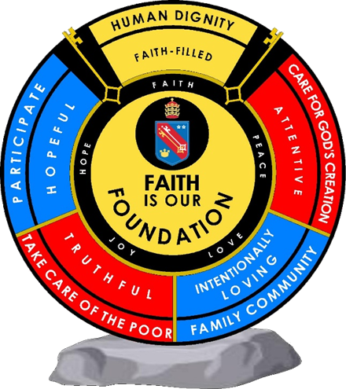  Human dignity  Intentionally loving  Human dignity  Truthful  Intentionally loving  Human dignity  Hopeful  Intentionally loving  Human dignity  Hopeful  Human dignity  Truthful  Intentionally loving  Human dignity  Attentive  Intentionally loving |  | Unit 3: Technology  All pupils will know:  - How to describe the advantages and disadvantages of technology  - How to talk about technology, smartphones and how they use them.  - How to talk about recent and future uses of technology  All pupils will be assessed:  - Short knowledge quizzes every 3 lessons for key lexical items.  - End of unit te sts.  - Data Feeds.  - In-class formative assessment by the teacher  - Written feedback given on specified pieces of writing and speaking throughout the topic.  Impact - Why do we teach this?  - Through this topic, students will interweave concepts and structures that have been developed throughout the year – complex opinions and justifications, modal verbs and multiple tenses.  - The topic allows for recycling of the free time vocabulary, whilst adding more complex lexical items e.g., about the potential dangers of technology | Unit 4: Environmental issues  All pupils will know:  - How to name environmental issues.  - How to give solutions.  - How to link this to TL countries.  - How to link TL issues to UK issues.  - How to discuss poverty and social issues.  - How to create a radio role play.  All pupils will be assessed:  - Short knowledge quizzes every 3 lessons for key lexical items.  - En d of unit tests.  - Data Feeds.  - In-class formative assessment by the teacher  - Written feedback given on specified pieces of writing and speaking throughout the topic.  Impact - Why do we teach this?  - Through this topic, students will stretch their knowledge into a more mature level where they will start thinking about their environment and what is the impact, they have on it.  - They will also discuss solutions to improve our environment.  - And the most characteristic part of this unit is where they will compare countries and learn how to learn better ideas from other countries will improve their own. | Unit 5: Differences between the UK and France/Spain  All pupils will know:  - How to name differences and similarities in TL dishes.  - How to name differences and similarities about the educational system.  - How to name differences and similarities on free time activities.  - How to name differences and similarities shopping.  - How to name differences and similarities on Royal families.  All pupils will be assessed:  - Short knowledge quizzes every 3 lessons for key lexical items.  - End of unit tests.  - Data Feeds.  - In-class formative assessment by the teacher  - Written feedback given on specified pieces of writing and speaking throughout the topic.  Impact - Why do we teach this?  - Through this topic, students will deep in their understanding of their own country as much as they will learn about TL speaking countries in different basic aspects of their day to day. | Unit 6: Film Project  All pupils will know:  - How to introduce films vocabulary.  - How to analyse Tl culture throughout a film.  - How to answer questions about a TL film.  All pupils will be assessed:  - Final project.  Impact - Why do we teach this?  - Through this topic, students will analyse a TL movie, and get to learn a bout the TL countries in real context. | Subject specific skills being developed:  developed:  - Reading  - Listening  - Speaking  - Writing  - Giving and justifying opinions  - Present tense conjugations  - Future tense conjugations  - Past tense conjugations
Reading Skills needed for this unit:
- Reading aloud
- Reading for gist
- Reading for detail
- Sound/spelling links

Key Vocabulary:
See knowledge organisers.

Opportunity for cross-curricular skill development
- Literacy
- Numeracy
- Cultural knowledge
- Computing
- PSHE
- Catholic values (human dignity, hopeful and intentionally loving)
- British values

 |  | Ensuring this curriculum meets the needs of all pupils: this curriculum has been designed to ensure pupils from all starting points will develop the key curriculum skills and knowledge identified. The curriculum design ensures that each unit forms part of the overall learning journey and there are opportunities for revisiting skills and linking together key pieces of knowledge. Whole Academy policies and practices are followed to tailor the delivery of the curriculum for individuals and groups of students. For example, SEND students have individual learning profiles that outline needs/strategies to be used, Whole group RIPs are in place to identify key teaching strategies that will be used with individual teaching groups. Ongoing formative assessment and clear summative assessment points allow individual staff and departments to identify misconception and adjust curriculum appropriately.
Enrichment opportunities:
- Learning about Francophone or Hispanic cultures
- Foreign language trips in the summer term
- Languagenut weekly competitions
- External opportunities with other education establishments
- Cultural trips
 |  | Career opportunities/ links: whole school careers and MFL presentations. Jobs in the tourist sector (where around the French or Spanish speaking world could you work); translation (skills needed to work in this industry).

