Year 10 Curriculum and Assessment Plan for MFL

The curriculum and assessment of pupils at this stage of education has been carefully designed to provide a solid foundation for second language acquisition.
Research shows that 75% of time communicating is spent listening and speaking, and our Year 7 MFL curriculum is built around this idea, ensuring that students have plenty of opportunities to hear, mimic and practise speaking the language before progressing onto the written form – just as you would when you learn your native language. We have designed our KS3 curriculum around a set of communicative functions so that students regularly practise the most useful sentence patterns, and we teach vocabulary in chunks to progress fluency and help with long-term memory recall. Through frequent exposure to the language of a particular topic, students will also be taught phonemes, syllables, lexis, grammar, syntax and meaning. Our aim is for students to routinise the language we teach so that they can retrieve it quickly and effortlessly in order to understand as well as speak and write confidently in the target language.
Unit 1: Identity and relationships with other  All pupils will know:  How to great in TL (Target Language)  How to say their name, age birthday.  How to describe their bodies and personality.  How to describe someone else’s appearance and personality.  How to introduce themselves and other people, giving key information such as their age, birthday, nationality  How to describe friends and family members  How to describe their personality  How to describe their physical appearance  All pupils will be assessed by:  - Short knowledge quizzes every 3 lessons for key lexical items.  - End of unit tests.  - Data Feeds.  - In-class formative assessment by the teacher  - Written feedback given on specified pieces of writing and speaking throughout the topic.  Impact- Why do we teach this?  We use this topic in conjunction with the previous knowledge from KS3, so that students can describe themselves, their hobbies and where they live in substantial detail.  This topic builds on the grammar taught in the previous two, so it is used to cement key concepts such as present tense verb conjugations, adjective agreement, word order, negatives before students move onto more complex structures.    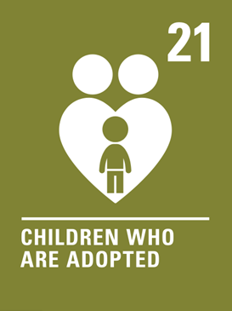  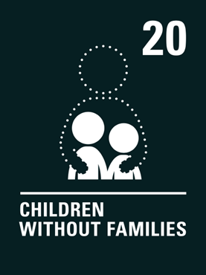    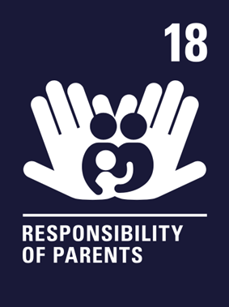  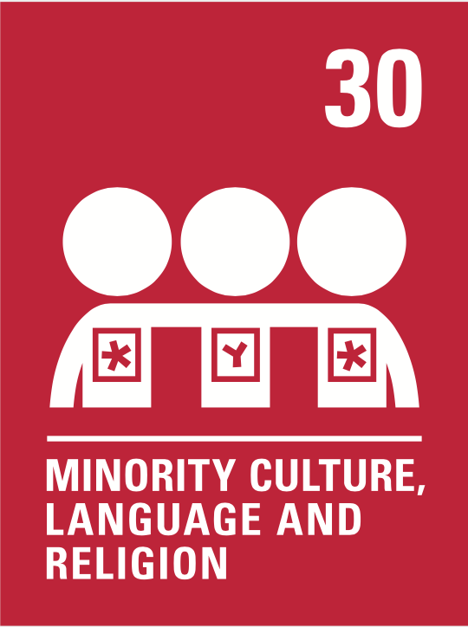  Human dignity  Truthful  Attentive  Intentionally loving  Human dignity  Truthful  Intentionally loving  Human dignity  Truthful  Hopeful  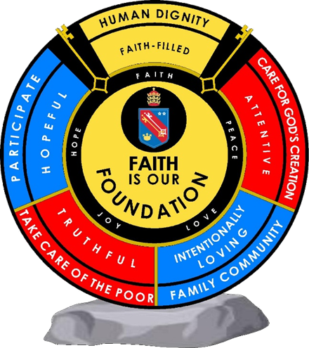  Human dignity  Truthful  Hopeful  Human dignity  Hopeful  Human dignity  Truthful  Intentionally loving |  | Unit 2: Work and education  All pupils will know:  Describe all aspects of their daily routine.  Talk about school.  Talk about the world of work.  Make plans for the future.  Compare the Tl culture to the UK one.  All pupils will be assessed by:  - Short knowledge quizzes every 3 lessons for key lexical items.  - End of unit tests.  - Data Feeds.  - In-class formative assessment by the teacher  - Written feedback given on specified pieces of writing and speaking throughout the topic.  Impact - Why do we teach this?  In this unit students will explore their immediate surrounding in TL.  They will have a close look at all parts of their daily routine at home but overall, during school days.  Students will navigate through their day-to-day routine, being able to name subjects, teachers… identify their routine and the differences between British and TL daily routines.    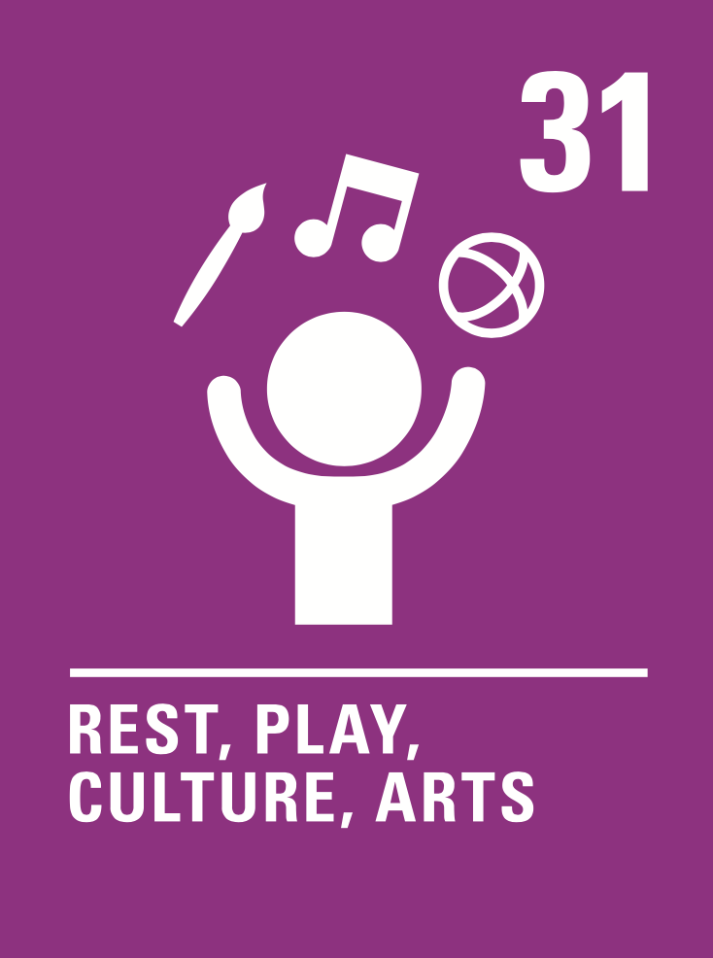  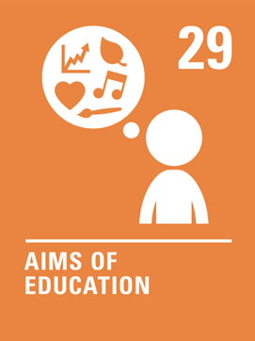    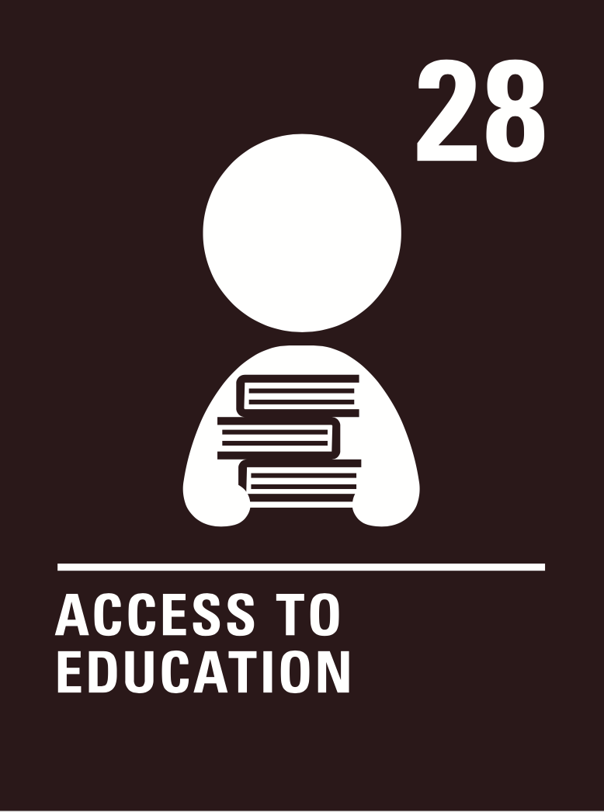  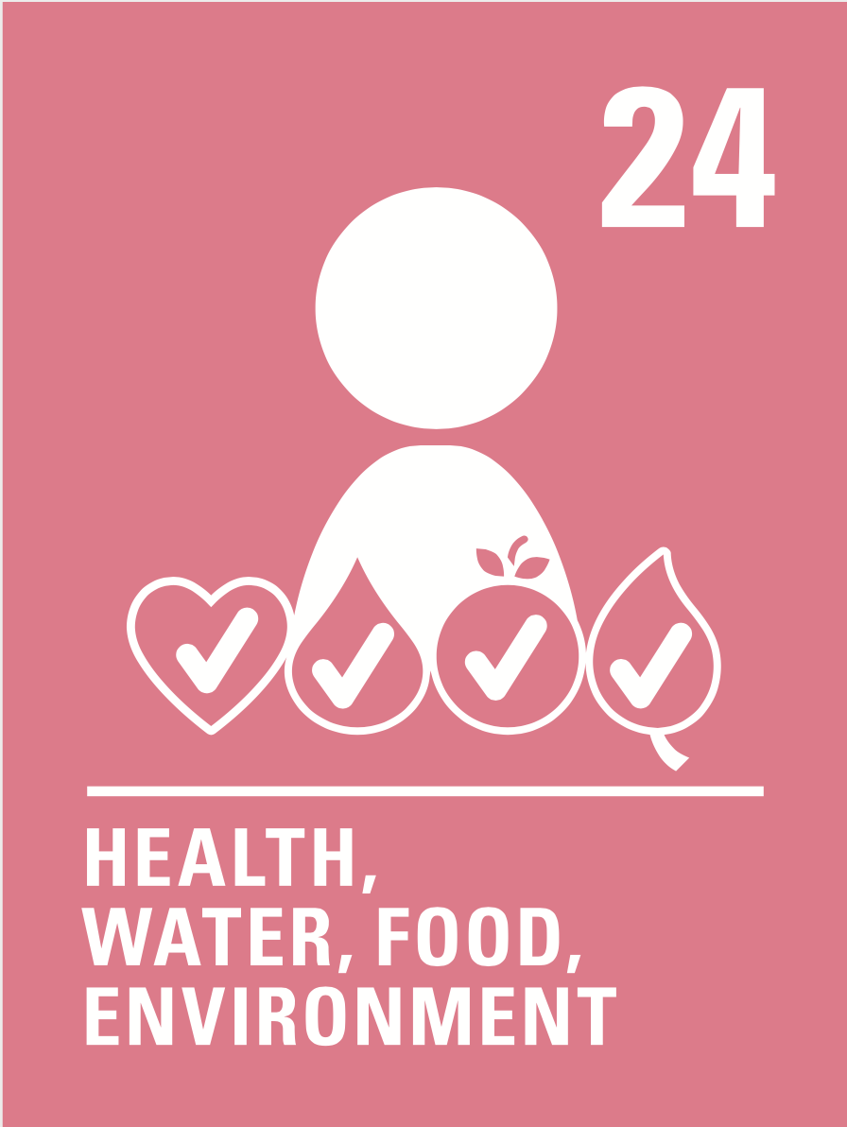 | Unit 3: Healthy living and lifestyle  All pupils will know:  How to state what they eat and drink.  How to identify cultural foods.  How to ask for quantities.  How to state healthy and unhealthy dishes.  How to name healthy and unhealthy habits.  How to name actions to improve your health.  How to describe body parts.  How to describe someone’s body.  All pupils will be assessed by:  - Short knowledge quizzes at the end of every sub-unit of work to assess the recall of key lexical items.  - In-class formative assessment by the teacher  - Written feedback given on specified pieces of writing throughout the topic.  - A summative assessment testing listening, reading and writing skills.  Impact - Why do we teach this?  In this unit students will get closer to the culture of the language they study, and they will have the chance to compare lifestyles.  They will give freedom to their imagination creating TL monsters.  And will get essential experience in role plays for their future GCSEs.  Apart from languages, this unit will allow students to think about the healthy and unhealthy routines they may have and think about how to improve those. | Unit 4: Free time activities  All pupils will know:  How to describe the weather  How to say what they do in their free time  How to say what others do in their free time.  How to give opinions about different activities  How to describe what clothes they wear for different occasions.  All pupils will be assessed by:  - Short knowledge quizzes every 3 lessons for key lexical items.  - End of unit tests.  - Data Feeds.  - In-class formative assessment by the teacher  - Written feedback given on specified pieces of writing and speaking throughout the topic.  Impact - Why do we teach this?  This topic leads on from the topic of the town. and grammatical structures  Students develop their opinions further with a wider range of phrases, including adjectives – a key skill they will need throughout their MFL careers.  Students build on the verb they learnt in the first unit to practise other fundamental present tense conjugations.  Students further explore the idea of adjective agreement and word order within sentences. | Unit 5: customs and festivals  All pupils will know:  How to give their opinion about different types of festivals and justify it.  How to describe a typical day at a festival in the present tense  How to make plans to go to a festival  All pupils will be assessed:  - Short knowledge quizzes every 3 lessons for key lexical items.  - End of unit tests.  - Data Feeds.  - In-class formative assessment by the teacher  - Written feedback given on specified pieces of writing and speaking throughout the topic.  Impact - Why do we teach this?  This topic continues to recycle vocabulary from Year 7 and Year 8, helping embed this in students’ long-term memories.  We build on the grammar taught throughout Year 7 (present tense, modal verbs, past tense) in this unit of work, so students are given further opportunities to practise and secure this knowledge. | Unit 6: Celebrity culture  All pupils will know:  - How to recognise singers and songs.  - How to recognise writers and books.  - How to recognise actor and films.  - How to recognise designers and brands.  - How to recognise restaurants.  - How to recognise Fashion week.  - How to recognise cinema festivals.  All pupils will be assessed by:  - Short knowledge quizzes at the end of every sub-unit of work to assess the recall of key lexical items.  - In-class formative assessment by the teacher  - Written feedback given on specified pieces of writing throughout the topic.  Impact- Why do we teach this?  - This topic links with the culture of the European countries.  - This unit will get them identified with the TL country where they will study differences and similarities as much as how do TL countries affect us in the UK.  - This unit will allow students to speak with cultural knowledge, explore other cultures and approach a more realistic learning of real life. | Subject specific skills being developed:  - Listening  - Reading  - Speaking  - Writing  - Phonics  - Adjective agreement  - Developing opinions  - Negative structures  - Present tense conjugations
Reading Skills needed for this unit:
- Reading aloud
- Reading for gist
- Reading for detail
- Sound/spelling links

Key Vocabulary:
See Unit 4 knowledge organisers
Opportunity for cross-curricular skill development
- Literacy
- Numeracy
- PSHE
- RE
- Catholic values (human dignity, hopeful and intentionally loving)
- British values

 | Ensuring this curriculum meets the needs of all pupils: this curriculum has been designed to ensure pupils from all starting points will develop the key curriculum skills and knowledge identified. The curriculum design ensures that each unit forms part of the overall learning journey and there are opportunities for revisiting skills and linking together key pieces of knowledge. Whole Academy policies and practices are followed to tailor the delivery of the curriculum for individuals and groups of students. For example SEND students have individual learning profiles that outline needs/strategies to be used, Whole group RIPs are in place to identify key teaching strategies that will be used with individual teaching groups. Ongoing formative assessment and clear summative assessment points allow individual staff and departments to identify misconception and adjust curriculum appropriately.
Enrichment opportunities:
- Learning about Francophone or Hispanic cultures
- Foreign language trips in the summer term
- Languagenut weekly competitions
- External opportunities with other education establishments
- Cultural trips
 | Career opportunities/ links: whole school careers and MFL presentations. Jobs in the tourist sector (where around the French or Spanish speaking world could you work); translation (skills needed to work in this industry).

