Year 11 Curriculum and Assessment Plan for MFL

The curriculum and assessment of pupils at this stage of education has been carefully designed to provide a solid foundation for second language acquisition.
Research shows that 75% of time communicating is spent listening and speaking, and our Year 7 MFL curriculum is built around this idea, ensuring that students have plenty of opportunities to hear, mimic and practise speaking the language before progressing onto the written form – just as you would when you learn your native language. We have designed our KS3 curriculum around a set of communicative functions so that students regularly practise the most useful sentence patterns, and we teach vocabulary in chunks to progress fluency and help with long-term memory recall. Through frequent exposure to the language of a particular topic, students will also be taught phonemes, syllables, lexis, grammar, syntax and meaning. Our aim is for students to routinise the language we teach so that they can retrieve it quickly and effortlessly in order to understand as well as speak and write confidently in the target language.
Unit 7: Travel and tourism  All pupils will know:  How to describe the weather  How to say what they do in their free time  How to say what others do in their free time.  How to give opinions about different activities  How to describe what clothes they wear for different occasions.  All pupils will be assessed by:  - Short knowledge quizzes every 3 lessons for key lexical items.  - End of unit tests.  - Data Feeds.  - In-class formative assessment by the teacher  - Written feedback given on specified pieces of writing and speaking throughout the topic.  Impact - Why do we teach this?  This topic leads on from the topic of the town. and grammatical structures  Students develop their opinions further with a wider range of phrases, including adjectives – a key skill they will need throughout their MFL careers.  Students build on the verb they learnt in the first unit to practise other fundamental present tense conjugations.  Students further explore the idea of adjective agreement and word order within sentences. |  | Unit 8: Environmental and social issues  All pupils will know:  How to state what they eat and drink.  How to identify cultural foods.  How to ask for quantities.  How to state healthy and unhealthy dishes.  How to name healthy and unhealthy habits.  How to name actions to improve your health.  How to describe body parts.  How to describe someone’s body.  All pupils will be assessed by:  - Short knowledge quizzes at the end of every sub-unit of work to assess the recall of key lexical items.  - In-class formative assessment by the teacher  - Written feedback given on specified pieces of writing throughout the topic.  - A summative assessment testing listening, reading and writing skills.  Impact - Why do we teach this?  In this unit students will get closer to the culture of the language they study, and they will have the chance to compare lifestyles.  They will give freedom to their imagination creating TL monsters.  And will get essential experience in role plays for their future GCSEs.  Apart from languages, this unit will allow students to think about the healthy and unhealthy routines they may have and think about how to improve those. | Unit 9: Media and technology  All pupils will know:  How to describe the advantages and disadvantages of technology  How to talk about technology, smartphones and how they use them.  How to talk about recent and future uses of technology  All pupils will be assessed:  - Short knowledge quizzes every 3 lessons for key lexical items.  - End of unit tests.  - Data Feeds.  - In-class formative assessment by the teacher  - Written feedback given on specified pieces of writing and speaking throughout the topic.  Impact - Why do we teach this?  Through this topic, students will interweave concepts and structures that have been developed throughout the year – complex opinions and justifications, modal verbs, and multiple tenses.  The topic allows for recycling of the free time vocabulary, whilst adding more complex lexical items e.g., about the potential dangers of technology.  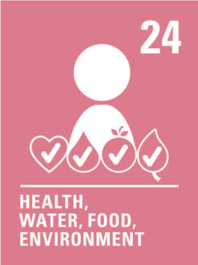  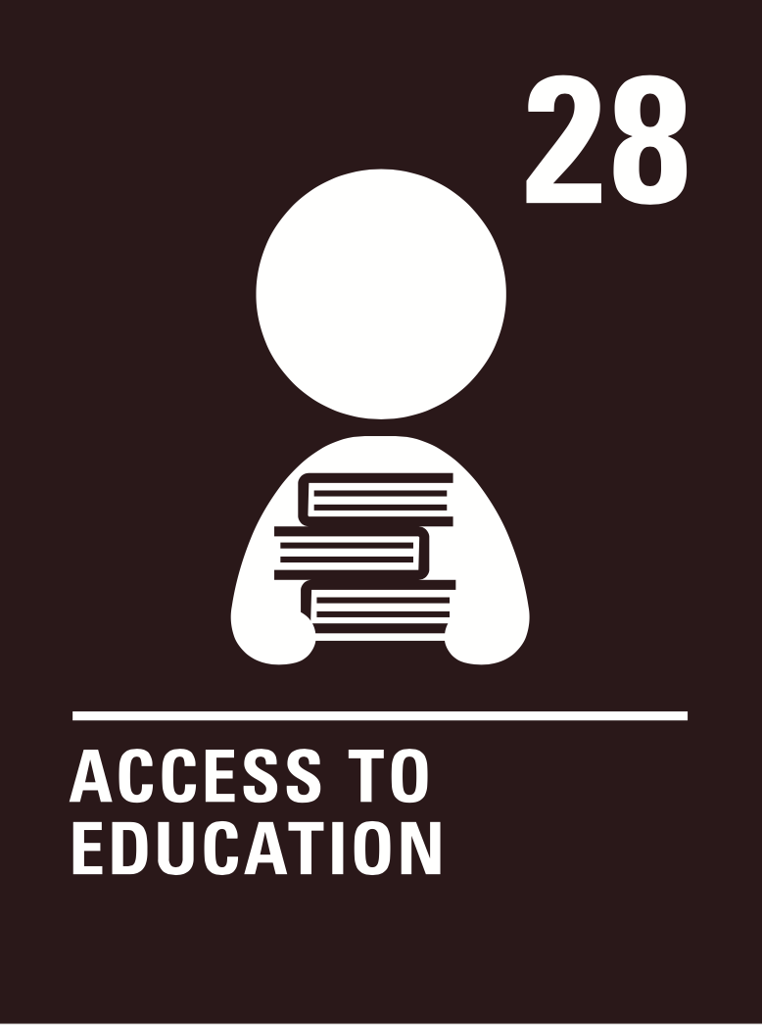  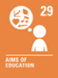    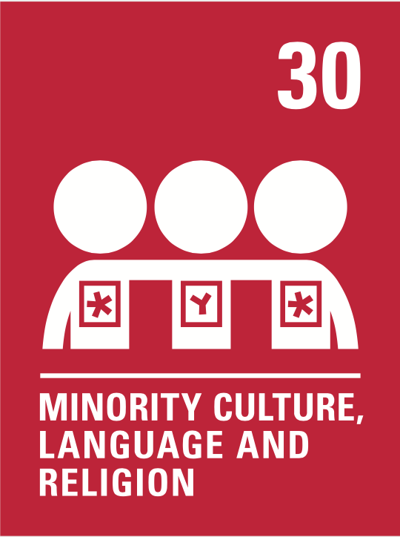  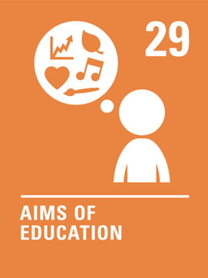    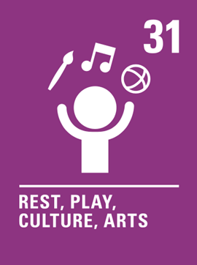  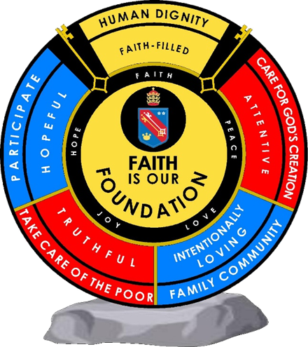  Human dignity  Hopeful  Truthful  Attentive  Intentionally loving  Human dignity  Attentive  Intentionally loving  Human dignity  Hopeful  Human dignity  Truthful  Intentionally loving  Human dignity  Hopeful  Intentionally loving | Exam practice  All pupils will know:  HAP revision techniques  Wheel of tenses booklets  MFL mind maps  Grammar booklets  All pupils will be assessed:  GCSE  Impact - Why do we teach this?  For pupils to get confidence on the topics and how to cover each of the GCSE’s Tasks | Exam practice  All pupils will know:  HAP revision techniques  Wheel of tenses booklets  MFL mind maps  Grammar booklets  All pupils will be assessed:  GCSE  Impact - Why do we teach this?  For pupils to get confidence on the topics and how to cover each of the GCSE’s Tasks | N/A | Subject specific skills being developed:  - Listening  - Reading  - Speaking  - Writing  - Phonics  - Adjective agreement  - Developing opinions  - Negative structures  - Present tense conjugations
Reading Skills needed for this unit:
- Reading aloud
- Reading for gist
- Reading for detail
- Sound/spelling links

Key Vocabulary:
See Unit 4 knowledge organisers
Opportunity for cross-curricular skill development
- Literacy
- Numeracy
- PSHE
 | Ensuring this curriculum meets the needs of all pupils: this curriculum has been designed to ensure pupils from all starting points will develop the key curriculum skills and knowledge identified. The curriculum design ensures that each unit forms part of the overall learning journey and there are opportunities for revisiting skills and linking together key pieces of knowledge. Whole Academy policies and practices are followed to tailor the delivery of the curriculum for individuals and groups of students. For example SEND students have individual learning profiles that outline needs/strategies to be used, Whole group RIPs are in place to identify key teaching strategies that will be used with individual teaching groups. Ongoing formative assessment and clear summative assessment points allow individual staff and departments to identify misconception and adjust curriculum appropriately.
Enrichment opportunities:
- Learning about Francophone or Hispanic cultures
- Foreign language trips in the summer term
- Languagenut weekly competitions
- External opportunities with other education establishments
- Cultural trips
 | Career opportunities/ links: whole school careers and MFL presentations. Jobs in the tourist sector (where around the French or Spanish speaking world could you work); translation (skills needed to work in this industry).

