Year 12 French Curriculum and Assessment Plan for MFL

The curriculum and assessment of pupils at this stage of education has been carefully designed to promote deep learning of grammar and vocabulary on a range of topics required to develop students into confident and established linguists by the end of KS5 who make excellent progress and succeed in the A Level course.
Throughout this year, we aim to help our students become confident linguists, enabling them to feel prepared for their A Level examination. We begin the AQA A Level French course, building on core vocabulary and grammar taught at KS4, whilst raising the level of challenge to allow students to communicate more complex ideas with detail. Finally, we ensure that key exam skills are interwoven throughout the topics so that students feel prepared when approaching the summer examinations.
Half Term 1: Aspects of French-speaking society: current trends.  1 Changing families  1.1 Life as a couple: new trends  Describe and discuss trends in marriage and other forms of partnership.  1.2 Different types of families  Consider and discuss the merits and problems of different family structures.  1.3 Relationships between grand-parents, parents, and their children.  Bridging the gap between GCSE & A Level – a 5-week programme to revisit key grammar and vocabulary in preparation for A level study.  All pupils will know:  - How to give their opinions and expand and justify their ideas  - Embed the grammar and tenses learned at KS3 and KS4 before extending that knowledge further at KS5.  All pupils will be assessed by:  - Weekly vocabulary tests  - In-class formative assessment by the teacher every 3 weeks  - Written feedback given on specified pieces of writing throughout the topic.  - Mock examinations in all four skills.  Impact- Why do we teach this?  - We begin Year 12 ensuring that students feel fully secure in a minimum of six tenses as this is a key part of the A Level specification. Higher ability students will have the opportunity to revise other tenses if they are already secure in this area.  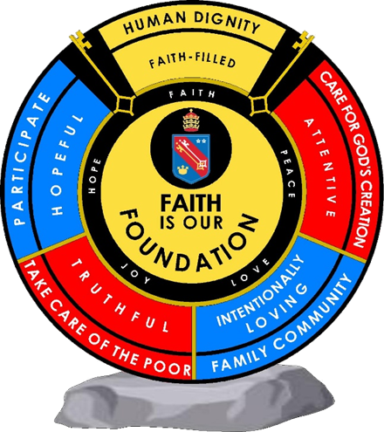  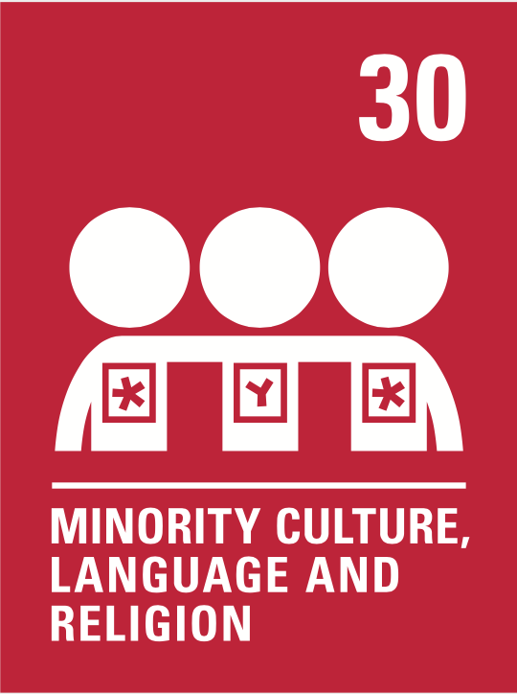        Human dignity  Truthful  Intentionally loving | Subject specific skills being developed:  - Reading  - Listening  - Speaking  - Writing  - Understand more complex grammar terminology and key expressions.  - Giving and justifying opinions  - Giving pros and cons  - Demonstrate independence using French online dictionaries and websites for research.  - Participate in conversations in front of others.  - Asking questions.  - Translation techniques.  - Course organisation skills. | Half Term 2: Aspects of French-speaking society: current trends.  2 Cyberspace  2.1 How technology facilitates daily life  Describe and discuss how technology has transformed everyday life.  2.2 The dangers of technology  Consider and discuss the dangers of digital technology  2.3 Who uses technology  Consider the different users of digital technology and discuss possible future developments.  All pupils will be assessed:  - Weekly vocabulary tests  - In-class formative assessment by the teacher every 3 weeks  - Written feedback given on specified pieces of writing throughout the topic.  - Mock examinations in all four skills  Impact - Why do we teach this?  - This is the topic students often find the most challenging, so we teach this after we have ensured a confident start to the year.  - Students build on the tenses from the previous topic, now adding impersonal verbs and structures.  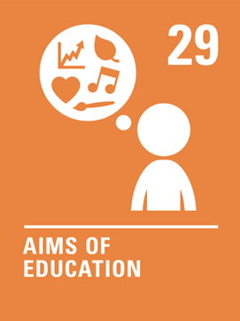    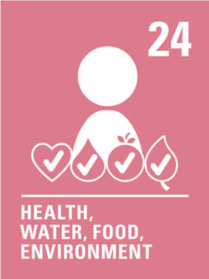  Human dignity  Hopeful | Subject specific skills being developed:  - Reading  - Listening  - Speaking  - Writing  - Giving and justifying opinions  - Present tense conjugations  - Past tense conjugations  - Immediate future tense conjugations  - For Higher Tier students: imperfect, simple future, conditional tenses  - Impersonal and modal verbs | Half Term 3: Aspects of French-speaking society: current trends  3 The role of voluntary work  3.1 Who are volunteers and what do they do  Examine the voluntary sector in France and the range of work volunteers provide.  3.2 The benefits for the recipients of voluntary work  Discuss the benefits of voluntary work for those that are helped and how beneficiaries request help.  3.3 The benefits for those who volunteer  Look at the benefits of voluntary work for those that do it and for society as a whole.  All pupils will be assessed:  - Weekly vocabulary tests  - In-class formative assessment by the teacher every 3 weeks  - Written feedback given on specified pieces of writing throughout the topic.  - Mock examinations in all four skills  Impact - Why do we teach this?  - We continue with a more challenging topic that links well with the previous, recycling many of the same structures.  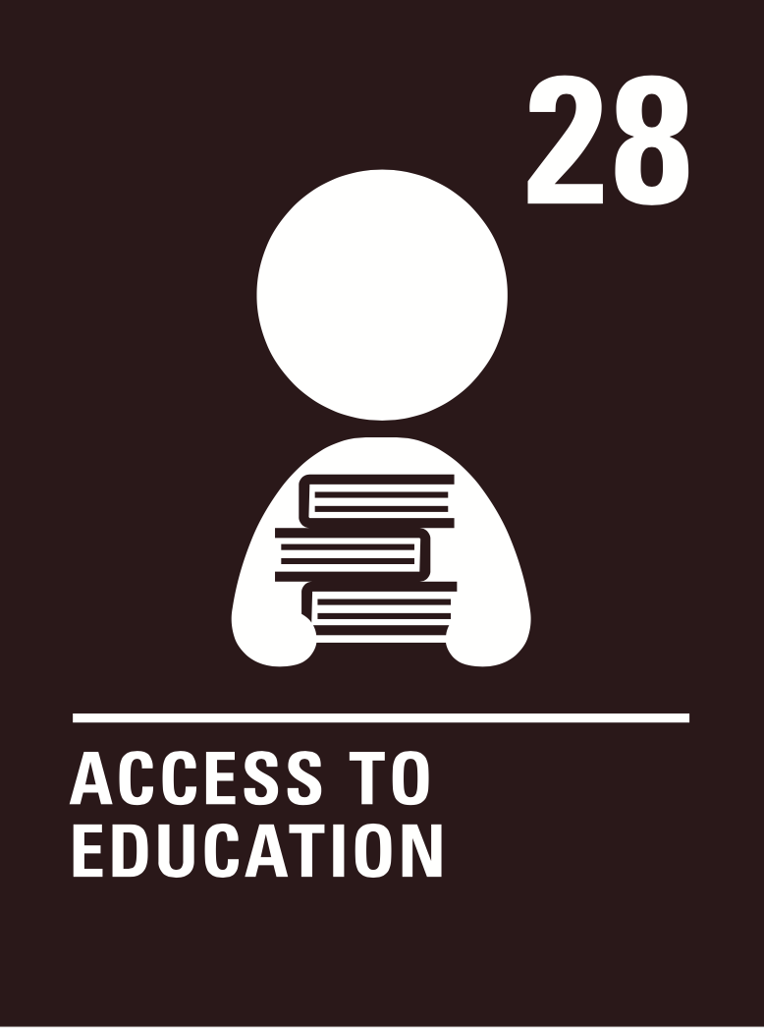  - We continue to practise the key tenses for each tier, whilst the most confident students learn the subjunctive ..  Human dignity  Hopeful  Truthful  Attentive  Intentionally loving | Subject specific skills being developed:  developed:  - Reading  - Listening  - Speaking  - Writing  - Giving and justifying opinions  - Present tense conjugations  - Past tense conjugations  - Immediate future tense conjugations  - For Higher Tier students: imperfect, simple future, conditional tenses; subjunctive  - Impersonal and modal verbs
 | Reading Skills needed for this unit:  - Reading aloud  - Reading for gist  - Reading for detail  - Sound/spelling links  Key Vocabulary:  See knowledge organisers. |  | Reading Skills needed for this unit:  - Reading aloud  - Reading for gist  - Reading for detail  - Sound/spelling links  Key Vocabulary:  See knowledge organisers. |  | Reading Skills needed for this unit:  - Reading aloud  - Reading for gist  - Reading for detail  - Sound/spelling links  Key Vocabulary:  See knowledge organisers
 | Opportunity for cross-curricular skill development  - Literacy  - Geography  - PSHE  - Sociology  - Catholic values  - British values |  | Opportunity for cross-curricular skill development  - Literacy  - Geography  - PSHE  - Sociology  - Catholic values  - British values |  | Opportunity for cross-curricular skill development  - Literacy  - Geography  - PSHE  - Sociology  - Catholic values  - British values
Half Term 4: Artistic culture in the French-speaking world  4 French and francophone heritage  4.1 National, regional and local heritage  Understand the notion of heritage and heritage preservation on a regional and national scale.  4.2 Heritage and tourism  Consider the ways in which some of the country’s most famous heritage sites market themselves.  4.3 How heritage reflects French culture  Understand how heritage impacts upon and is guided by culture in society.  All pupils will be assessed:  - Weekly vocabulary tests  - In-class formative assessment by the teacher every 3 weeks  - Written feedback given on specified pieces of writing throughout the topic  - Mock examinations in all four skills  Impact – Why do we teach this?  - This topic allows for the consolidation of key structures taught in the previous two topics, including multiple tenses, detailed opinions, impersonal verbs  - Although students tend to find the vocabulary for this topic easier, teaching it towards the end of Year 11 encourages them to use more complex language in their writing and speaking answers than they might perhaps if it were taught earlier, as they can draw on their knowledge from the entire course  Human dignity  Truthful  Intentionally loving | Subject specific skills being developed:  - Reading  - Listening  - Speaking  - Writing  - Giving and justifying opinions  - Present tense conjugations  - Past tense conjugations  - Immediate future tense conjugations  - Simple future tense conjugations  - Imperfect tense conjugations  - Impersonal and modal verbs  - Perfect infinitive phrases | Half Term 5: Artistic culture in French-speaking world  5 Modern francophone music  5.1 Diversity of modern francophone music  Consider the popularity of contemporary francophone music and its diversity of genre and style.  5.2 Who listens and appreciates francophone music  Consider who listens to contemporary French music, how often and by what means.  5.3 How to safeguard francophone music  Consider and discuss the threats to contemporary francophone music and how it might be safeguarded.  All pupils will be assessed:  - Weekly vocabulary tests  - In-class formative assessment by the teacher every 3 weeks  - Written feedback given on specified pieces of writing throughout the topic  - Mock examinations in all four skills  Impact - Why do we teach this?  - This topic draws on many of the phrases learnt throughout the course, particularly those from the future tense topic taught early in Year 10. This allows lots of opportunities to revisit and revise content from across the course as a whole, making it the ideal topic to teach before the examinations begin.  - We continue to practise all the grammar taught over the year in this topic.  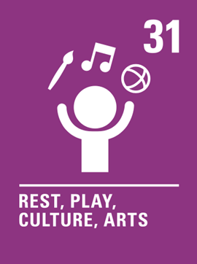  Human dignity  Intentionally loving | Subject specific skills being developed:  - Reading  - Listening  - Speaking  - Writing  - Giving and justifying opinions  - Present tense conjugations  - Past tense conjugations  - Immediate future tense conjugations  - Simple future tense conjugations  - Imperfect tense conjugations  - Conditional tense conjugations | Half Term 6: Artistic culture in the French-speaking world  6 French cinema  6.1 Why is French cinema known as the seventh art?  Consider a variety of aspects of French cinema.  6.2. The evolution of cinema  Consider the major developments in the evolution of French cinema from its beginnings until the present day.  6.3 French cinema as a national passion  Consider the continuing popularity of French cinema and film festivals.  All pupils will be assessed:  - Weekly vocabulary tests  - In-class formative assessment by the teacher every 3 weeks  - Written feedback given on specified pieces of writing throughout the topic  - Mock examinations in all four skills  Impact- Why do we teach this?  - Students will have a series of revision lessons to help with their preparation for the upcoming examinations  Human dignity  Intentionally loving  Truthful  Hopeful | Subject specific skills being developed:  - Reading  - Listening  - Speaking  - Writing  - Giving and justifying opinions  - All the grammar taught over the two-year course
 | Reading Skills needed for this unit:  - Reading aloud  - Reading for gist  - Reading for detail  - Sound/spelling links  Key Vocabulary:  See knowledge organisers |  | Reading Skills needed for this unit:  - Reading aloud  - Reading for gist  - Reading for detail  - Sound/spelling links  Key Vocabulary:  See knowledge organisers |  | Reading Skills needed for this unit:  - Reading aloud  - Reading for gist  - Reading for detail  - Sound/spelling links  Key Vocabulary:  See knowledge organisers
 | Opportunity for cross-curricular skill development  - Literacy  - PSHE  - Geography  - Catholic values  - British values |  | Opportunity for cross-curricular skill development  - Literacy  - PSHE  - History  - Music  - Catholic values  - British values |  | Opportunity for cross-curricular skill development  - PSHE  - Literacy  - Film studies Catholic values  - British values
Ensuring this curriculum meets the needs of all pupils: this curriculum has been designed to ensure pupils from all starting points will develop the key curriculum skills and knowledge identified. The curriculum design ensures that each unit forms part of the overall learning journey and there are opportunities for revisiting skills and linking together key pieces of knowledge. Whole Academy policies and practices are followed to tailor the delivery of the curriculum for individuals and groups of students. For example SEND students have individual learning profiles that outline needs/strategies to be used, Whole group RIPs are in place to identify key teaching strategies that will be used with individual teaching groups. Ongoing formative assessment and clear summative assessment points allow individual staff and departments to identify misconception and adjust curriculum appropriately.
Enrichment opportunities:
- Learning about Hispanic cultures, trips, online extracurricular cultural activities.
Career opportunities/ links: What can I do with a modern languages degree? | Prospects.ac.uk
whole school careers and MFL presentations. Jobs in the tourist sector (where around the French or Spanish speaking world could you work); translation (skills needed to work in this industry).
Film study: Along with the curriculum we will study the film “La Haine” , directed by Matthieu Kassovitz from December until the end of the academic year. Students will be required to write an essay I n French of approximately 300 words about an aspect of the film, for example a theme or a character, as part of their exam assessment at the end of year 13.

