Year 12 Spanish Curriculum and Assessment Plan for MFL

The curriculum and assessment of pupils at this stage of education has been carefully designed to promote deep learning of grammar and vocabulary on a range of topics required to develop students into confident and established linguists by the end of KS5 who make excellent progress and succeed in the A Level course.
Throughout this year, we aim to help our students become confident linguists, enabling them to feel prepared for their A Level examination. We begin the AQA A Level Spanish course, building on core vocabulary and grammar taught at KS4, whilst raising the level of challenge to allow students to communicate more complex ideas with detail. Finally, we ensure that key exam skills are interwoven throughout the topics so that students feel prepared when approaching the summer examinations.
Half Term 1: Aspects if Hispanic society: current trends.  1 Cyberspace  1.1 The influence of the Internet  Discuss the positive and/or negative influence of the Internet.  1.2 Smartphones in our society  Discuss the positive and/or negative effect of smartphones.  1.3 Social networks: benefits and dangers  Consider the type of influence social networks have on society.  Alon with Grammar revision - Bridging the gap between GCSE & A Level.  All pupils will know:  - How to give their opinions and expand and justify their ideas  - Embed the grammar and tenses learned at KS3 and KS4 before extending that knowledge further at KS5.  All pupils will be assessed by:  - Weekly vocabulary tests  - In-class formative assessment by the teacher every 3 weeks  - Written feedback given on specified pieces of writing throughout the topic.  - Mock examinations in all four skills.  Impact- Why do we teach this?  - We begin Year 12 ensuring that students feel fully secure in a minimum of six tenses as this is a key part of the A Level specification. Higher ability students will have the opportunity to revise other tenses if they are already secure in this area. | Subject specific skills being developed:  - Reading  - Listening  - Speaking  - Writing  - Understand more complex grammar terminology and key expressions.  - Giving and justifying opinions  - Giving pros and cons  - Demonstrate independence using a Spanish online dictionaries and websites for research.  - Participate in conversations in front of others.  - Asking questions.  - Translation techniques.  - Course organisation skills. | Half Term 2: Aspects if Hispanic society: current trends.  2 Traditional and modern values  2.1 Changes in the family  Describe the various types of 21st-century Spanish family and how these differ from the family model of the past.  2.2 Attitudes towards marriage and divorce  Understand trends in marriage and how modern and traditional values differ Understand the situation regarding divorce.  2.3 The influence of the Catholic Church  Understand the religious history of Spain Discuss changes in the influence of the church.  All pupils will be assessed:  - Weekly vocabulary tests  - In-class formative assessment by the teacher every 3 weeks  - Written feedback given on specified pieces of writing throughout the topic.  - Mock examinations in all four skills  Impact - Why do we teach this?  - This is the topic students often find the most challenging, so we teach this after we have ensured a confident start to the year.    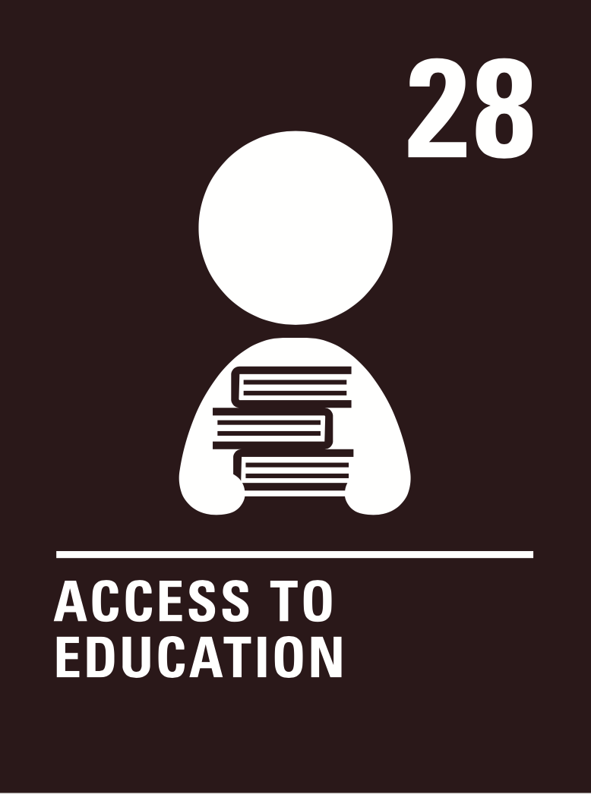  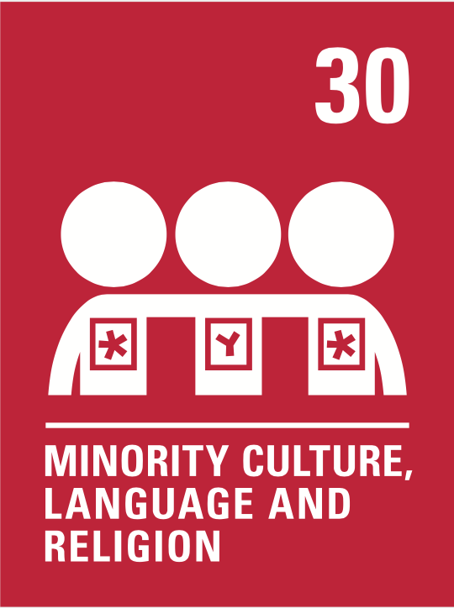  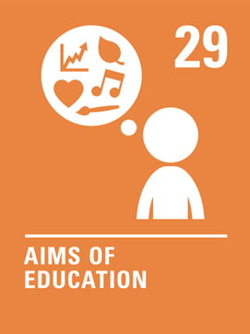  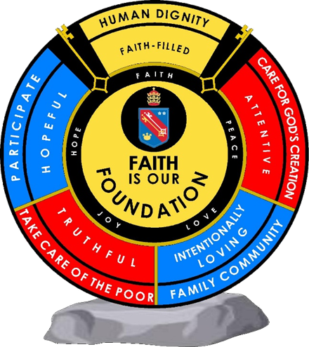  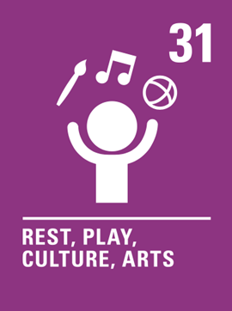  - Students build on the tenses from the previous topic, now adding impersonal verbs and structures.  Human dignity  Truthful  Intentionally loving  Human dignity  Intentionally loving  Human dignity  Intentionally loving  Truthful  Hopeful  Human dignity  Truthful  Intentionally loving  Human dignity  Intentionally loving  Human dignity  Intentionally loving  Truthful  Hopeful | Subject specific skills being developed:  - Reading  - Listening  - Speaking  - Writing  - Giving and justifying opinions  - Present tense conjugations  - Past tense conjugations  - Immediate future tense conjugations  - For Higher Tier students: imperfect, simple future, conditional tenses  - Impersonal and modal verbs | Half Term 3: Aspects if Hispanic society: current trends.  Human dignity  Truthful  Intentionally loving  Human dignity  Intentionally loving  Human dignity  Intentionally loving  Truthful  Hopeful  3 Gender equality  3.1 Women in the labour market  Discuss women in the world of work Study the role of women at home.  3.2 Machismo and feminism  Discuss male chauvinism Look at the role of feminism.  3.3 The rights of gay and transgender people  Understand and talk about changes to LGBT rights.  Discuss gay marriage in Spain and the Hispanic world.  All pupils will be assessed:  - Weekly vocabulary tests  - In-class formative assessment by the teacher every 3 weeks  - Written feedback given on specified pieces of writing throughout the topic.  - Mock examinations in all four skills  Impact - Why do we teach this?  - We continue with a more challenging topic that links well with the previous, recycling many of the same structures.  - We continue to practise the key tenses for each tier, whilst the most confident students learn the subjunctive .. | Subject specific skills being developed:  developed:  - Reading  - Listening  - Speaking  - Writing  - Giving and justifying opinions  - Present tense conjugations  - Past tense conjugations  - Immediate future tense conjugations  - For Higher Tier students: imperfect, simple future, conditional tenses; subjunctive  - Impersonal and modal verbs
 | Reading Skills needed for this unit:  - Reading aloud  - Reading for gist  - Reading for detail  - Sound/spelling links  Key Vocabulary:  See knowledge organisers. |  | Reading Skills needed for this unit:  - Reading aloud  - Reading for gist  - Reading for detail  - Sound/spelling links  Key Vocabulary:  See knowledge organisers. |  | Reading Skills needed for this unit:  - Reading aloud  - Reading for gist  - Reading for detail  - Sound/spelling links  Key Vocabulary:  See knowledge organisers
 | Opportunity for cross-curricular skill development  - Literacy  - Geography  - History  - PSHE |  | Opportunity for cross-curricular skill development  - Literacy  - Geography  - PSHE |  | Opportunity for cross-curricular skill development  - Literacy  - Geography  - PSHE
Half Term 4: Artistic culture in the Hispanic world  4 The influence of idols  4.1 Singers and musicians  Discuss the positive and/or negative influence singers and musicians have on people.  4.2 Television and film stars  Discuss the positive and/or negative effect TV and cinema stars have in our society.  4.3 Models  Consider the type of influence fashion models have on young people.  All pupils will be assessed:  - Weekly vocabulary tests  - In-class formative assessment by the teacher every 3 weeks  - Written feedback given on specified pieces of writing throughout the topic  - Mock examinations in all four skills  Impact – Why do we teach this?  - This topic allows for the consolidation of key structures taught in the previous two topics, including multiple tenses, detailed opinions, impersonal verbs  - Although students tend to find the vocabulary for this topic easier, teaching it towards the end of Year 11 encourages them to use more complex language in their writing and speaking answers than they might perhaps if it were taught earlier, as they can draw on their knowledge from the entire course | Subject specific skills being developed:  - Reading  - Listening  - Speaking  - Writing  - Giving and justifying opinions  - Present tense conjugations  - Past tense conjugations  - Immediate future tense conjugations  - Simple future tense conjugations  - Imperfect tense conjugations  - Impersonal and modal verbs  - Perfect infinitive phrases | Half Term 5: Artistic culture in the Hispanic world  5 Regional identity in Spain  5.1 Traditions and customs  Describe and discuss Spanish customs and traditions.  5.2 Gastronomy  Discuss similarities and differences in the gastronomy of Spain.  5.3 Languages  Consider the languages that are spoken in Spain and the issues surrounding.  All pupils will be assessed:  - Weekly vocabulary tests  - In-class formative assessment by the teacher every 3 weeks  - Written feedback given on specified pieces of writing throughout the topic  - Mock examinations in all four skills  Impact - Why do we teach this?  - This topic draws on many of the phrases learnt throughout the course, particularly those from the future tense topic taught early in Year 10. This allows lots of opportunities to revisit and revise content from across the course as a whole, making it the ideal topic to teach before the examinations begin.  - We continue to practise all the grammar taught over the year in this topic.  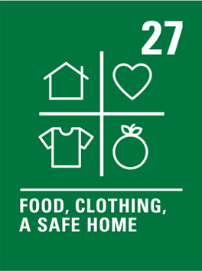  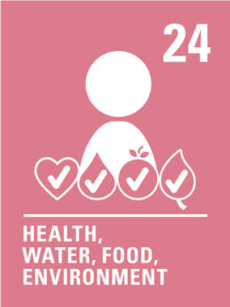  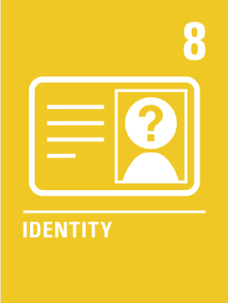  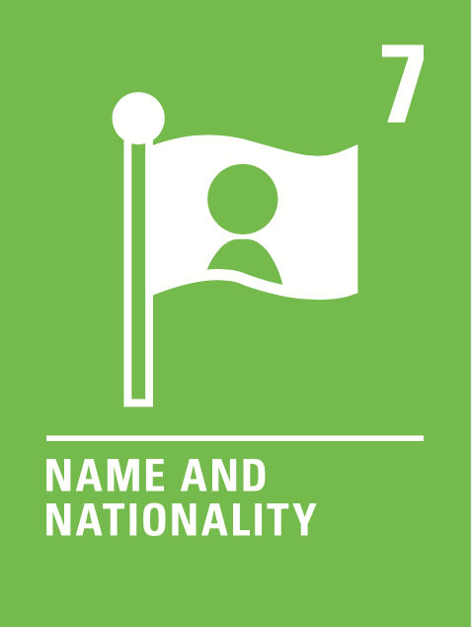  Human dignity  Hopeful  Truthful  Attentive  Intentionally loving  Human dignity  Hopeful  Human dignity  Truthful  Intentionally loving  Human dignity  Truthful  Intentionally loving  Human dignity  Intentionally loving  Human dignity  Intentionally loving  Truthful  Hopeful | Subject specific skills being developed:  - Reading  - Listening  - Speaking  - Writing  - Giving and justifying opinions  - Present tense conjugations  - Past tense conjugations  - Immediate future tense conjugations  - Simple future tense conjugations  - Imperfect tense conjugations  - Conditional tense conjugations | Half Term 6: Artistic culture in the Hispanic world  6.Cultural heritage  6.1 Historical sites and pre-Hispanic civilizations  Understand civilisations that coritributed to the cultural heritage of Spain.  6.2. Art and architecture  Discuss the pre-Columbiari heritage of Latin America.  6.3 Musical heritage and its diversity  Discuss Spanish and Latin American artists and the role of architecture in Spain.  All pupils will be assessed:  - Weekly vocabulary tests  - In-class formative assessment by the teacher every 3 weeks  - Written feedback given on specified pieces of writing throughout the topic  - Mock examinations in all four skills  Impact- Why do we teach this?  - Students will have a series of revision lessons to help with their preparation for the upcoming examinations | Subject specific skills being developed:  - Reading  - Listening  - Speaking  - Writing  - Giving and justifying opinions  - All the grammar taught over the two-year course
 | Reading Skills needed for this unit:  - Reading aloud  - Reading for gist  - Reading for detail  - Sound/spelling links  Key Vocabulary:  See knowledge organisers |  | Reading Skills needed for this unit:  - Reading aloud  - Reading for gist  - Reading for detail  - Sound/spelling links  Key Vocabulary:  See knowledge organisers |  | Reading Skills needed for this unit:  - Reading aloud  - Reading for gist  - Reading for detail  - Sound/spelling links  Key Vocabulary:  See knowledge organisers
 | Opportunity for cross-curricular skill development  - Literacy  - PSHE  - History |  | Opportunity for cross-curricular skill development  - Literacy  - PSHE  - Geography |  | Opportunity for cross-curricular skill development  - PSHE  - Literacy
Ensuring this curriculum meets the needs of all pupils: this curriculum has been designed to ensure pupils from all starting points will develop the key curriculum skills and knowledge identified. The curriculum design ensures that each unit forms part of the overall learning journey and there are opportunities for revisiting skills and linking together key pieces of knowledge. Whole Academy policies and practices are followed to tailor the delivery of the curriculum for individuals and groups of students. For example SEND students have individual learning profiles that outline needs/strategies to be used, Whole group RIPs are in place to identify key teaching strategies that will be used with individual teaching groups. Ongoing formative assessment and clear summative assessment points allow individual staff and departments to identify misconception and adjust curriculum appropriately.
Enrichment opportunities:
- Learning about Hispanic cultures, trips, online extracurricular cultural activities.
Career opportunities/ links: What can I do with a modern languages degree? | Prospects.ac.uk
whole school careers and MFL presentations. Jobs in the tourist sector (where around the French or Spanish speaking world could you work); translation (skills needed to work in this industry).
Film study: Along with the curriculum we will study the movie “Volver” from December spread out through out the rest of the year.

