Year 13 Spanish Curriculum and Assessment Plan for MFL

The curriculum and assessment of pupils at this stage of education has been carefully designed to promote deep learning of grammar and vocabulary on a range of topics required to develop students into confident and established linguists by the end of KS5 who make excellent progress and succeed in the A Level course.
Throughout this year, we aim to help our students become confident linguists, enabling them to feel prepared for their A Level examination. We begin the AQA A Level Spanish course, building on core vocabulary and grammar taught at KS4, whilst raising the level of challenge to allow students to communicate more complex ideas with detail. Finally, we ensure that key exam skills are interwoven throughout the topics so that students feel prepared when approaching the summer examinations.
Half Term 1: Multiculturalism in Hispanic society.  1 Immigration  1.1 The benefits and negative aspects  Discuss the positive and negative aspects of immigration.  1.2 Immigration in the Hispanic world  Learn more about immigration in the Spanish-speaking world.  1.3 The undocumented - problems  Discuss what problems illegal migrants might face.  All pupils will be assessed:  - Weekly vocabulary tests  - In-class formative assessment by the teacher every 3 weeks  - Written feedback given on specified pieces of writing throughout the topic.  - Mock examinations in all four skills  Impact - Why do we teach this?  - This is the topic students often find the most challenging, so we teach this after we have ensured a confident start to the year.    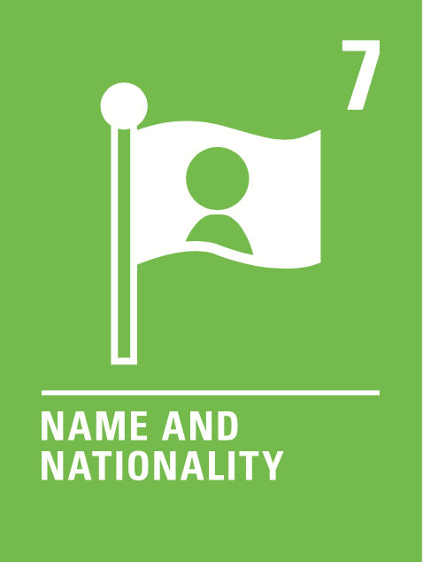    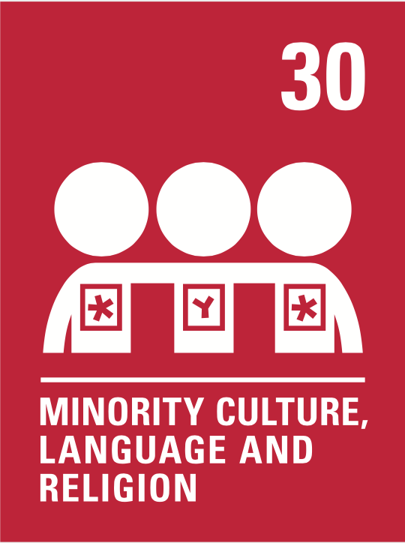  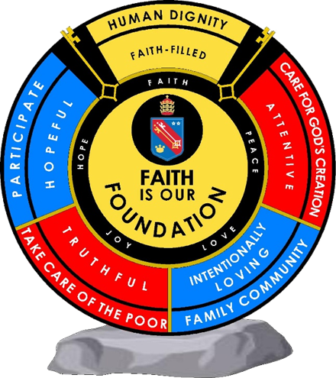  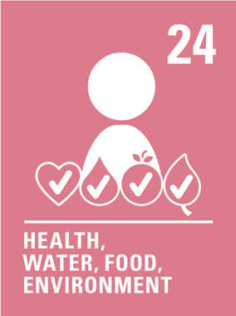    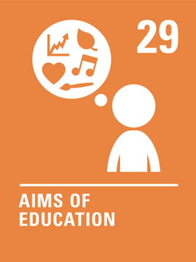  Students build on the tenses from the previous topic, now adding impersonal verbs and structures.  Human dignity  Truthful  Intentionally loving  Human dignity  Hopeful  Intentionally loving  attentive  Human dignity  Hopeful  Truthful  Attentive  Intentionally loving | Subject specific skills being developed:  - Reading  - Listening  - Speaking  - Writing  - Understand more complex grammar terminology and key expressions.  - Giving and justifying opinions  - Giving pros and cons  - Demonstrate independence using a Spanish online dictionaries and websites for research.  - Participate in conversations in front of others.  - Asking questions.  - Translation techniques.  - Course organisation skills. | Half Term 2: Multiculturalism in Hispanic society.  2 Racism  2.1 Racist and xenophobic attitudes  Describe and discuss racist and xenophobic attitudes in the Spanish- speaking world.  2.2 Measures against racism  Understand and discuss measures to combat racism and their effectiveness.  2.3 Anti-racist legislation  Look at existing legislation against racism Discuss possible new legislation.  All pupils will be assessed:  - Weekly vocabulary tests  - In-class formative assessment by the teacher every 3 weeks  - Written feedback given on specified pieces of writing throughout the topic.  - Mock examinations in all four skills  Impact - Why do we teach this?  - This is the topic students often find the most challenging, so we teach this after we have ensured a confident start to the year.  - Students build on the tenses from the previous topic, now adding impersonal verbs and structures. | Subject specific skills being developed:  - Reading  - Listening  - Speaking  - Writing  - Giving and justifying opinions  - Present tense conjugations  - Past tense conjugations  - Immediate future tense conjugations  - For Higher Tier students: imperfect, simple future, conditional tenses  - Impersonal and modal verbs | Half Term 3: Multiculturalism in Hispanic society.  3 Coexistence  3.1 The coexistence of cultures  Understand and describe the different ways cultures integrate in Hispanic society.  3.2 Education  Understand and describe the issues surrounding the integration of different cultures within the sphere of education.  3.3 Religions  Understand and describe the coexistence of various religions in the Hispanic world.  All pupils will be assessed:  - Weekly vocabulary tests  - In-class formative assessment by the teacher every 3 weeks  - Written feedback given on specified pieces of writing throughout the topic.  - Mock examinations in all four skills  Impact - Why do we teach this?  - We continue with a more challenging topic that links well with the previous, recycling many of the same structures.  - We continue to practise the key tenses for each tier, whilst the most confident students learn the subjunctive .. | Subject specific skills being developed:  developed:  - Reading  - Listening  - Speaking  - Writing  - Giving and justifying opinions  - Present tense conjugations  - Past tense conjugations  - Immediate future tense conjugations  - For Higher Tier students: imperfect, simple future, conditional tenses; subjunctive  - Impersonal and modal verbs
 | Reading Skills needed for this unit:  - Reading aloud  - Reading for gist  - Reading for detail  - Sound/spelling links  Key Vocabulary:  See knowledge organisers. |  | Reading Skills needed for this unit:  - Reading aloud  - Reading for gist  - Reading for detail  - Sound/spelling links  Key Vocabulary:  See knowledge organisers. |  | Reading Skills needed for this unit:  - Reading aloud  - Reading for gist  - Reading for detail  - Sound/spelling links  Key Vocabulary:  See knowledge organisers
 | Opportunity for cross-curricular skill development  - Literacy  - Geography  - History  - PSHE  - Catholic values  - British values  - History  - DT |  | Opportunity for cross-curricular skill development  - Literacy  - Geography  - PSHE  - Catholic values  - British values  - History  - DT |  | Opportunity for cross-curricular skill development  - Literacy  - Geography  - History  - PSHE  - Catholic values  - British values
Half Term 4: Artistic culture in the Hispanic world  4 Youth of today, citizens of tomorrow  4.1 Young people and their attitude towards politics: activism or apathy  Discuss the importance of politics in young people's lives Understand why their attitude to politics is changing.  4.2 Youth unemployment  Discuss the unemployment situation amongst young people nowadays and how it is affecting them.  4.3 Your ideal society  Describe and discuss the type of society young people in the Hispanic world want to live in.  All pupils will be assessed:  - Weekly vocabulary tests  - In-class formative assessment by the teacher every 3 weeks  - Written feedback given on specified pieces of writing throughout the topic.  - Mock examinations in all four skills  Impact – Why do we teach this?  - This topic allows for the consolidation of key structures taught in the previous two topics, including multiple tenses, detailed opinions, impersonal verbs.  - Although students tend to find the vocabulary for this topic easier, teaching it towards the end of Year 11 encourages them to use more complex language in their writing and speaking answers than they might perhaps if it were taught earlier, as they can draw on their knowledge from the entire course.  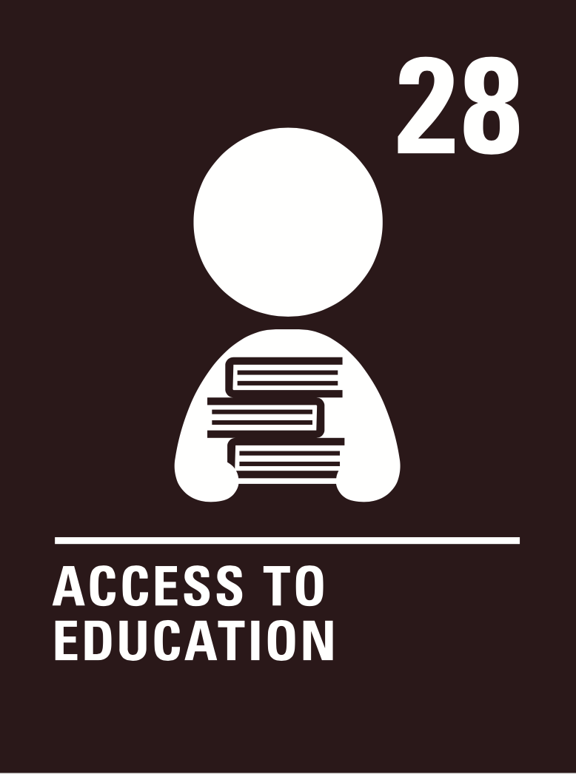  Human dignity  Hopeful  Truthful  Attentive  Intentionally loving | Subject specific skills being developed:  - Reading  - Listening  - Speaking  - Writing  - Giving and justifying opinions  - Present tense conjugations  - Past tense conjugations  - Immediate future tense conjugations  - Simple future tense conjugations  - Imperfect tense conjugations  - Impersonal and modal verbs  - Perfect infinitive phrases | Half Term 5: Artistic culture in the Hispanic world  5 Monarchies and dictatorships  5.1 Franco's dictatorship  Understand the impact of the civil war Discuss life under Franco's dictatorship.  5.2 The evolution of the monarchy in Spain  Describe and discuss the changes from monarchy and republic to dictatorship Describe the transition from dictatorship to monarchy.  5.3 Latin American dictators  Discuss dictatorships in Latin America, particularly in Panama, Chile, and Argentina.  All pupils will be assessed:  - Weekly vocabulary tests  - In-class formative assessment by the teacher every 3 weeks  - Written feedback given on specified pieces of writing throughout the topic.  - Mock examinations in all four skills  Impact - Why do we teach this?  - This topic draws on many of the phrases learnt throughout the course, particularly those from the future tense topic taught early in Year 10. This allows lots of opportunities to revisit and revise content from across the course, making it the ideal topic to teach before the examinations begin.  - We continue to practise all the grammar taught over the year in this topic.  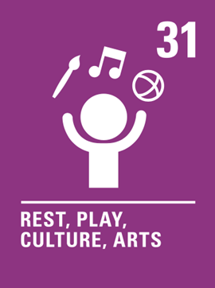  Human dignity  Hopeful  Truthful  Attentive  Intentionally loving  Human dignity  Hopeful  Truthful  Attentive  Intentionally loving | Subject specific skills being developed:  - Reading  - Listening  - Speaking  - Writing  - Giving and justifying opinions  - Present tense conjugations  - Past tense conjugations  - Immediate future tense conjugations  - Simple future tense conjugations  - Imperfect tense conjugations  - Conditional tense conjugations | Half Term 6: Artistic culture in the Hispanic world  6 Popular movements  6.1 The effectiveness of demonstrations and strikes  Consider and discuss how effective protests and strikes are.  6.2 The power of unions  Describe and discuss the power of trade unions.  6.3 Examples of social protests  Consider and discuss the 15-M Movement in Spain and the mothers of the Plaza de Mayo in Argentina.  All pupils will be assessed:  - Weekly vocabulary tests  - In-class formative assessment by the teacher every 3 weeks  - Written feedback given on specified pieces of writing throughout the topic.  - Mock examinations in all four skills  Impact- Why do we teach this?  - Students will have a series of revision lessons to help with their preparation for the upcoming examinations | Subject specific skills being developed:  - Reading  - Listening  - Speaking  - Writing  - Giving and justifying opinions  - All the grammar taught over the two-year course
 | Reading Skills needed for this unit:  - Reading aloud  - Reading for gist  - Reading for detail  - Sound/spelling links.  Key Vocabulary:  See knowledge organisers. |  | Reading Skills needed for this unit:  - Reading aloud  - Reading for gist  - Reading for detail  - Sound/spelling links.  Key Vocabulary:  See knowledge organisers. |  | Reading Skills needed for this unit:  - Reading aloud  - Reading for gist  - Reading for detail  - Sound/spelling links.  Key Vocabulary:  See knowledge organisers.
 | Opportunity for cross-curricular skill development  - Literacy  - PSHE  - History  - Catholic values  - British values  - History |  | Opportunity for cross-curricular skill development  - Literacy  - PSHE  - Geography |  | Opportunity for cross-curricular skill development  - PSHE  - Literacy
Ensuring this curriculum meets the needs of all pupils: this curriculum has been designed to ensure pupils from all starting points will develop the key curriculum skills and knowledge identified. The curriculum design ensures that each unit forms part of the overall learning journey and there are opportunities for revisiting skills and linking together key pieces of knowledge. Whole Academy policies and practices are followed to tailor the delivery of the curriculum for individuals and groups of students. For example, SEND students have individual learning profiles that outline needs/strategies to be used, Whole group RIPs are in place to identify key teaching strategies that will be used with individual teaching groups. Ongoing formative assessment and clear summative assessment points allow individual staff and departments to identify misconception and adjust curriculum appropriately.
Enrichment opportunities:
- Learning about Hispanic cultures, trips, online extracurricular cultural activities.
Career opportunities/ links: What can I do with a modern languages degree? | Prospects.ac.uk
whole school careers and MFL presentations. Jobs in the tourist sector (where around the French or Spanish speaking world could you work); translation (skills needed to work in this industry).
Film study: Along with the curriculum we will study the book “ La casa de Bernarda Abla”.

Human dignity
Hopeful
Truthful
Attentive
Intentionally loving
Human dignity
Hopeful
Truthful
Attentive
Intentionally loving
Human dignity
Hopeful
Truthful
Attentive
Intentionally loving

