Curriculum Booklet

Activities to complete to prepare you for St. Peter’s…


Welcome to St Peter’s!

To get you ready for year 7, teachers at St Peter’s have designed lots of tasks for you to complete.
There is a lot of work in this booklet, but you do not have to complete all of the work. Choose the tasks that you like the look of and complete them to the best of your ability.
We can’t wait to see what you have done.
See you in September.
Contents page

Page 2 – Drama
Page 3 – Music
Page 4 – English
Page 5 – MFL
Page 9 – ICT
Page 11 – Art and DT
Page 13 – Maths
Page 14 – History
Page 16 – PE
Page 21 – RE
Page 22 – Geography
Page 27 – Science

Drama

Create both a storyboard and a script for your own theme park or ride.
Stage 1 – Research
Watch as many different theme park adverts on YouTube as you can. (I.e. Disney World, Alton Towers, Drayton Manor). Answer the following questions about them.
- What activities do you see the people in the advert doing?
- What emotions do you think they are all experiencing?
- What type of rides do you see in the advert?
- Do they include any special offers within their adverts? (Give an example)
- How do they make the atmosphere of the theme park feel exciting? (Talk about the music, the colours, and the activities shown)

Stage 2 – Storyboard
Create a story board that could be used to create your own advert for your own theme park.
Things to consider:
- Who are your park guests in the advert going to be?
- What activities/rides are they going to do? (different one per panel or will you focus on one attraction)
- How long will each scene (or panel) last?
- How are you going to make the emotions of the park guests clear? (You want the audience to see them enjoying themselves)

Stage 3 – Script
You may have noticed that there is a narrator in most of the adverts that your researched. Create a script for your advert so that the person doing the voice over knows what to say about your theme park.
Things you might want to consider:
- Keep it short, sharp and snappy
- What special offers can you include
- Stage directions (pauses, emotions, etc.)
- Use exciting descriptions of the ride(s) in your advert to entice people to visit?

Music Challenge

Choose one or more of the tasks and email to office@st-peters.solihull.sch.uk. Blue cards will be awarded for those who put time and effort into these tasks- good luck!

Create a short recording playing an instrument or singing. This is to show your teachers the musical skills you have from your primary school. This could be from a school production or an event that you have performed at, or something you record at home in your house!

Create a power point to show us the music that you like to listen to. Create a slide for each of your five favourite songs. Include a YouTube clip of the song and a description of why you like each song.

Composition task: Share some song lyrics that you have written, or some beats you have made using music ICT. E.g.: on GarageBand.



English

When you join us at St Peter’s in September, you will unlock a world of fresh challenges and exciting new opportunities. But what is it that you are most eager to experience?

Create a spider diagram of all the things that excite you about joining St Peter’s. Think about:
- the new skills you will learn.
- the new people you will meet.
- the new opportunities you will have.
- what being part of our school community means.
- how you will be able to continue to develop your relationship with God.

Studying a wider array of subjects like drama, design technology, art and cooking.



Use these ideas to write a short description of St Peter’s, focusing on all of the things that you are most excited about experiencing. You can use the first two sentences to help you to start.
Think about:
- your word choices- are they effective and ambitious?
- your punctuation- have you used ambitious punctuation in your description?
- using figurative techniques to develop your description, e.g., similes, metaphors, and personification.

Behind the gates of St Peter’s lies a world of wonder and excitement ready to be explored. In every classroom curiosity dances in the air and knowledge blooms like flowers in springtime.Students…____________________________________________________________________________________________________________________________________________________________________________________________________________________________________________________________________________________________________

Modern Foreign Languages

Spanish Reading Comprehension based on the first unit studied in Year 7.

Hola, me llamo Clara. Tengo un hermano se llama Carlos. Vivo en Birmingham que es una ciudad grande en el centro de Inglaterra. Me gustaría vivir en Solihull que es un pueblo grande.
Hola, soy Carlos. Clara es mi hermana. Vivo en Bristol que es una ciudad grande en el oeste de Inglaterra. Sin embargo, me gustaría vivir en Londres que es una ciudad grande en el sur de Inglaterra.
Me llamo Cristina. Soy la hermana de Clara y Carlos. Resido en Liverpool que es una ciudad grande en el norte de Inglaterra. Pero me gustaría vivir en Dickens Heath que es un pueblo pequeño.
Read the text and answer the following questions in English:

- Where does Clara live?
- How does Clara describe where she lives?
- How does Clara describe Solihull?
- Where does Carlos live?
- Where would Carlos like to live?
- How does Carlos describe London?
- Where does Cristina live?
- How does Cristina describe where she lives?
- How does Cristina describe where she would like to live?
10. What is the family relation between Clara, Carlos and Cristina?

French Reading Comprehension based on the first unit studied in Year 7.

Bonjour, je m’appelle Clara. J’ai un frère qui s’appelle Gabriel. J’habite à Birmingham qui est une grande ville dans le centre de l’Angleterre. Je voudrais habiter à Solihull qui est un grand village.
Bonjour, je m’appelle Gabriel. Clara est ma sœur. Je vis à Bristol qui est une grande ville dans l’ouest de l’Angleterre. Cependant, je voudrais habiter à Londres qui est une grande ville dans le sud de l’Angleterre.
Je m’appelle Marie. Je suis la sœur de Clara et Gabriel. Je vis à Liverpool qui est une grande ville dans le nord de l’Angleterre. Mais je voudrais habiter à Dickens Heath, qui est une petite ville.

Read the text and answer the following questions in English:

Where does Clara live?
How does Clara describe where she lives?
How does Clara describe Solihull?
Where does Gabriel live?
Where would Gabriel like to live?
How does Gabriel describe London?
Where does Marie live?
How does Marie describe where she lives?
How does Marie describe where she would like to live?
What is the family relation between Clara, Gabriel and Marie?

Answers (Spanish):
- Clara lives in Birmingham
- A big city in the centre of England
- Solihull is a big town
- Carlos lives in Bristol
- He would like to live in London
- A big city in the south of England
- Cristina lives in Liverpool
- She would like to live in Dickens Heath
- A small town
10.They are all siblings (brothers and sisters)

Answers (French):
- Clara lives in Birmingham
- A big city in the centre of England
- Solihull is a big town
- Gabriel lives in Bristol
- He would like to live in London
- A big city in the south of England
- Marie lives in Liverpool
- She would like to live in Dickens Heath
- A small town
10. They are all siblings (brothers and sisters)

Verb | Place | Connective and verb | Description | Location
Vivo  (I live)  Resido  (I live)  Me gustaría vivir  (I would like to live) | en Birmingham  (in Birmingham)  en Bristol  (in Bristol)  en Dickens Heath  (in Dickens Heath)  en Liverpool  (in Liverpool)  en Londres  (in London)  en Manchester  (in Manchester)  en Solihull  (in Solihull) | que es  (which is) | una ciudad grande  (a big town/city)  una ciudad pequeña  (a small town/city)  un pueblo grande  (a big village)  un pueblo pequeño  (a small village) | en el norte de Inglaterra  (in the north of England)  en el sur de Inglaterra  (in the south of England)  en el este de Inglaterra  (in the east of England)  en el oeste de Inglaterra  (in the West of England)  en el centro de Inglaterra  (in the centre of England)
¿Cómo es tu pueblo? What is your town like? (Spanish)

Sentence starters to help build vocabulary…
Comment est ta ville ? What is your town like? (French)

Verb | Place | Connective and verb | Description | Location
J’habite  (I live)  Je vis  (I live)  Je voudrais habiter  (I would like to live) | à Birmingham  (in Birmingham)  à Bristol  (in Bristol)  à Dickens Heath  (in Dickens Heath)  à Liverpool  (in Liverpool)  à Londres  (in London)  à Manchester  (in Manchester)  à Solihull  (in Solihull) | qui est  (which is) | une grande ville  (a big town/city)  une petite ville  (a small town/city)  un grand village  (a big village)  un petit village  (a small village) | dans le nord de l’Angleterre  (in the north of England)  dans le sud de l’Angleterre  (in the south of England)  dans l’est de l’Angleterre  (in the east of England)  dans l’ouest de l’Angleterre  (in the West of England)  dans le centre de l’Angleterre  (in the centre of England)

ICT

Mobile phones have developed at an incredible rate over the last few years.
They are getting smaller and smarter. It wasn’t that long ago that all you could do was to make a call. But now you can connect to the internet, listen to music, watch films, use apps etc.
Wearable technology is the latest innovation and we keep hearing that we may well be ‘wearing’ our phones in the not too distant future. The introduction of smart watches has seen this become real life already.
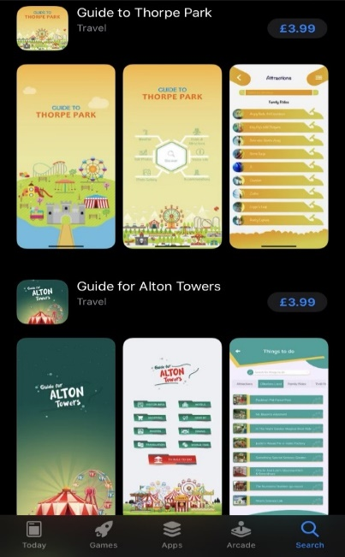
We’d like you to design a mobile app you think Year 7 would be interested in.

Planning your app
How will users control your app? Type, swipe, camera, speech recognition? Explain your choice.

What is the purpose of the app? How will the app help new Year 7s?

Write a description of your app. This description will appear on the app store so make sure your description helps to sell your app.

Designing your app

Designing your app. In the below boxes draw the following –
- Home Screen – this is the page that will a user will first see when they open the app
- Menu Screen – What will the main menu look like and what options will it give the user

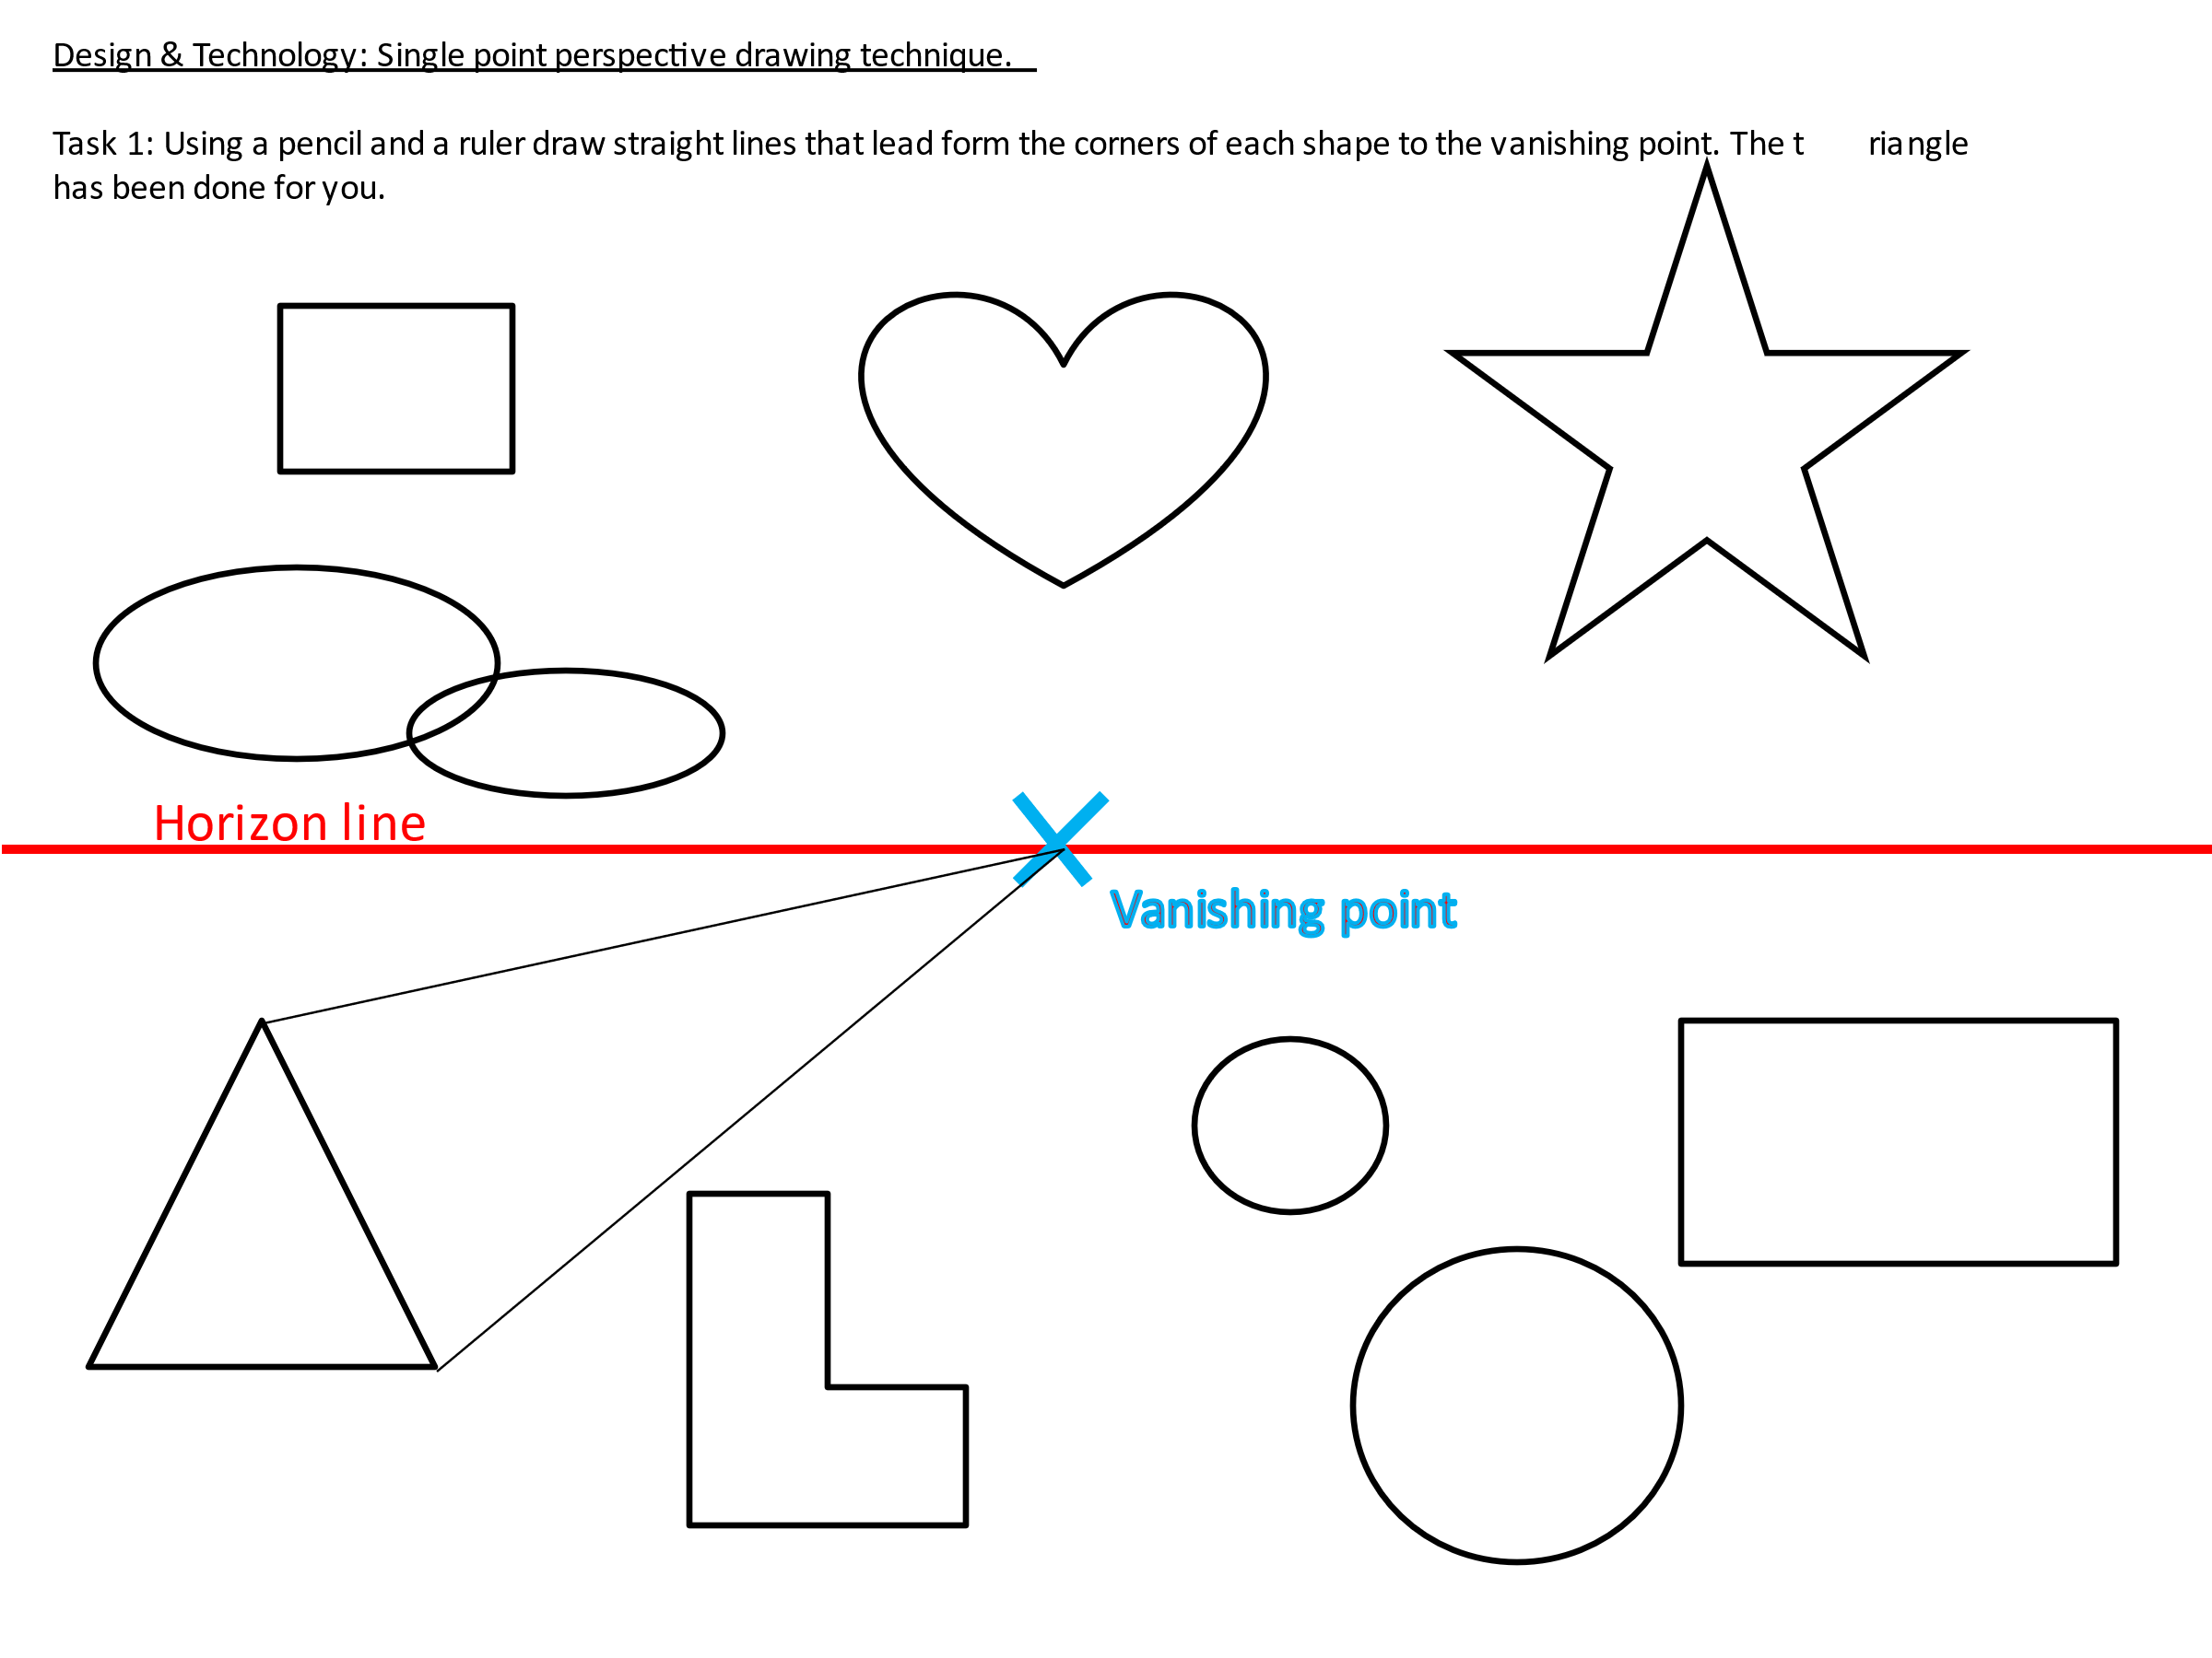
Art and DT

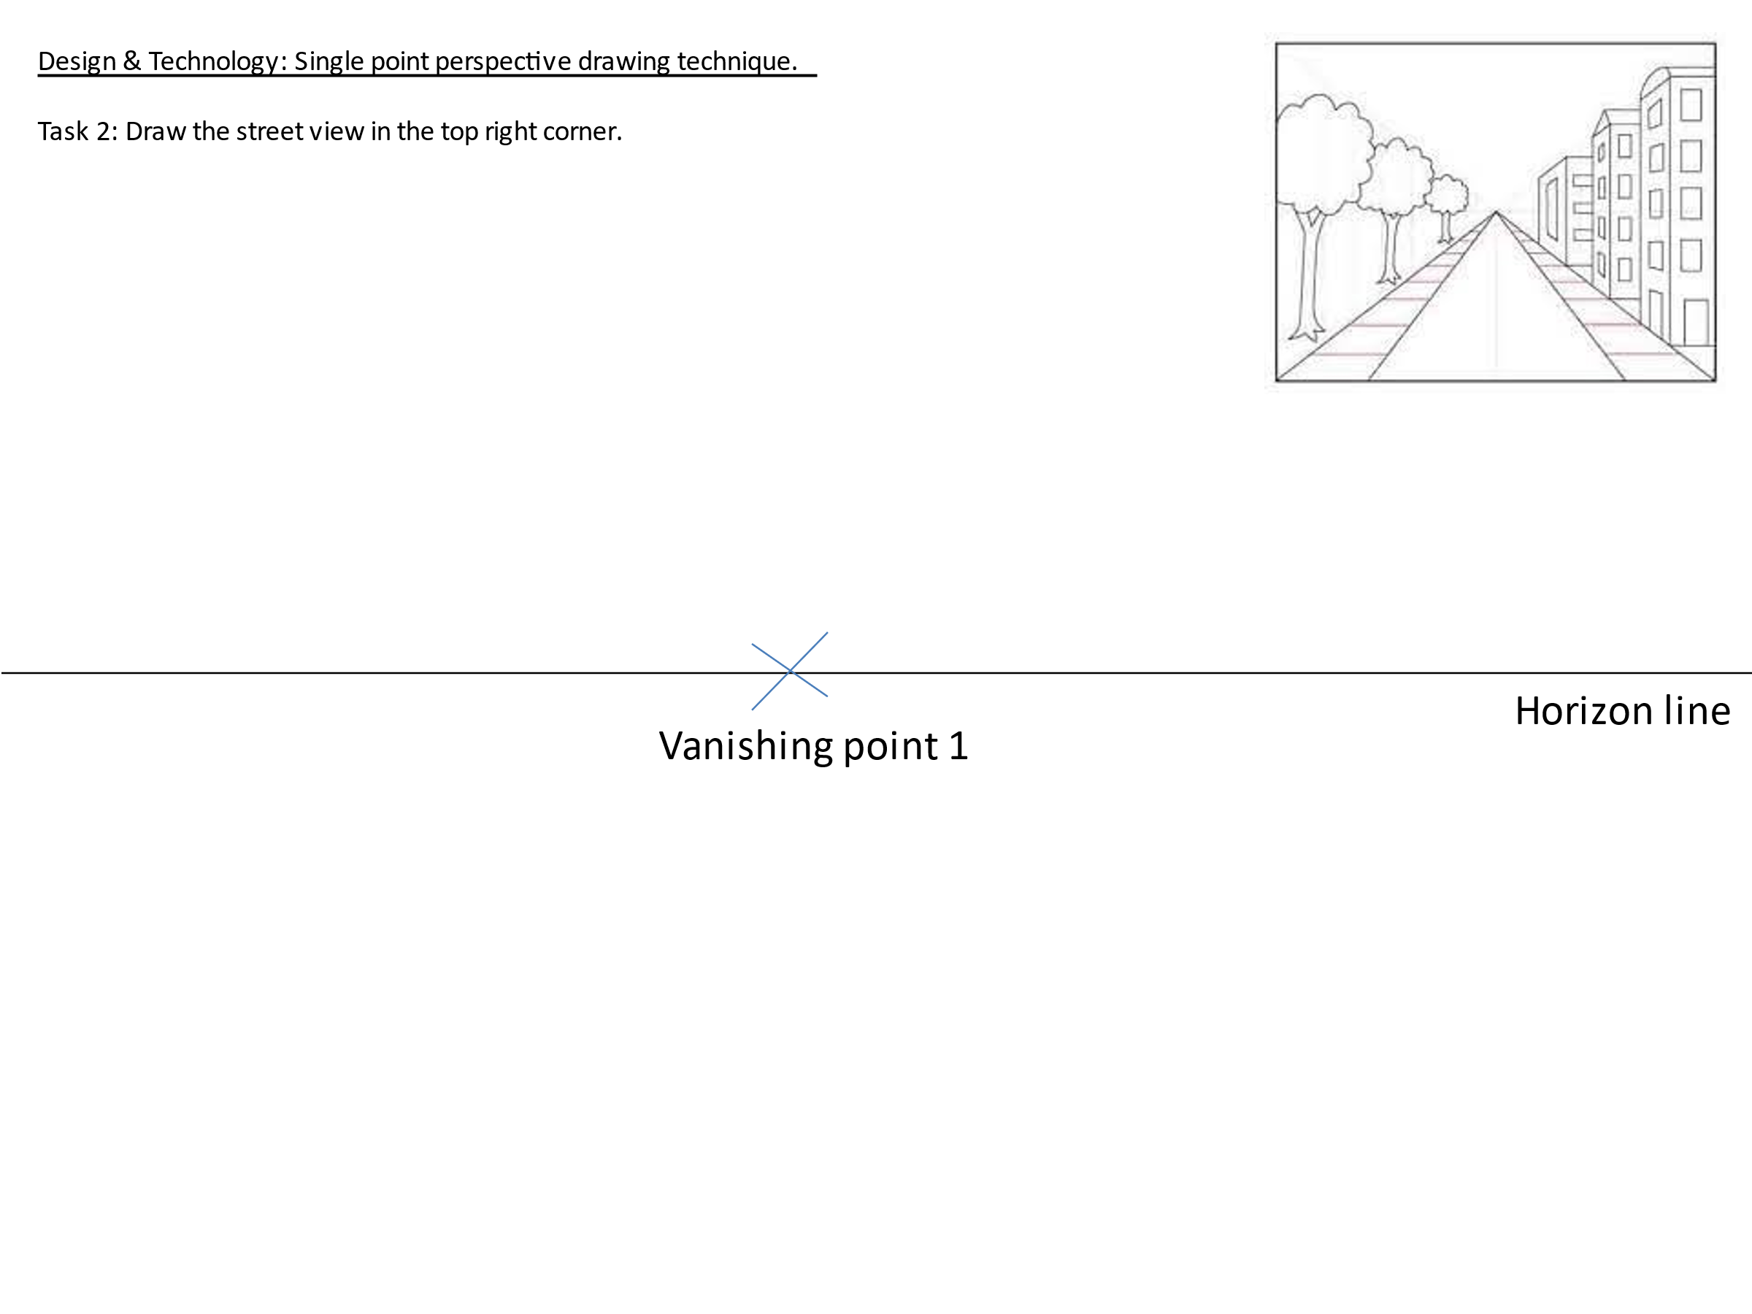

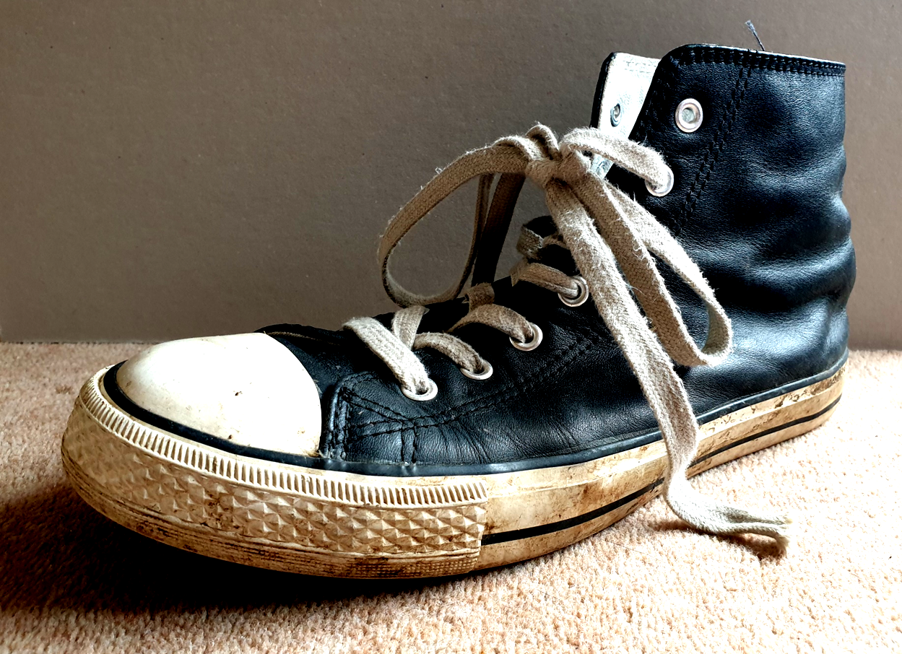

Tonal Observational Study of Footwear
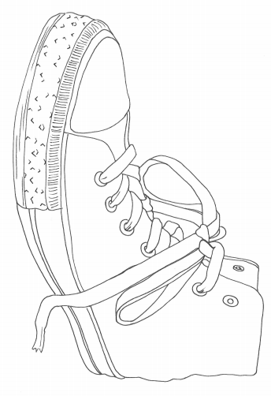
Task:

Using only a pencil, shade in this picture to create the different values of dark and light tones.

Maths

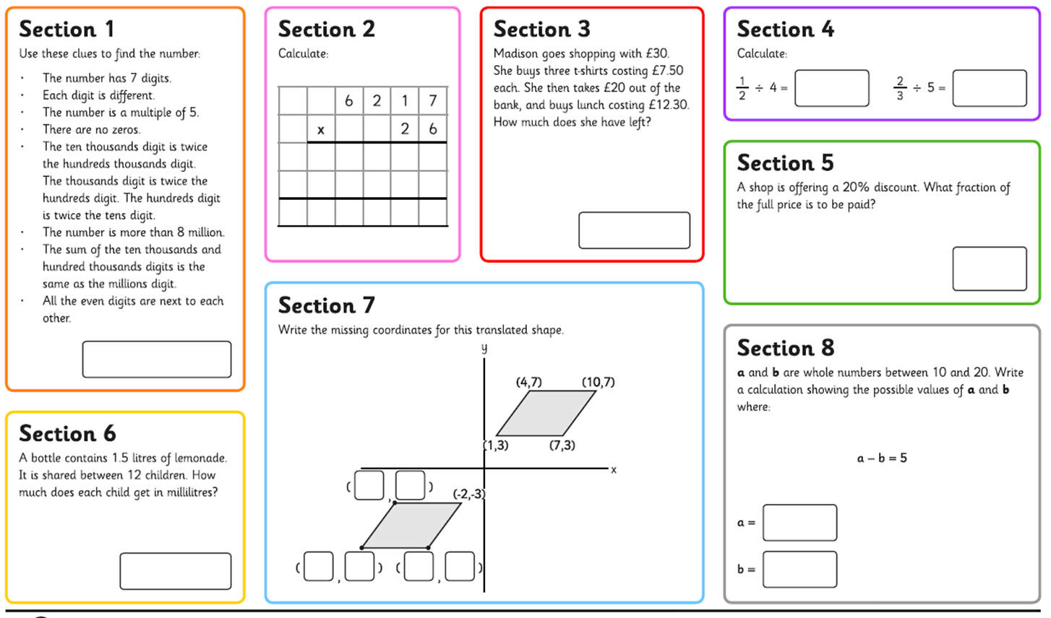

History
Choose your challenge from the menu:

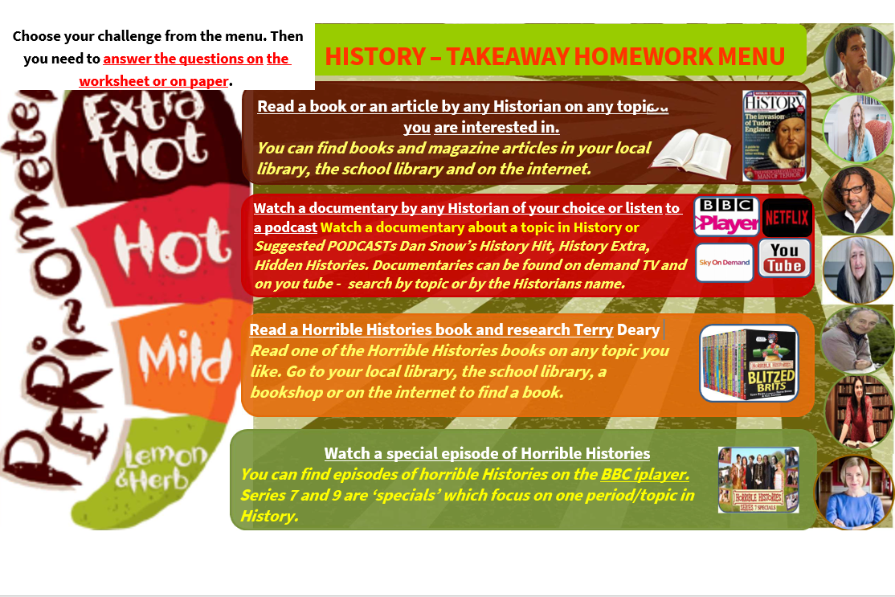

Q1 – Which task did you choose?  Q2 – What was the Historical topic? | Q3 – When was this source of information made?  Q4 – Who made this source of information (e.g. the name of the Historian who wrote it or the presenter in the documentary). | Write down 10 things that you have learnt about your chosen topic from the source of information.
Q5 – Where did you find this source of information? | Q7 – Information about the Historian – Research who made the source of information. For example, if it is was a Historian can you find more information about them? For example…  What is their specialist topic?  What University did they go to?  What other sources of information have they made?  What other jobs do they have?

PE

Creating a warmup

Task: using this resource you need to create an effective three part warm up for your peers. A three-part warm up includes:
- Pulse Raiser
- Stretches
- Sport Specific Activity

You will need to decide on a sport that your participants are warming up for.
Pulse Raiser

________________________________________________________________________________________________________________________________________________________________________________________________________________________________________________________________________________________________________________________________________________________________________________________________________________________________________________________________________________________________________________________________________________________________________________________________________________________________________________________________________________________________________________

Stretches

______________________________________________________________________________________________________________________________________________________________________________________________________________________________________________________________________________________________________________________________________________________________________________________________________________________________________________
Sport Specific Activity

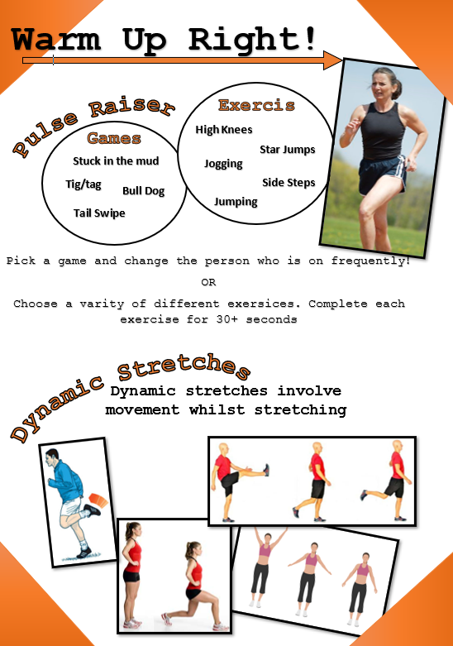

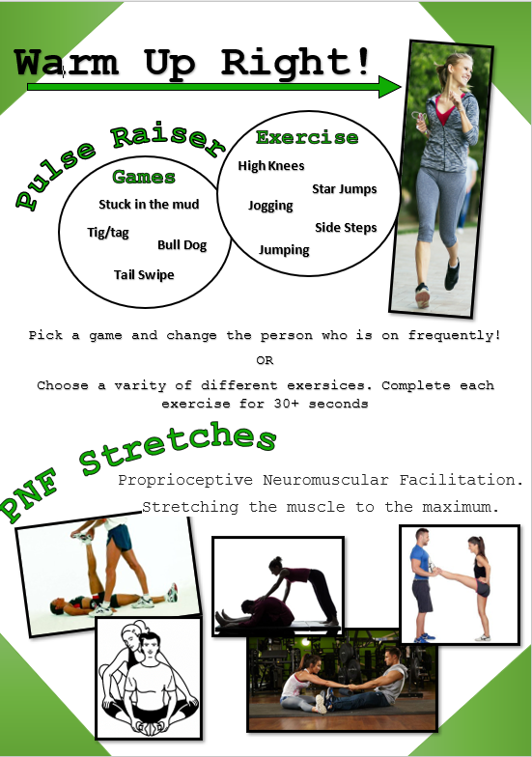

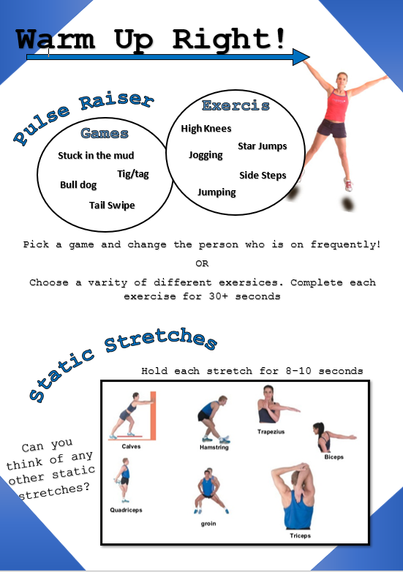

RE

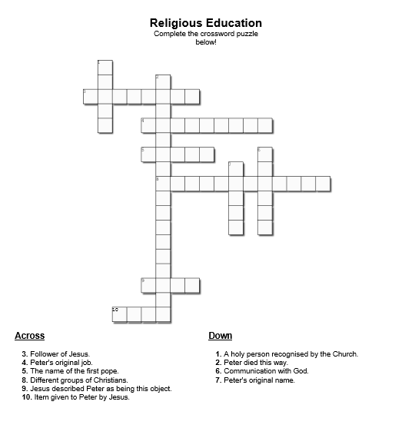

Geography

The top of most maps is north and a compass can be used to find which direction north is. Compasses show four directions - north, east, south and west.
The needle always points north, so when that is lined up with the map it is easy to see in which direction things are.

Task 1- Compass points
1.Add North, East, South and West to the correct points on the 4-point compass.
2. Add North, South, East, West, North East, North West, South East and South West to the 8 point compass.
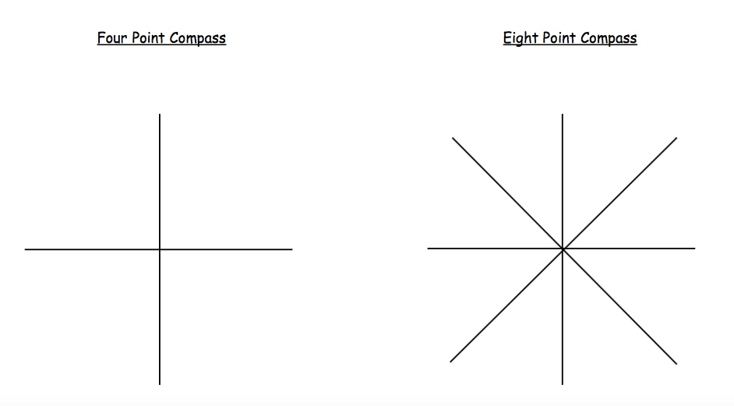

Task 2: Using Direction
Follow the directions to find the key words:
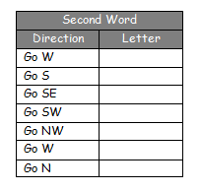
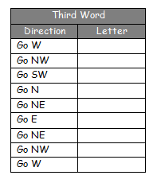
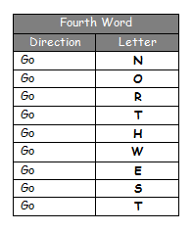
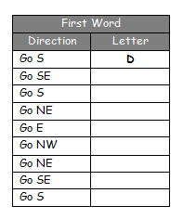
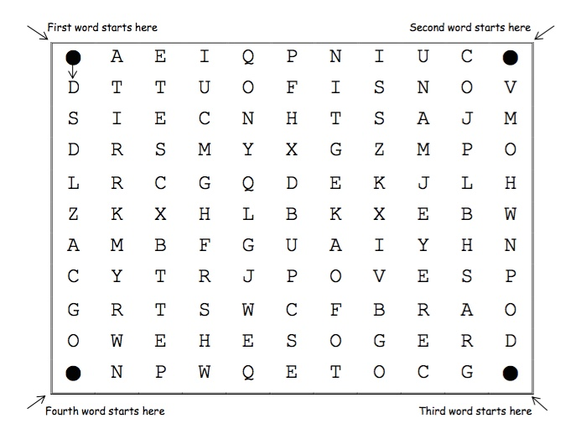

Task 3- Symbols
Symbols are generally the same on most types of map. For example, buildings or tourist attractions are shown with blue symbols. Different types of roads are shown in different colors - blue for a motorway, red for a main road and yellow or orange for narrower roads. Dotted green lines are usually used to show footpaths.
Match the symbols to the correct description
 |  | School
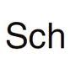 |  | Place of worship
 |  | Parking
 |  | Railway Station
 |  | Campsite

Task 4- Grid References
A grid of squares helps the map-reader to locate a place. The vertical lines are called eastings. They are numbered - the numbers increase to the east. The horizontal lines are called northings as the numbers increase in an northerly direction.

Things to remember:
- When you give a grid reference, always give the easting first: "Along the corridor and up the stairs".
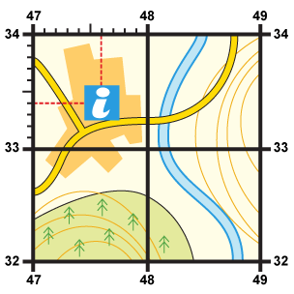
Four-figure grid references can be used to pinpoint a location to within a square. To find the number of the square:
- Start at the left-hand side of the map and go east until you get to the bottom-left-hand corner of the square you want. Write this number down.
- Move north until you get to the bottom-left corner of the square you want. Look at the number of this grid line and add it to the two-digit number you already have.
- This is your four-figure grid reference.
- In this case, the tourist information office is in grid square 4733.
Sometimes it is necessary to be even more accurate. In this case you can imagine that each grid is divided into 100 tiny squares. The distance between one grid line and the next is divided into tenths.
- First, find the four-figure grid reference but leave a space after the first two digits.
- Estimate or measure how many tenths across the grid square your symbol lies. Write this number after the first two digits.
- Next, estimate how many tenths up the grid square your symbol lies. Write this number after the last two digits.
- You now have a six-figure grid reference. In this instance, the tourist information office is located at 476334.

Put your new skills to use and design your school map for St Peter’s

Task 1- Add a compass to your St Peter’s school map. Remember the top of the map is usually north.

Task 2- Create your own map symbols. Add these symbols to the key underneath your map.

Task 3- Starting from the entrance of the school give visitors directions to key areas for example the toilets, subject areas. Remember to use your eight compass points to describe the directions your visitors should take.
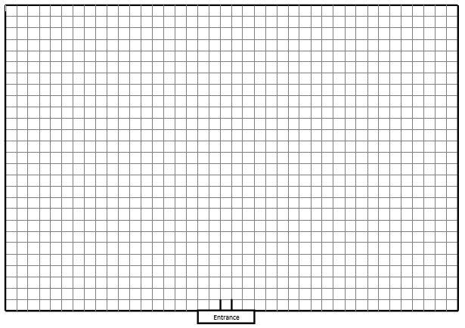
Task 4- Add the grid reference to the school map. You will need to add grid numbers to your map before you begin. Try to use six figure grid references to make sure you are giving visitors the precise location for each ride and attraction.

Key

Science

You are going to try out an experiment:
Watch this link: https://www.youtube.com/watch?v=hQ9JPQN87pI
A few key ideas:
The mass of an object is how much ‘stuff’, or matter it is made of (and is measured in grams or kilograms).
Mass is not a force. The mass of an object (how much of it there is) doesn't change but the weight of it can change. Weight is a force - the measure of gravity's pull on the mass of an object – so if gravity changes then the weight of an object will change.
Weight is measured in Newtons (N)
Watch this link: http://www.bbc.co.uk/education/clips/zhmqxnb
Can you match up these key words and their definitions?
Acceleration |  | something which could change in value, such as time or temperature
Air resistance |  | an increase in speed
Data |  | something which will affect either the movement or shape of an object
Deceleration |  | the force on an object due to gravity
Drag |  | bits of information you have gathered about something you are investigating
Evidence |  | a force which resists motion through a fluid, a fluid being anything that can flow e.g. liquids, gases
Friction |  | a force which resists motion through water
Force |  | a decrease in speed
Gravity |  | information or measurements you use to help you come to a conclusion
Motion |  | a move or change in position
Variables |  | a force which resists the motion of objects sliding over each other
Water resistance |  | attraction between physical objects, easily noticeable when one of the objects is massive, such as the Earth
Weight |  | a force which resists motion through air

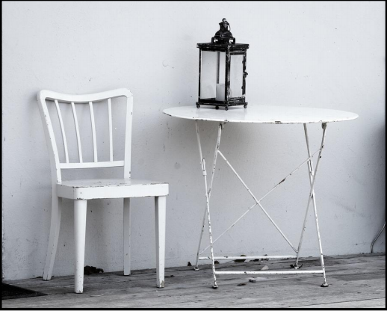
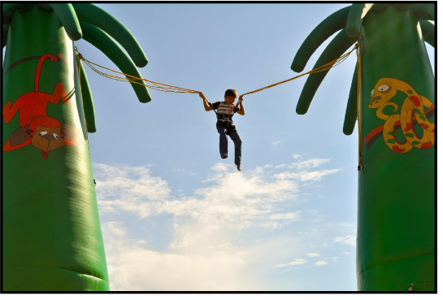
Draw labelled arrows showing the direction of gravity and resistance forces.
Are the forces balanced or unbalanced? How do you know?

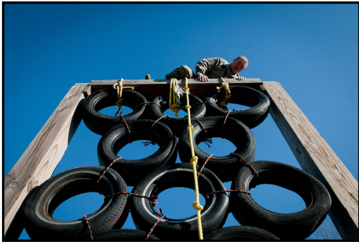

Bungee – Pick one of these questions

How does the size of an object added to an elastic band, affect the distance the band stretches?
How does the weight of an object added to an elastic band, affect the distance the band stretches?
How does the length of an elastic band affect the distance it stretches?

Equipment needed
• Toys/items of different weights
• A balance (your kitchen scales)
• A ruler (showing mm divisions)
• A hook or door handle
• Elastic band
• Paper clip
• Clear plastic bag with handles (big enough for toys to fit into)

Investigation
• Use the planning sheet to organise your investigation and start by identifying or composing your enquiry question.
• Make predictions and ensure that you have identified variables to enable a fair test.
• What measurements will you need to take before you start? Clue: you will need to use your scales and a ruler.
• Once pre-testing measurements have been completed, attach one end of your elastic band to a fixed hook or door handle. Make a paper clip hook to add to the other end of the band, the toys/items can then be suspended from this in their bags.
• Measure the amount of stretch of the elastic band using a ruler – how can you ensure that your measurements are accurate?
• How will you record your measurements in table and graph form?
• Look for patterns and outline any health and safety guidance you may need to send back.

Enquiry Question

Variables
Things I could change
Things I could observe or measure
I will change
I will observe
I will keep these things the same
Predicting
When I change
What will happen to
I think….

Results
What I observed
My data in a table

(clue – put what you changed in the first column and what you measured in the second)

I discovered…

Extension – could you produce a graph of your results?

