Special Educational Needs & Disability Policy

Written by: Katie Wolfe
Approved by: Governors
Last reviewed on: December 2025
Next review due by: December 2026

Our vision is the creation of lifelong learners, whose confidence in independent learning has been developed through teaching which recognises the importance of creativity, critical thinking and the artistic exploration and expression of self and identity.

At St. Peter’s all pupils are entitled to a broad, balanced, relevant, and differentiated curriculum. As a Catholic school, we acknowledge the unique creation of every person and endeavour to meet the individual educational needs of all pupils. We are committed to providing the right support to meet the needs of every pupil so that they can reach their full potential. At St. Peter’s we believe that this inclusive education is one that promotes a child’s sense of belonging and makes education an enjoyable and fulfilling experience socially, emotionally, and academically.

St. Peter’s believe that Faith is our Foundation and live out our mission through the virtues and values of the Catholic Pupil Profile. The SEND policy supports and endorses this philosophy.

This policy complies with the statutory requirement laid out in the Special Educational Needs and Disability Code of Practice: 0 to 25 years, January 2015 and has been written with reference to the following guidance and documents:
- Equality Act 2010: advice for schools DfE (updated June 2018)
- Statutory Guidance on Supporting pupils at school with medical conditions, April 2014 (updated August 2017)
- Keeping Children Safe in Education, September 2025
- Teachers Standards 2011 (updated December 2021)
- Anti-bullying, Behaviour, Safeguarding, Complaints Procedures, Disability Equality Scheme and Policy, Freedom of Information, Looked After Children, Pupil Premium and Race Equality Policy.
We understand our responsibility to have ‘due regard’ to the considerations and implications set out in the Equality Act, 2010. In doing so, we strive to prevent discrimination, to promote equality of opportunity and to foster good relations.
We acknowledge our duty to make reasonable adjustments, including the provision of auxiliary aids and services for disabled children, to prevent them being at a substantial disadvantage to others of the same age.

St. Peter’s Special Educational Needs Co-ordinator
Mrs Katie Wolfe is the school’s Special Educational Needs Coordinator (SENDCo) and completed the National Award for SEND Coordination in November 2024. Please contact Mrs Wolfe via the school office on 0121 705 3988 or by email sendinfo@st-peters.solihull.sch.uk. Ms Alison Edden is the SEND Administration Manager and can be contacted via the school office on 0121 705 3988 or by email sendinfo@st-peters.solihull.sch.uk.

According to the SEN and Disability Code of Practice 0 to 25 years (2015)
“A child or young person has SEND if they have a learning difficulty or disability which calls for special educational provision to be made for him or her.”

“A child of compulsory school age or young person has a learning difficulty or disability if he or she:
- Has a significantly greater difficulty in learning than the majority of others of the same age or has a disability which prevents or hinders him or her from making use of facilities of a kind provided for others of the same age in mainstream schools or mainstream post-16 institutions.”

DfES: Special Educational Needs and Disability code of practice: 0 to 25 years, January 2015 p15-16.
Aims
- To provide an environment in which all pupils can reach their potential.
- To raise the aspirations of and expectations for all pupils with special educational needs, improving their outcomes.
- To ensure that the special educational needs of pupils are identified, assessed, and provided for.
- To identify the roles and responsibilities of staff in providing for a pupil’s special educational needs.
- To ensure pupils are partners with school and parents in the decision making about their education.
- To ensure that parents can play their part in supporting their child’s education.

Objectives
- To implement the SEN and Disability Code of Practice 0 to 25 years (January 2015).
- To use a four-part cycle of ‘Assess-Plan-Do-Review’ as set out in the SEND Code of Practice.
- To respond to the requirements of any Education and Health Care Plan (EHC Plan) relating to a pupil in school.
- To adhere to the Solihull Local Authority (LA) guidelines for Inclusion.
- To implement the Equality Act 2010.
- To maintain a register of pupils with special educational needs and disabilities (SEND Support and EHC Plan).
- To liaise with outside agencies to assist in making appropriate provision for pupils with special educational needs and disabilities.
- To monitor, record and evaluate the progress of pupils on a continuous basis.
- To establish an effective communication system, both within the school and between school, external agencies, governors, and parents/carers.
- To work closely with senior staff, pastoral staff, and subject teachers, providing information on pupils and their needs.
- To ensure that a wide variety of teaching strategies (High Quality Teaching) are used for pupils with special educational needs, including the use of information technology to support learning.
- To ensure that pupils with special educational needs are fully included in all aspects of school life.
- To work with pupils in order that they find suitable college/training/employment when they leave school.
- To encourage parents to become partners with the school in their child’s education.
- To regularly review the policy and provision for special educational needs and disabilities (SEND).

Role of the SENDCo
The role of the SENDCo involves:
- Coordinating provision for pupils with SEND to ensure all pupils have access to consistent and high-quality teaching to meet their needs in school.
- Liaising with parents/carers of pupils with SEND, ensuring that they are:
- involved in supporting their child’s learning;
- part of the planning for how to best support their child and achieve the desired outcomes;
- regularly informed about the support their child is receiving;
- involved in reviewing the progress of their child.
- Liaising with external agencies that may come to St. Peter’s to help support pupils’ learning. This could include Educational Psychologists, Social Care professionals, Speech and Language therapists, advisory teachers from the Specialist Inclusion Support Services.
- Liaising with Primary schools, other schools, and other external agencies to ensure a smooth transition of pupils with SEND to St. Peter’s.
- Updating the school’s SEND support register (a system to record the SEND needs of all pupils to ensure that they are known to all members of staff) and ensuring that any records of pupils with SEND are kept up to date.
- Providing specialist advice and support (or signposting) for teachers and support staff in the school to enable them to support SEND pupils in achieving the best progress possible.
- Liaising with potential next stage providers to ensure that parents and their child are fully informed about options and a smooth transition is planned.
- Advising on the deployment of the school’s delegated budget and other resources to meet the needs of pupils with SEND.

Identification and Assessment at St. Peter’s
Pupil’s needs should be identified and met as early as possible. The following outlines the various methods by which the school identifies pupils as having additional needs.
- Shared information at KS2/KS3 transition.
- Screening/baseline tests at the start of Year 7.
- Information from Parent/Carer.
- Referral from mainstream teaching staff.
- Classroom-based assessment and monitoring arrangements.
- Tracking individual pupil’s progress over time.
- Reports/assessments carried out by other professionals e.g., Educational Psychologist, Occupational Therapist.

When a pupil is identified as having an additional need, in line with the definitions outlined previously, then they will be placed on the school’s SEND register. In line with the SEND Code of Practice, a pupil’s learning needs will be categorised under the following headings:

- Communication and Interaction – including Speech, Language and Communication Needs, and Autism Spectrum Disorder.
- Cognition and Learning – including Specific Learning Difficulties such as Dyslexia, Severe Learning Difficulties and Profound and Multiple Learning Difficulties.
- Social, Mental and Emotional Health – including ADHD, Anxiety Disorder and Attachment Disorder.
- Sensory and/or Physical – including visual impairment, hearing impairment and physical disabilities.

If, over a period of time, a pupil is considered to be making limited progress and is continuing to experience difficulties despite the specific interventions implemented by the school, and if all strategies are unsuccessful, the SENDCo, in consultation with parents, may decide to seek support from external services.

Any intervention at this stage, would be co-ordinated by the SENDCo where learning difficulty is the identified issue, and by the school’s Pastoral team in consultation with the SENDCo, where social, mental, and emotional health issues are predominant.

Ordinarily, external services would provide support and advice to the school about additional or different strategies for pupils who have not made progress through school-based interventions. Specific targets are usually agreed at this stage and reviewed at regular intervals by school staff and parents. The SENDCo will take the lead in any further assessment of the pupil, planning future interventions for the pupil in discussion with colleagues and monitoring and reviewing the action taken.

Every endeavour will be made to make reasonable adjustments for pupils who may have a disability under the Equality Act 2010. Pupils who need specialist help at a level which school is unable to provide, are referred to an appropriate outside agency.

It is important to consider the following that may impact on progress and attainment but are not special educational needs:
- Disability (the Code of Practice outlines the “reasonable adjustment “duty for all settings and schools provided under current Disability Equality legislation – these alone do not constitute SEND)
- Attendance and Punctuality
- Health and Welfare
- English as an Additional Language
- Being in receipt of Pupil Premium Grant
- Being a Looked After Child
- Being a child of a Serviceman/woman

A Graduated Approach to SEND Support
Subject teachers are responsible for the progress and development of pupils in their class, including the support given by Learning Support Assistants or external agencies. High quality teaching, differentiated for pupils’ needs, is the main way we respond to pupils with SEND. Additional intervention and support cannot make up for a lack of good teaching. However, if pupils still experience a significantly greater difficulty in learning, then further assessments will be carried out. St. Peter’s Catholic School practises the recommended graduated approach of: Assess, Plan, Do and Review.

- Assess: Information is gathered from the teacher, pupil, parents, teaching assistants and assessments. This will help to identify the pupil’s barriers to learning. Parents will always be invited to this early discussion to support the identification of action to improve outcomes.
- Plan: The SENDCo, will liaise with key stakeholders and decide what additional support is required to overcome these barriers. If review of the action taken indicates that “additional to and different from” support will be required, then the views of all involved including the parents and the pupil, will be obtained and appropriate evidence-based interventions identified, recorded and implemented by the class/subject teacher with advice from the SENDCo. This will be recorded on the SEND register.
- Do: The subject teacher remains responsible for working with the pupil. SEND support will be recorded on a plan that will identify a clear set of outcomes, which will include stretching and relevant academic and developmental targets (this may include for young people targets around preparing for adulthood) that take into account parents’ aspirations for their child. Parents and the pupil will also be consulted on the action they can take to support attainment of the desired outcomes. This will be recorded and a date made for reviewing attainment.
- Review: The interventions are formally reviewed termly against expected impact on progress, considering, the views of the parent and pupil. As a result of the review process we may decide to involve outside agencies for specialist support.

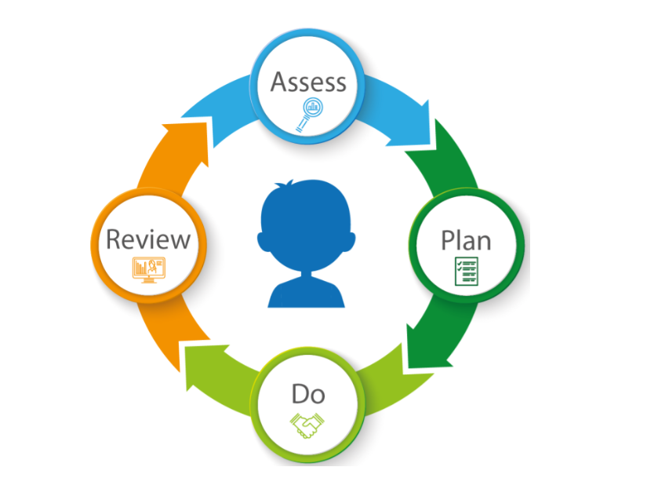

Managing pupils’ needs on the SEND Register
To fully comply with the SEN and Disability Code of Practice 0 to 25 years, 2015, the SENDCo has a managerial role in coordinating effective educational provision for pupils with special educational needs. The responsibilities are:
- overseeing the day-to-day operation of this policy
- liaising with and advising colleagues and subject departments
- coordinating provision for pupils with special needs
- maintaining the school’s SEND Register and overseeing the records on all pupils with SEND
- advising on the graduated approach to providing SEND support
- liaising with parents of pupils with SEND
- contributing to the in-service training of staff and governors
- advising on the deployment of the school’s delegated budget and other resources to meet pupils’ needs effectively.
- liaising with and being a key point of contact to external agencies and other support services, medical and children’s services and voluntary bodies
- liaising with the next providers of education to ensure a pupil and their parents are informed about options for a smooth transition.
- working with the Head teacher and school governors to ensure school meets its responsibilities under the Equality Act (2010) regarding reasonable adjustments and access arrangements.

SEND Admissions
St. Peter’s Catholic School is committed to fulfilling its duty to comply with national and local admission arrangements for all pupils with special educational needs and disabilities. St. Peter’s, in conjunction with LAs, carefully considers applications from parents and carers of pupils with additional needs and disabilities and does not discriminate against them in circumstances where reasonable adjustments and/or the provision of auxiliary aids and services can be made to meet their needs.

Please refer to St. Peter’s Catholic School admission arrangements for the year of application.

SEND Support and the Curriculum Offer at St. Peter’s:
St. Peter’s Catholic School is an over-subscribed mainstream school where the majority of learning is delivered in mixed ability groupings. Every pupil at St. Peter’s can follow all National Curriculum subjects as well as following an appropriate KS4/KS5 pathway (GCSE/BTEC/GCE). We are committed to narrowing the attainment gap between SEND and non-SEND pupils. We attempt to do this through quality teaching, the use of whole school intervention programmes or through targeting specific groups in certain subject areas, particularly in English and Mathematics. It is our policy to not withdraw pupils from lessons wherever possible. We ensure that pupils with SEND receive equality of entitlement to the National Curriculum and are integrated into all the activities of the school as far as it is practicable. However, there are occasions when the individual needs of certain pupils do require smaller groups or one to one intervention outside of the mainstream classroom.

The school’s arrangements for assessing the progress of pupils with special educational needs:

“Special educational provision is educational or training provision that is additional to or different from” that made generally for others of the same age. This means provision that goes beyond the differentiated approaches and learning arrangements normally provided as part of high quality, personalised teaching.” 0-25 SEND Code of Practice (2015)

Our interventions are categorised as the following:
- Wave 1: High Quality Teaching from all class teachers to all pupils including children with SEND (Pupils with an EHC plan and those identified as SEND Support).
- Wave 2: other school-based programmes of support that specifically target pupils with SEND including small group interventions for pupils with specific difficulties in literacy and a differentiated pathway at KS4. This level of intervention can also include the use of Learning Support Assistants (LSAs). However, please note that priority LSA support is given to pupils with an Educational, Health and Care (EHC) plan at St. Peter’s. Pupils will be offered additional SEND support when it is clear that their needs require intervention which is “additional to” or “different from” the well differentiated curriculum offer for all pupils in the school, in other words they have a special educational need as defined by the SEN Code of Practice 2015.
- Wave 3: extra specialist support in school provided by a professional from an external service. This is targeted at pupils with specific barriers to learning that cannot be overcome, initially, through quality first teaching and school-based intervention programmes. This level of intervention could involve a specialist professional working with a pupil either individually or in a small group so that they can understand their needs and make further recommendations to staff within the school.
- Wave 3 plus: a request for more specified individual support which is usually provided via an EHC plan (before September 2014 a Statement of Educational Needs). The school can request from the Local Authority, in which a child resides, to carry out a statutory assessment of a child’s needs. This is for pupils whose learning needs are severe, complex, and lifelong. It will mean that a child will have been identified by the class teachers, SENDCo and outside professionals as needing a particularly elevated level of individual or small group teaching that cannot be provided solely from the resources available to school. A request for a statutory assessment should be made for pupils who have consistently failed to make progress in line with their peers, despite Waves 1 to 3 interventions.

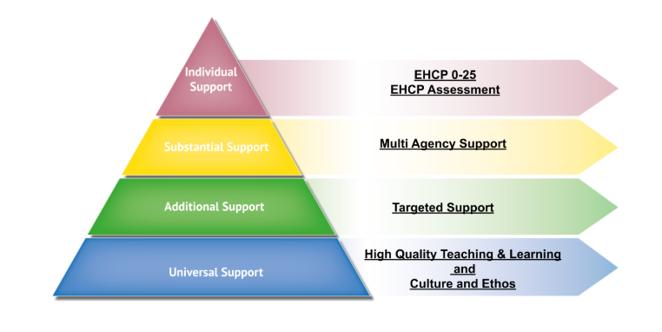

Monitoring and Evaluation
The monitoring and evaluation of the effectiveness of St. Peter’s provision for pupils with SEND is carried out in the following ways:
- Classroom observations by subject leaders, the SENDCO and other members of the SLT.
- Ongoing assessment of progress made by pupils including any intervention groups.
- Work sampling and scrutiny of planning by subject leaders.
- Moderation of assessments and marking procedures.
- Informal feedback from all staff.
- Pupil voice.
- Pupil progress tracking using assessment data (whole-school processes).
- Attendance records and liaison with Lead Tutor.
- Regular meetings about pupils’ progress between the SENDCo and other members of the SLT.
- Head teacher’s report to parents and governors.

Pupils with an Education, Health, and Care Plan:
The SENDCo will take the lead in:
- Planning the curriculum and arranging support for pupils.
- Liaising with staff, pupils, and parents/carers.
- Advising staff on strategies for support as set out in the EHC Plan.
- Monitoring progress of educational outcomes.
- Involving necessary external support services and any subsequent liaison.
- Developing INSET for staff, where appropriate.
- Maintaining records of pupils’ progress.
- Organising statutory reviews of the EHC Plan.

School Request for an Education and Health Care Plan Assessment
If, at the review of a pupil who has been in receipt of ongoing support, including support from external services, those involved decide that the pupil is not making adequate progress, the SENDCo, in consultation with parents, may consider whether to ask the LA to initiate a Single EHCP assessment. The SENDCo will be responsible for collating the information related to the strategies employed and targets set and achieved. There would need to have been at least two reviews at which it was clear and evident that the planned interventions had failed to provide the intended outcomes.

In general, the school will provide evidence related to:
- School provision/intervention provided since the pupil was placed on the SEND register.
- Pupil Passports.
- Records of reviews.
- A pupil’s health and medical records, where relevant.
- Evidence of progress data, including attainment in literacy and numeracy.
- Any educational or other assessments which may be relevant.
- Views of parents and pupils.
- Reports of other professionals and agencies.

The SENDCo will be responsible for liaising with the LA during the process of statutory assessment. This may vary dependent on the LA.

Parental involvement with the education of a child with SEND
Our school has an open-door policy to parents ensuring we are always approachable, so parents and carers feel involved in the education of their child.
In addition, our school aims to regularly involve parents and carers in the education of their child through a variety of diverse ways including:
- Meetings with our SENDCo, subject teachers, Lead Tutors, and support staff.
- Parent Forums (starting in 2025-26).
- Information on the school website.
- Parents’ evenings.
- Signposting to external agencies/support groups.
- Parent questionnaires.
- SEND Information Evenings for parents.

How are pupils with Special Educational Needs involved in their own education?
We aim to involve all pupils in our school in the evaluation and implementation of their own education. For pupils with special educational needs, we use a variety of strategies to support this including:
- Person Centred Reviews through EHC Plan reviews
- Self-assessment: through gathering of views and involvement in target setting.
- Having a range of equipment available for the pupil to choose to use.
- Ensuring the pupil has a designated adult to go to if they need help.
- Membership of the school council & extra-curricular activities (by choice)
- Pupil Passports
- Medical alert cards and medication passes, including toilet passes for medical conditions.
- Visual timetables
- Time out cards
- Pupil questionnaires and ongoing pupil voice work

Transition between the Key Stages
For pupils in Year 6 at feeder primary schools, induction days are organised in the summer term, introducing pupils to a variety of teaching staff, lessons, and additional activities that they may expect in Year 7. In addition, the SENDCo and other key staff will visit the feeder primary schools to attend Year 6 reviews in the summer term. Additional bespoke support for transition is available for pupils in consultation with primary schools, and additional transition visits are available. For older pupils selecting their options in Year 9, the SENDCo will offer further guidance to pupils and parents on request this is in addition to the support put in place via whole school procedures. For pupils in Year 11 and 13, the SENDCo, Careers Support and Sixth Form Team will work with SEND pupils and their parents/carers to ensure that they make a successful transition to post-16 education/higher education. If necessary, the SENDCo/pastoral team will arrange visits to new schools/colleges/university for pupils.

External agency support
St. Peter’s Catholic School works in a collaborative partnership with many different agencies. This means that a supportive plan is developed to meet a child’s needs both in and out of school. Services provided are categorised into 3 areas and are as follows:
Directly funded by the school:
- Learning Support Assistants.
- Specialist Inclusion Support Services (SISS) Traded Service –CLD (Communication and Learning Difficulties) and SEMH (Social, Emotional and Mental Health team).
- Educational Psychology Service
- EM Space – Emotional Wellbeing Support
- Mindcraft Psychotherapy – access to Child & Adolescent Psychotherapy

Paid for centrally by Solihull LA:
- Specialist Inclusion Support Services (SISS) The Local Authority (LA) currently, in agreement with schools, maintains a centrally retained non-traded ‘low incidence’ service made available to schools on a referral-based system. The current services in this category include Sensory and Physical Impairment, Autism Outreach team, Speech, Language and Communication Disorders, SEND Under 6 support, Speech, and Language Therapy (SLT) - provided by health but paid for by the LA.

Provided and paid for by the Health Service:
- School nurse – weekly sessions in school.
- Occupational Therapy (OT)
- Physiotherapy

Dealing with complaints
If you have a complaint about the school, please contact the SENDCo in the first instance and we will do everything we can to respond to the complaint. If this does not resolve the issue, please direct the complaint to our Head teacher, Mr Stuart Shelton. Our school and governing body take complaints seriously and will act upon these on an individual basis.

Monitoring and reporting arrangements
The Headteacher, Stuart Shelton, is responsible for day-to-day management of all aspects of the school's work including special educational needs and keeps the governing body fully informed.

The SENDCo will provide an annual written report to the Governing Body, detailing current issues, developments, and future plans. The SENDCo and SEND Governor meet to discuss current practice. The SENDCo expects challenge from the SEND Governor, to continually improve practice and delivery for all pupils with SEND at St. Peter’s Catholic School.
The school’s named SEND governor is Clare Campbell.

Reviewing the policy
The Headteacher and the SENDCo will monitor the policy. They also receive support from the named Governor for SEND at St. Peter’s Catholic School.

In accordance with statutory responsibilities, St. Peter’s also has a SEND Information Report which is reviewed annually. This is also available on the school’s website.

Support services that can help parents and carers with pupils who have Special Educational Needs
The SEND Parent Partnership service exists to provide advice and information to parents and pupils in Solihull. They can explain the special educational needs procedures, help parents understand the law and procedures and provide information on other issues that may be useful. They provide a free, confidential, and impartial service for all parents and carers of children with special educational needs in Solihull and can offer the advice, information, and guidance necessary for to make the right choices for your child. They are based at Sans Souci Training Centre, Tanworth Lane, Shirley, Solihull, West Midlands, B90 4DD and can be contacted by email solihullsendpartnership@prospects.co.uk or phone 0121 733 7290.

Appendix 1: Provision for other vulnerable groups of pupils

Pupils with English as an Additional Language

Pupils having difficulty with English because it is their second language do not have Special Educational Needs. Such pupils do not have materials with a reduced cognitive content unless there is a confirmed learning difficulty in the pupil’s first language. St. Peter’s believes that the best place for learners of English as a second language is a mainstream classroom with their peer group. Bi-lingual children are an advantage in the classroom rather than a problem. Evidence shows they will make greater progress in English if they feel their first language is valued. The SEND Department offer support with EAL provision, where appropriate, for those with a limited grasp of English.

Looked After Children
St. Peter’s Catholic School recognises that pupils who are looked after in local authority care have the same rights as all children but may have additional needs due to attachment issues, early neglect, separation and loss, trauma and many placement moves. These barriers to learning can affect their educational outcomes and their personal, social, and emotional development. There are commonly understood reasons (Social Exclusion Unit Report: 2003] why children who are looked after in local authority care often fail to make expected progress at school:

- Placement instability.
- Unsatisfactory educational experiences of many carers.
- Significant amount of time outside of education.
- Insufficient support to close the gap in educational support.
- Unmet needs – emotional, mental, physical.

There is a statutory requirement for all schools to have a designated teacher (DT) for looked after children. The names of the current designated teachers at St. Peter’s is Miss Shiner. The responsibilities of our designated teachers include:

- Monitoring the progress of children who are ‘looked after’ to ensure that they have the best life chances possible and access to the full range of opportunities in school.
- Ensuring that children who are ‘looked after’ have access to the appropriate network of support.
- Checking that the statutory Personal Education Plan (PEP) has been arranged and that it is regularly reviewed, at least every six months.
- Ensuring that information concerning the education of children who are ‘looked after’ is transferred between agencies and individuals.
- Preparing a report on the child’s educational progress to contribute towards the statutory review (These are usually held at six monthly intervals or more frequently if there is a concern).
- Liaising with the child’s social worker to ensure that there is always effective communication.
- Celebrating the child’s successes and acknowledge the progress they are making as well as how they are included in the life of the school.

