
Year 9
Dafa Feed 1 revision
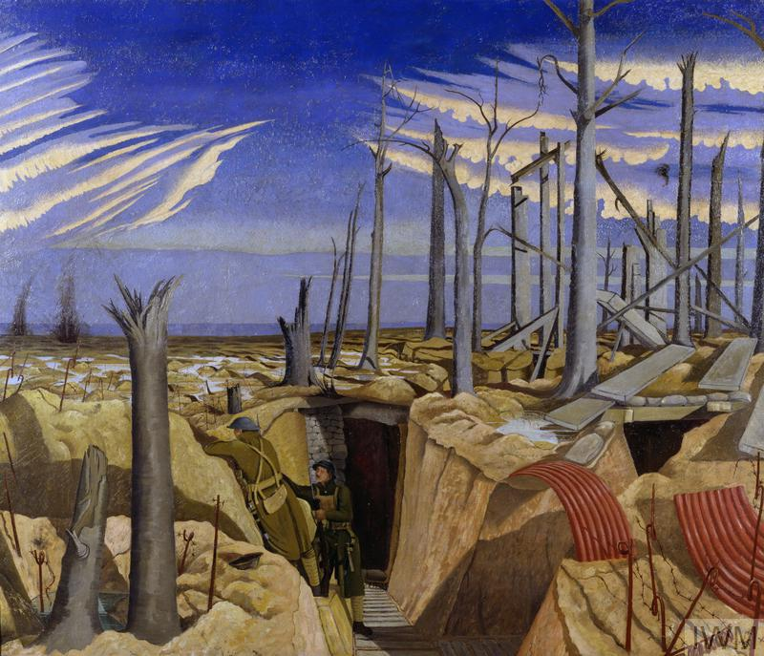

Revision checklist
- The MAIN causes of WW1
Militarism Alliances Imperialism Nationalism
- Membership of the Triple Entente and the Triple Alliance
- The assassination of Archduke Franz Ferdinand
- Trench warfare including conditions, tasks, food, diseases and impact on the mental health of the soldiers.
- Using interpretations in History and why the origin of the interpretation affects what we learn from the interpretation.

Knowledge Organiser: By 1914, the first World War was inevitable?
Long Term Causes of World War One
Militarism
Building up the army and navy with more soldiers and equipment
- Countries make their armies bigger
- Governments spend more on military
- Governments say it is for defensive reasons, but often attack other countries
Alliances
A relationship between countries of mutual benefit
Triple Alliance  - Germany  - Austria-Hungary  - Italy | Triple Entente  - Britain  - France  - Russia
Imperialism
A policy of extending a country's power and influence by taking over other countries and claiming them as part of their ‘empire’
The British feared Germany in Africa.
The Austrians feared Serbia / Russia in the Balkans.
Nationalism
A policy of being extremely patriotic for one’s country.
Individual countries were forming across Europe and Slavs wanted to assert their own rule, not be under Austrian rule. Serbia and Russia said they would support the Slavs.

Assassination of Franz Ferdinand
Archduke Franz Ferdinand was heir to the throne of Austria-Hungary. He was inspecting the army in Sarajevo with his wife Sophie. The royal couple arrived by train at 9.28am. Seven young Bosnian Serbs planned to assassinate Franz Ferdinand as he drove along the main road in Sarajevo, the Appel Quay. The first conspirator who tried to kill Franz Ferdinand threw a bomb at his car. He missed and was arrested. The Archduke escaped unhurt. He decided to abandon the visit and return home via a different route to the one planned. No one had told the driver the route had changed. On the way back, therefore, the driver turned into Franz Josef Street, following the published route and, when told of his error, stopped the car to turn around. Unfortunately, the car stopped in front of Gavrilo Princip, one of the conspirators, who was on his way home thinking he had failed. Princip pulled out a gun and shot at Franz Ferdinand, hitting him in the jugular vein. There was a tussle, during which Princip shot and killed Sophie. By 11.30am, Franz Ferdinand had bled to death.
Outbreak of War
28th June 1914: Franz Ferdinand assassinated
28th July 1914: Austria-Hungary declares war on Serbia
4th August 1914: Britain declares war on Germany
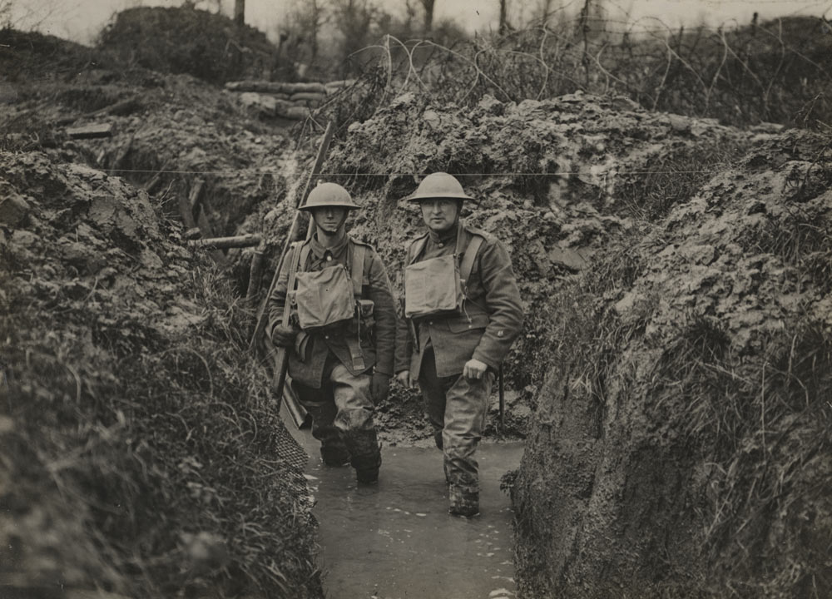

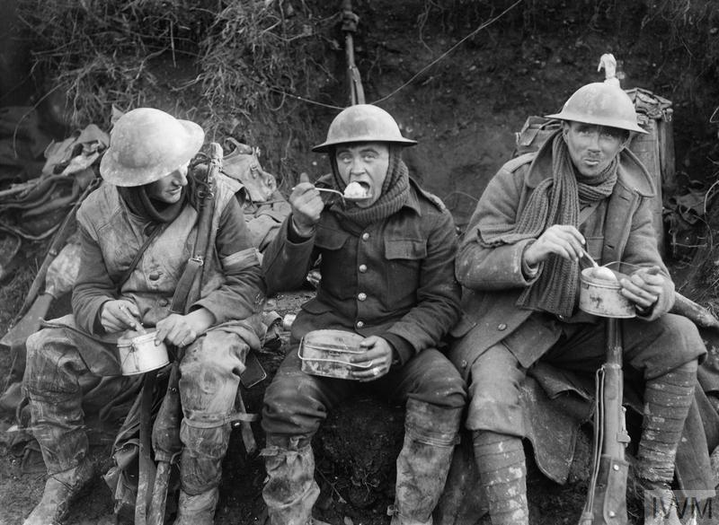
Trench Life
The entente and allied troops met across the Eastern part of France and Western part of Belgium. This was a result of the failure of the Schlieffen plan. The ‘front line’ only moved slightly throughout the entire war. No proper place to sleep or eat.
No rest from the Front Line. Bad conditions that could lead to trench foot and other diseases such as Trench Fever and lice.
Men suffered from mental health conditions due to the fear of the war and the constant heavy bombardment called Shell Shock which today is called PTSD – Post traumatic Stress disorder.
Soldiers experienced rationing and limited food supplies and lived off biscuits and tinned meat called bully beef.
USE THE LINKS AT THE END TO HELP WITH REVISION
Propaganda
Information, especially of a biased or misleading nature, used to promote something
Campaign led by Lord Kitchener to recruit a huge volunteer army. 12 million posters printed in one year alone. Created a sense of patriotic duty. Pals Battalions – sign up with your friends and serve with them.
Battle of Somme
The Battle of the Somme, also known as the Somme Offensive, was a battle of the First World War fought by the armies of the British Empire and French Third Republic against the German Empire. It took place between 1 July and 18 November 1916 on both sides of the upper reaches of the River Somme in France. Casualties from this one battle was 1 million.

End of the War
Feb 1917: Russia leave the war
April 1917: US join the war
March 1918: Stalemate ends with Germany trying to push through the front line

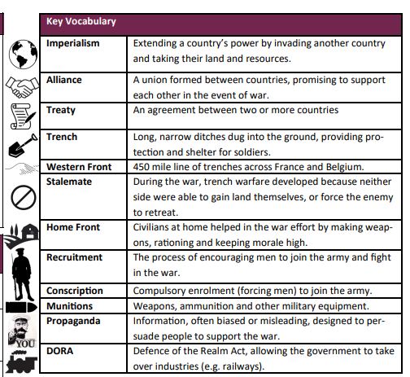

PTO for useful links
Useful revision websites to use
Causes of World War One – World War One – KS3 History – homework help for year 7, 8 and 9. – BBC Bitesize
What was life like on the front line in World War One? - World War One - KS3 History - homework help for year 7, 8 and 9. - BBC Bitesize
Life on the Western Front - BBC Bitesize
Life In The trenches Of The First World War
What Did Soldiers Eat in the Trenches of World War One? - YouTube
Could You Survive Life On The Front Line In WW1? - YouTube
A Soldier's Food - WW1 Uncut: Dan Snow - BBC - YouTube
How the Assassination of Archduke Franz Ferdinand Unfolded with Dan Snow - YouTube
Life in a Trench | World War I | History - YouTube

