Year 9
RE Assessment
Revision
Conscience and Sanctity of Life
NAME:………………………………………………………………………………………………….
RE teacher: …………………………………………………………………………………………..
What to expect:
- The assessment will take 45 minutes.
- There will be 3 sections:
1) 10 multiple choice questions
- 10 knowledge questions
- A section with an A/B/C type exam question. (There will be 2 of each.)
RE Revision list
The following is list of questions you need to be able to answer to be successful in your RE assessment.
Conscience
- What are the different ideas about conscience and how it is formed?
- What are some different moral situations and dilemmas where conscience is used?
- How does a conscience help make a moral decision?
- What are the problems with relying on the conscience?
- What is freewill and how does it link to the conscience?
- What happened in the story of the Fall?
- What is forgiveness, temptation and how does it link to the idea of conscience?
- Why is the conscience important in Catholic teaching?

Sanctity of Life
- What is the meaning of ‘sanctity of life’?
- Why do Catholics believe that life is sacred?
- What is the difference between pro-life and pro-choice?
- What is abortion?
- Why is the Catholic Church opposed to abortion?
- What are some reasons people want the right to have abortions?
Conscience
What can you remember?

Conscience…
Key words
Fill in the meanings of the key words below.
Conscience
Moral act
Amoral
Immoral
Non moral act
Psychology
Freewill
Forgiveness

Different views of the conscience
Complete the table below with information about the different views of the conscience.
 | Explain their view of the conscience (include a quote if you can). | Do they think the conscience is reliable? Explain their view.
St Paul
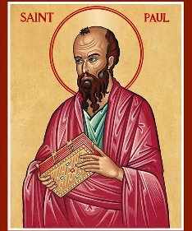
St Augustine
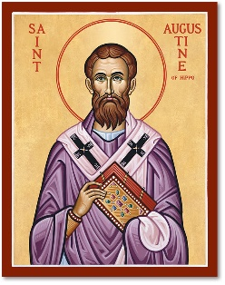
St Thomas Aquinas
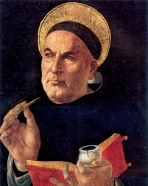
Sigmund Freud
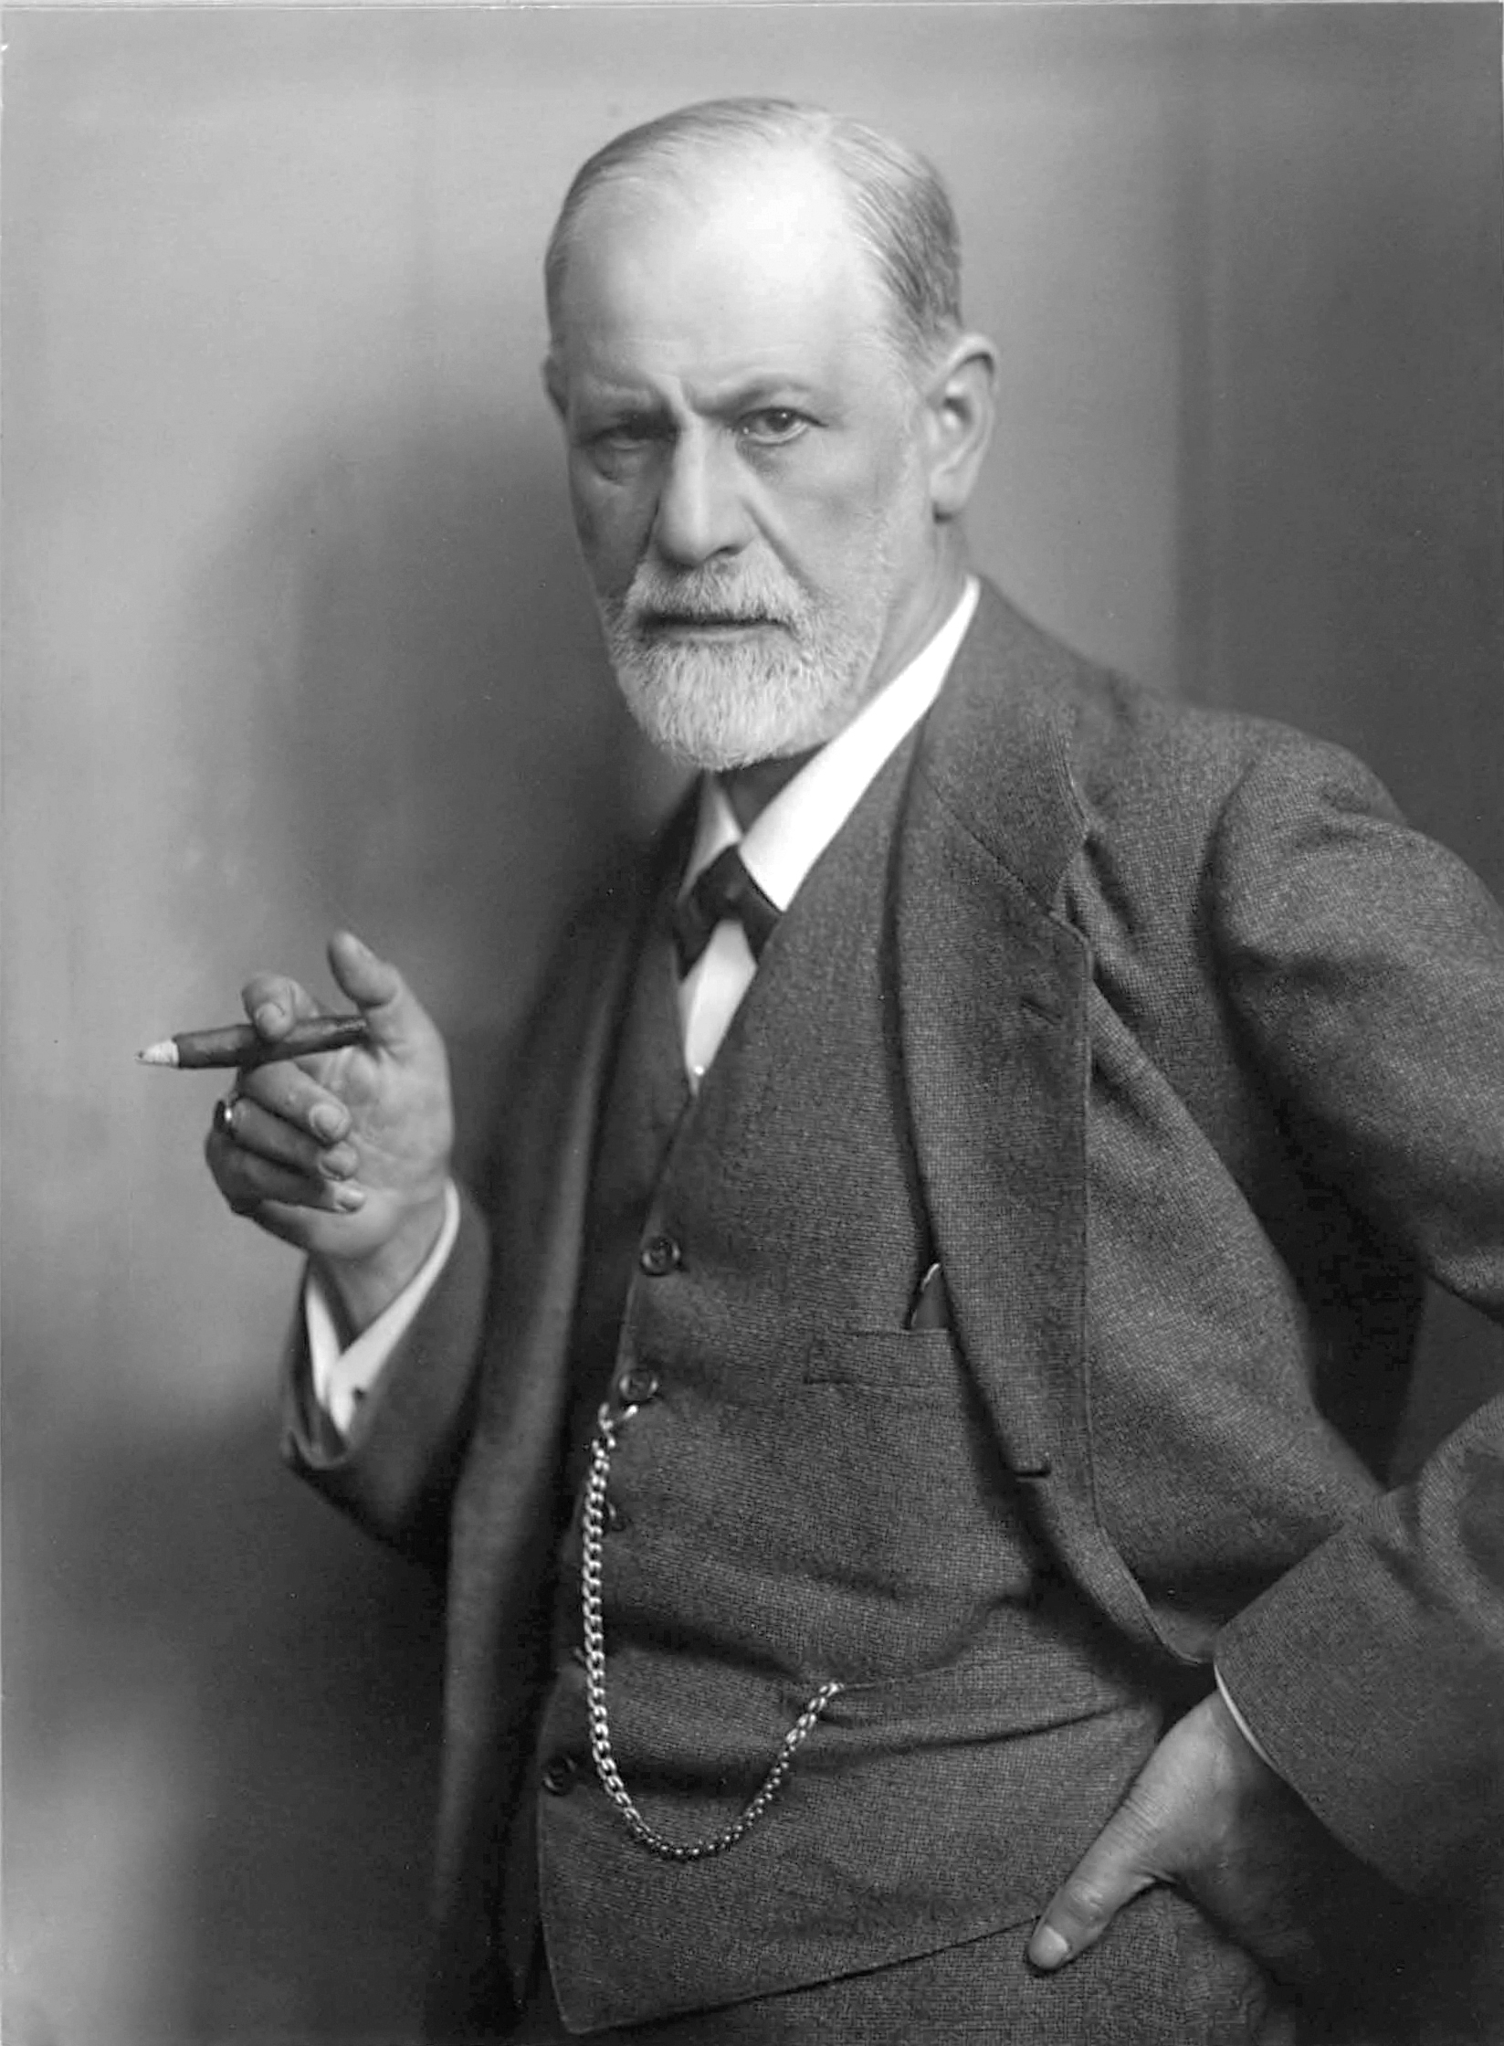
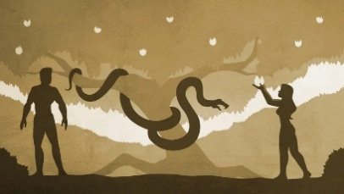
The Fall
Read the story of the Fall.
¹ The serpent^{[m]} was the most clever of all the wild animals that the Lord God had made. It said to the woman, “Is it true that God told you not to eat of any of the trees in the garden?”
² The woman answered the serpent, “We may eat of the fruit of the trees in the garden, ³ but as for the fruit of the tree in the midst of the garden, God said that we must not eat it, nor even touch it, lest we die.”
⁴ But the serpent said to the woman, “Certainly you shall not die! ⁵ God knows that when you eat from it, your eyes will be opened, and you will become like God, knowing that which is good and that which is evil.”
⁶ The woman saw that the tree was good for food and pleasing to look at and desirable for imparting wisdom. She took some fruit and ate it. Then she gave some to her husband who was with her, and he also ate it. ⁷ Their eyes were opened and they realized that they were naked. They took fig leaves and sewed them together, making themselves a covering.
⁸ They then heard the Lord God walking in the garden toward the evening. The man and his wife hid themselves from the Lord God amongst the trees of the garden. ⁹ But the Lord God called out to the man and said to him, “Where were you?”
¹⁰ He answered, “I heard you walking in the garden and I was afraid because I was naked, so I hid myself.”
¹¹ He said, “Who let you know that you were naked? Have you eaten from the tree from which I commanded you not to eat?”
¹² The man answered, “The woman whom you put here with me, she gave me some fruit from the tree and I ate it.”
¹³ The Lord God said to the woman, “What have you done?”
The woman answered, “The serpent tricked me and I ate it.”
¹⁴ The Lord God said to the serpent,^{[n]}
“Because you have done this, you will be the most cursed
of all the animals
and of all the wild beasts.
On your belly you shall crawl
and you shall eat dust
for all the days of your life.
¹⁵ I will establish hostility
between you and the woman,
between your line and her line.
Her offspring will crush your head
and you will bruise his heel.”^{[o]}
¹⁶ To the woman he said,
“I will multiply your sufferings in childbirth;
with pain you shall bear your children.
You shall desire your husband,
but he shall lord it over you.”
¹⁷ To the man he said, “Because you listened to the voice of your wife and you ate from the tree from which I had commanded you not to eat,
“Cursed be the soil because of you!
With effort you shall obtain food
all the days of your life.
¹⁸ Thorns and thistles shall it bring forth for you,
and you shall eat of the plants of the field.
¹⁹ You shall have to sweat
to eat your bread
until the day when you return to the earth,
for from it you were drawn.
You are dust,
and unto dust you shall return.”
²⁰ The man called his wife Eve, for she was the mother of all those who lived.
²¹ The Lord God made clothing for the man and woman out of animal skins and he clothed them. ²² The Lord God said, “Behold, man has become like one of us, for he has knowledge of that which is good and that which is evil. Now, we must prevent him from reaching out and taking the fruit of the tree of life lest he eat it and live forever.” ²³ The Lord God cast him out of the Garden of Eden; henceforth he was to labour tilling the soil from which he had come. ²⁴ When he expelled him, he placed cherubim^{[p]} to the east of the Garden of Eden with flaming swords to keep watch over the way to the tree of life.
Summarise the story of the Fall into 5 bullet points:

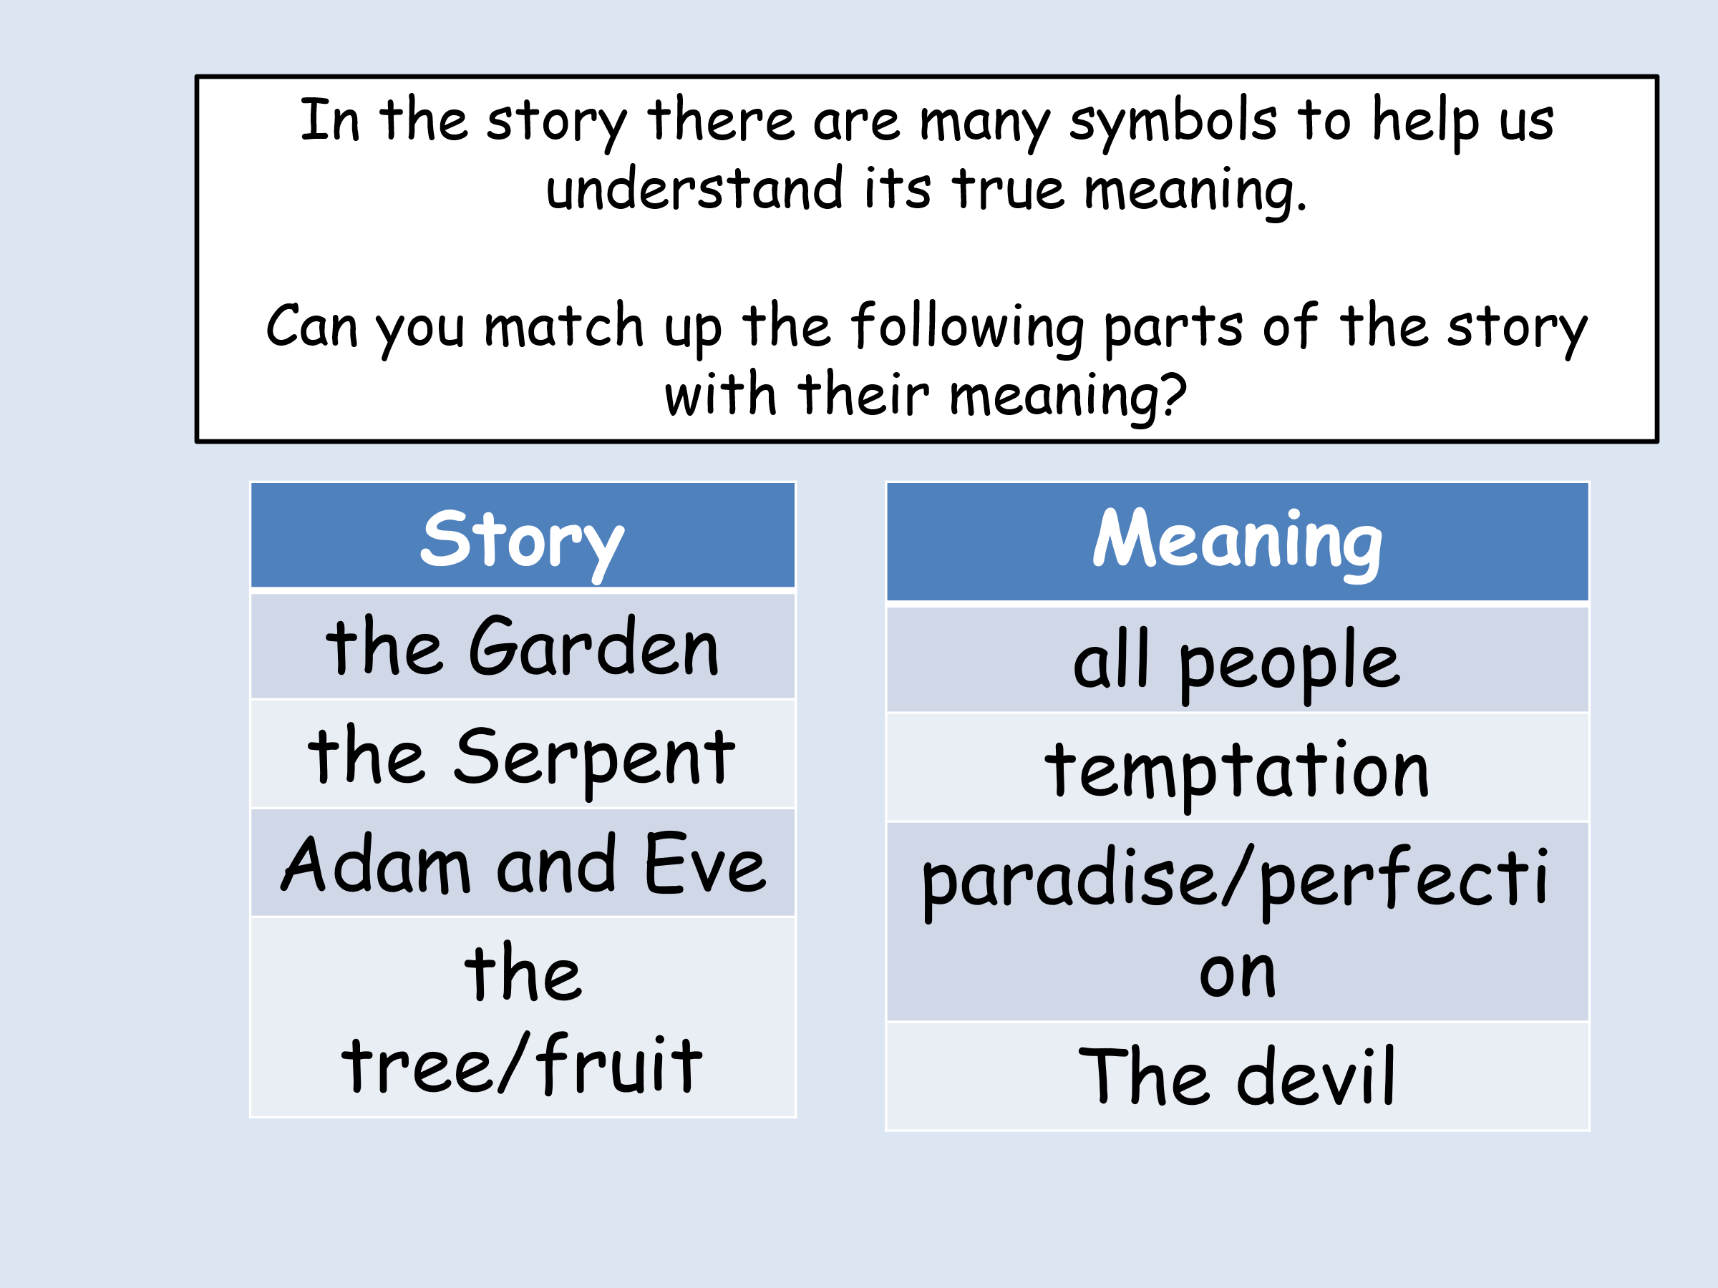
What were the punishments given to the characters in the story of the Fall?
Character | Punishment
The serpent
The woman
The man
Responses to evil and suffering in the world
What is the meaning of ‘theodicy’?
_____________________________________________________________________________________________________________________
Summarise the theodicies of St Augustine and St Irenaeus into 3 bullet points.
St Augustine’s theodicy  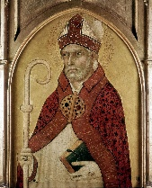 | St Irenaeus’ theodicy  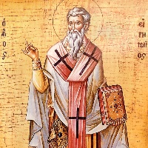

Sanctity of Life
Key word | Meaning
Sanctity of life
Imago Dei
Pro-life
Pro-choice

Why do Catholics believe that life is sacred?
Sanctity of life

Bible teaching about the belief that life is sacred
Explain how these examples of Bible teaching show that life is sacred.
Bible teaching | How does it show that life is sacred?
“In the image of God he made them, male and female he made them.” Genesis 1:27
“Do not kill.” Exodus 20:13
“Before I formed you in the womb I knew you…” Jeremiah 1:5
“I came that they might have life, life in all its fullness.” John 10:10
“Your body is a temple of the holy spirit, who lives in you and was given to you by God. You do not belong to yourself.” 1 Corinthians 6:19

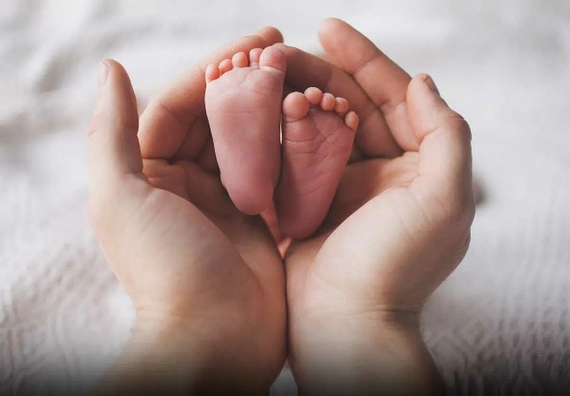

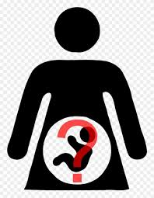
Abortion:
Abortion – Definition=

What is the UK law on Abortion?

Roman Catholic Atttude on Abortion
1)

2)

3)

Progress Check – True or False
- Sanctity of Life means that life is only worth living if a person is healthy.
- One doctor has to agree to a woman having an abortion.
- The legal limit for an abortion is 24 weeks.
- The Catholic Church teaches that life begins at the moment of conception.
- The Catholic church agrees that an abortion can be allowed if the woman has been raped.
Reasons in favour of allowing abortion | Reasons against abortion

Exam Technique

When we answer exam questions there is a set structure to follow.
For an A question I need: | For a B question I need: | For a C question I need:

Exam Questions:
A) Outline three reasons Catholics are opposed to abortion. (3)
_________________________________________________________________________________________________________________________________________________________________________________________________________________________________________________________________________________________________________________________________________________________________________________________________________________________________________________________________________________________________________________________________________________________________________________________________________________________________________________________________________
(b) Explain two reasons Catholics should use their conscience when making a moral decision. (4)
_______________________________________________________________________________________________________________________________________________________________________________________________________________________________________________________________________________________________________________________________________________________________________________________________________________________________________________________________________________________________________________________________________________________________________________________________________________________________________________________________________________________________________________________________________________________________________________________________________________________________________________________________________________________________________________________________________________________________________________________________________________________________________________________________________________________________________________________________________________________________________________________________________________________________________________________________________________________

(c) Explain two reasons Catholics believe life is sacred. Your answer must include a SOWA. (5)
_______________________________________________________________________________________________________________________________________________________________________________________________________________________________________________________________________________________________________________________________________________________________________________________________________________________________________________________________________________________________________________________________________________________________________________________________________________________________________________________________________________________________________________________________________________________________________________________________________________________________________________________________________________________________________________________________________________________________________________________________________________________________________________________________________________________________________________________________________________________________________________________________________________________________________________________________________________________



