Marxists and the nuclear family
Marxists argue the nuclear family performs many functions for capitalism:
- Families buy products for their members e.g. cars, houses, food, televisions, etc. Capitalism needs people to buy things so the rich can make a profit. Therefore the family is important as they buy things and support capitalism.
- Private property (owning a house) is important. Traditionally, men want property to pass on to their sons. This led to marriages so men knew the children being born were theirs, so the property would definitely get passed on to them! However, this also meant that the woman became the property of the husband who had her children. This reproduces the social class system.
- Primary socialisation creates class inequalities. The working class are socialised to accept their place in society as below the upper classes, the upper classes are socialised to believe they are above the working class.
- Families also support capitalism by providing unpaid labour. Children are socialised into being the next generation of workers and emotional support from mothers is provided for workers (the dads) to help them deal with any unfair treatment/exploitation at work.
Marxist sociologists focus on the inequalities in society and the family. They believe society is driven by profit. They believe there is conflict between the rich (upper classes) and the poor (working classes). The working classes are exploited and treated unfairly by the upper classes through work and laws.

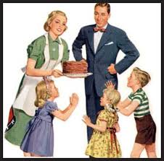

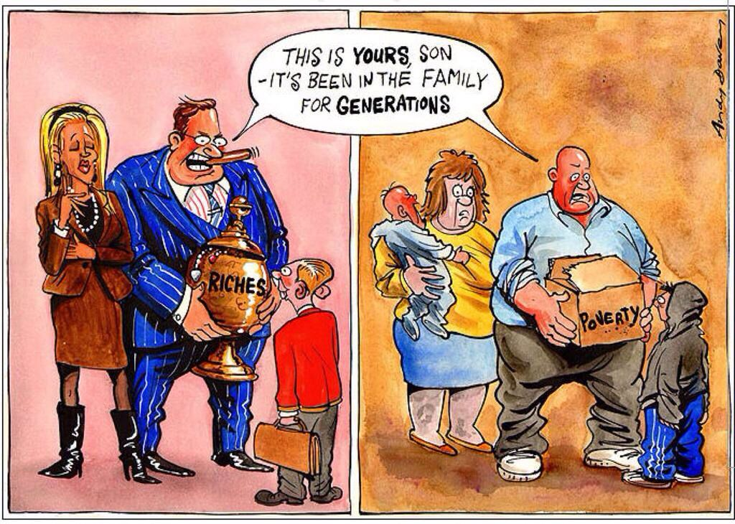
Criticisms of the Marxist theory

- Can be seen as old fashioned. The idea that men marry and have children to pass on property doesn’t really happen anymore.
- Many women now work themselves and have their own incomes so do not need to rely on a man’s salary anymore.
- The idea that families exist just to pass on the upper class status ignores other reasons for families. People today marry for love rather than social reasons such as class.
- Marxists ignore the benefits of the nuclear family, like the fact both parents support their children. Class isn’t as relevant today as it was in the past. Other factors hold importance now, such as ethnicity or gender.

