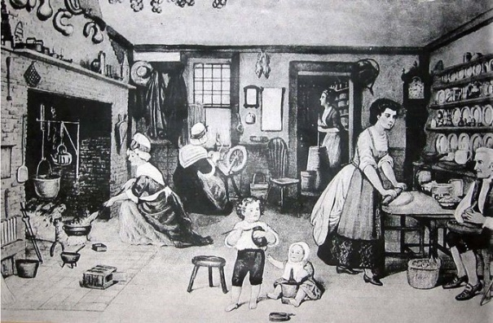
Changing relationships within families
Pre-Industrial families, 1600-1800: During these times all members of the family worked at productive tasks. They worked together to produce things needed for the family’s survival. The family also performed many functions such as health care, education and welfare. Pre-industrial societies were largely based on extended family networks. Land and other resources were commonly owned by a range of relatives extending beyond the nuclear family. The extended family was responsible for the production of food, shelter and clothing and would trade with other family groups for the things they could not produce themselves. Home and workplace were the same thing – very few people left home to go to work. At this time there was almost no social mobility, so roles passed from generation to generation and were determined by birth.
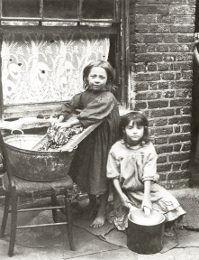
Industrialised families: Parsons, argued that the Industrial Revolution brought about large changes to family which became more geographically mobile as they needed to move towards town for work. Parsons believed the nuclear family helped this by making it easier for family members to move away from their wider families to find work. As industrialisation progressed, women and children became increasingly excluded from employment by legislation. This was to empower men since the family became dependent upon them being the breadwinner. Men earned the wages and decided how to spend them. Women remained in the home, responsible for the socialisation of children and the emotional care and support of family members. Children were seen as vulnerable and in need of protection and became dependent on adults. As mass education was introduced, children became a concern of the state – the state took over education, health and welfare. This meant the family became more home centred.


Contemporary families: The family today is seen to have family diversity, with many different types of families. Contemporary families in Britain are more self-sufficient and can become more isolated from other family members. Roles have changed within the family and there is more likely to be more sharing of roles by family members within the home. Families have become more child centred. The amount of time parents spend with their children has more than doubled since the 1960s. Parents listen to their children and involve them in family decisions. The family has become a unit of consumption with leisure activities centred on collective enjoyment such as having takeaways or days out.

Childhood in the past
Children were seen as miniature versions of adults and were expected to take on adult roles and responsibilities as soon as they were able. They did not lead separate lives but mixed with adults. During the 19th century middle class children were often looked after by a nanny, whereas working class children, especially boys, were expected to work in paid employment from an early age. Many girls worked unpaid at home, for example housework and childminding, but this was not officially recorded. Poverty may have prevented many parents from sending their children to school. Well into the 20th century many working class parents saw education as a barrier to them working. They sent their children out to work as soon as they could and relied on their income. However, following the Education Act of 1918, all children had to attend school until the age of 14 years.
Childhood today
Some sociologists argue that parents are becoming less authoritarian (less strict). There is less emphasis on discipline and obedience and more emphasis on individual freedom. Children are now listened to and taken seriously. They have rights and can make decisions in the family. It is said middle class families are more likely to have relationships where parents involve the children in decision-making. Today relationships are more ‘child-centred’ and focus on the needs of the child. The relationships are emotionally closer and warmer. The average family size has decreased so children get more attention from their parents. At the same time both parents often now work and leave children at nurseries for sometimes most of the working week. Young people are now much more dependent on their parents financially for longer as the school-leaving age has increased to 18 and their working hours are restricted by law. Youth unemployment also makes it difficult for young people to achieve independence, this can cause conflict and stress within families.
Theories view on childhood
Functionalists: says childhood improved as a result of more child-centred families. They say changes in attitudes resulted in happier, safer and more valued children. Rather than being units of production, where they had to work and bring in money, they are not units of consumption as adults invest time and resources on them. They say laws created now protect children from exploitation and neglect within the family.
Feminists: traditionally saw childhood as a time where girls were socialised to accept their secondary position to men in society. Girls watched the exploitation of their mothers in a patriarchal society and therefore learned their future roles. However, they recognise there are slow and positive changes for the role of women in terms of status within their family and society generally and daughters are being brought up to be equal to men.
Marxists: see childhood as an era where families socialise children to submit to a capitalist society rather than questioning it. As a capitalist society is driven by profit of the rich, working class children suffer the consequences such as poverty and inevitably become the next generation of workers who work long hours for low wages.

