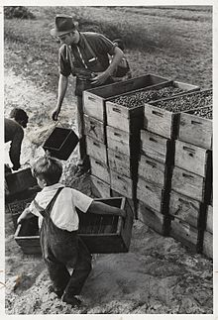
Relationships between children and parents
In the past children were seen as ‘mini adults’ where they were expected to take on adult roles as soon as they were able. They worked alongside their parents bringing money in for the family. Children were seen as ‘economic assets’ with girls working in fields with their mothers and boys working in factories or as chimney sweepers with their fathers.
Fathers were head of the household and the family was ‘patriarchal’- dads had little involvement with the care of their children.

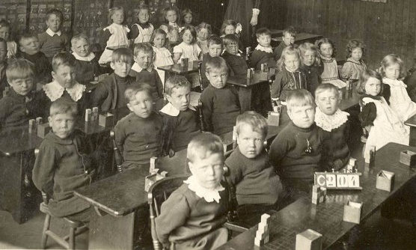
When industrialisation happened, changes in childhood came about. Laws were put into place to protect children from having to work and children were given much more legal rights than they had before. Children began to be seen as innocent and vulnerable with a need to be protected.

Education became compulsory from 1880 which made children dependant on adults. This led to the emergence of ‘childhood’ where children lacked independence and were supported by adults. This period is getting even longer today as young people are now staying in education until they are 18. Children are now seen as ‘economic burdens’ instead.


Parents now work a shorter working week (five days rather than six) which means they are spending far more time with their children. Adults are now having less children, meaning they can focus more time on the children that they have and because they are now bringing in more money, more of this is being spent on the children too.

There is a ‘consumer market’ now for children, where the media push the latest games, objects and gadgets on children through adverts. Children will use ‘pester power’ on their parents so that they buy them these things- this is where they nag and pester their parents as much as possible until they get what they want.

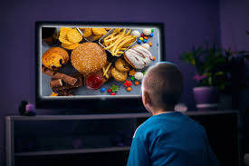
Sue Palmer believes there is now a ‘toxic childhood’- quality time together has been replaced by mobile phones, internet and social media. Children sit at home in their rooms with TVs and computers and this means parents are no longer able to control what their children are exposed to, reducing the ability to regulate their child’s behaviour. She also says children are exposed to things such as junk food and video games, which can be seen as having a negative impact on a child’s health and wellbeing.

