Is marriage still important today?
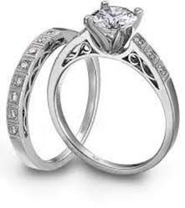
Reasons for the decline of marriage
- Changing role of women: as women have more economic independence, it has given them the freedom to now choose their relationships. Women are postponing marriage and focusing on their careers instead and now have their own money so they do not need to rely on a man.
- Changing social attitudes: there is now less stigma attached to living with someone without being married (co-habitation). Also, society is far more accepting of women being single and choosing to live alone and have a career rather than get married at a young age.
- Secularisation: people are now less religious in the UK today, so they are able to cohabit without thinking they are ‘living in sin’. Less than a third of marriages today involve a religious ceremony and church membership has dramatically declined.
- Rising divorce rates: many people choose not to marry because they see the rising divorce rates so this will put them off.
- Expense of marriage: the average cost of a wedding these days in the UK is over £20k! Cohabitation is a much cheaper option.

Factors that show marriage is still important
- The 2011 census showed that 65% of families in the UK were married couples. In 2013, 67% of all marriages were first marriages for both partners, 15% were remarriages for both partners and 13% were where one partner had been married before. This shows that even when people break up, they will remarry as they still see it as important.
- Civil Partnership Act 2004: same-sex couples were able to have virtually the same rights as married heterosexual couples.
- The Marriage (Same Sex Couples) Act of 2013 allows same-sex couples to legally marry and from December 2014, same-sex couples in civil partnerships could convert their partnership to marriage.

- UK statistics shows the highest amount of married couples are in Asian households. Bangledeshi (54%) Indian (53%) and Pakistani (51%) households contain a married couple compared to 37% of white British. This shows the importance of marriage for British Asian communities.

