
Reasons for family diversity
Legal changes
- Divorce Reform Act 1969- made it much easier for people to divorce as neither partner had to prove that it was their husband or wife’s fault to get a divorce. As a result, divorce rates rose and more than doubled between 1969 and 1972. Today around 42% of marriages end in divorce.
- Equal Pay Act 1970- meant men and women doing the same job got the same pay, which led to more independence for women and encouraged them to work outside of the home, resulting in divorce.
- The Marriage for Same Sex Couples Act 2013- gay couples could now get married and it was seen as the same as a marriage between a man and a woman by law. Over 15,000 same-sex couples married between 2014-2015


Changes in social attitudes
In the 20th century priorities and expectations of relationships changed. People began to marry later and stopped seeing having a family as the most important thing in life. In the past, a woman living alone would be seen as negative as she would have been seen as a failure not finding a husband, but today views have changed and it is much more acceptable for men and women to live alone. It is also more acceptable to cohabitate (live together without being married) than it used to be in the past. There is also less social stigma attached to sex-same couples.


Employment opportunities
There are far more employment opportunities for women today. Many choose not to marry young anymore and to focus on careers. Women who do marry now have more control over their fertility as they can use contraception such as the pill, so they do not have children and focus on developing their careers instead.


Longer life expectancy
People are now living much longer. This means couples today are spending a massive chunk of their lives with that one person. Over time, couples attitudes and interests may change and if they do divorce, there are many years left to go on and form new relationships.

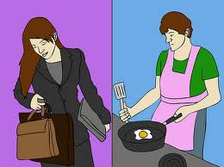
Changing gender roles
More women are now going out to work and no longer need to be financially dependent on men. Women also focus more now on building a career rather than having a family, with 47% of the workforce now being made up of women. This can explain single-parent families as women now have more power and more money, so choose never to marry and to have babies on their own through methods such as adoption or IVF.

Benefits for lone parents
The UK government provides benefits to lone parents to help support them, which can make the decision to divorce and raise children alone easier. Previously women just stayed in unhappy marriages because the man was the breadwinner and they had no money to support themselves, but with recent changes, women can now financially support themselves and their children.


Immigration
Immigration of people from other parts of the world has led to an increase in different family types. For example, families from south Asia bring with them their tradition family structures, such as living in an extended family with grandparents.

Decline in religion
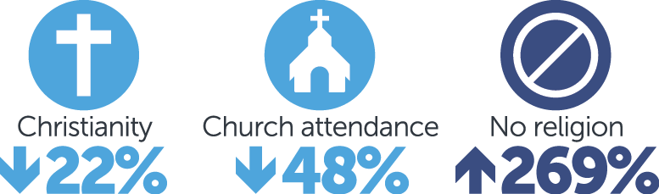
Secularisation means the decline in religious beliefs in society today. Sociologist William Goode said this has led to marriage becoming less sacred and special, with fewer couples getting married today by having a religious ceremony. Less than one in three marriages were celebrated in a church in 2015 compared to more than half in 1980’s. Also, as there is a decline in religion, cohabitation and divorce is less likely to be seen as morally wrong in society today.

